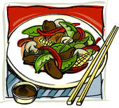
Stir Fry Making It Better
Student Name: __________________
Stir Fry Type:_________________

Stir Fry Dish | Looking for: | How could you plan do better next time?  Specific examples only!!!
Dish Preparation | Resourceful and independent preparation.
Knife Cuts | 3-5 different vegetable cuts for aesthetic value and variety.
Knife Cuts | Consistent vegetable cuts for proper cooking.
Storing | Product mise en place stored and labeled daily and properly.
Kitchen Professionalism | Preparation is efficient and well planned. Sanitation is a priority.
Dish Service | Dish met deadline.
Plating | Dish presentation was attractive and appetizing. Appropriate garnish was used.
Temperature | Appropriate temperature of dish served.
Sauce | Desired consistency and flavour.
Vegetable Texture | Al dente (firm), not mushy texture.

