APPENDIX A – Candle Holder
OCTE | http://www.octelab.com/
Best Practices Framework
JOHN HOBBINS
2016
Project Scope/Challenge
This project will provide students with an opportunity to demonstrate their understanding of project management as it pertains to manufacturing processes that support design concepts, part fabrication and finishing, and project presentations. Students have previously developed an array of skills through the use of manufacturing equipment where they have practiced a variety of machine operations. The Candle Holder project allows the student to design a candle holder that reflects their personal interests, and perhaps is reflective of their cultural background. Students will research existing candle holder designs from across the globe, and then implement design characteristics that they feel would combine to create a unique product and/or candle holder.
Criteria
- Can be made from – aluminum, brass, steel, wood inclusions (or a combination of materials)
- Must include 3-5 sketches and/or CAD drawings
- Completed project to provide evidence of a variety of machine operations
- Must include employment of metal lathe and milling machines
- Portfolio package to include – design brief, process planning, documentation, skills development list
- Culminating component is a presentation of project and electronic portfolio that will be presented to the class

Example Candle Holders
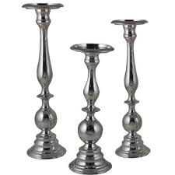
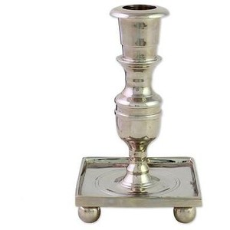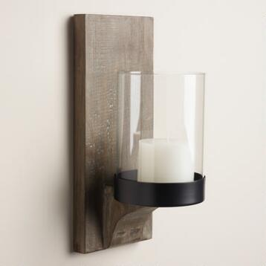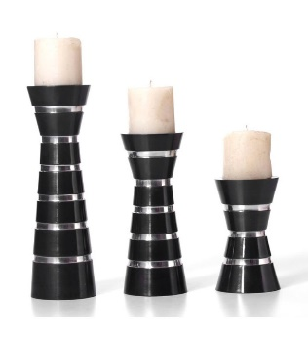

For this project, you will be provided with 2” round stock (8” long) and 3” square stock 1.5” thick. You may intend to create a set of three candle holders and must discuss provisions for the extra material with the teacher. The design of the holder is entirely up to you. Keep in mind time restraints when designing your project
The project is organized so that student participation will be in a true blended learning environment. Students will spend time developing and fabricating the project in the class/shop, while portions of research, planning and review will occur outside of class time. This document will designate Class Time and Blended Learning time with an abbreviation of CT and BL respectively.

Project Timeline
Note – Class Time = CT, Blended Learning Activity = BL

Introduction CT 1.0 hours, BL 2.0 hours
- Introduce in 3 or more days in advance of project start date (allows time to digest and prepare)
- Teacher introduces project and direct students to all resources (hard/virtual copies)
- Websites, design considerations, Technological Concepts, related Safety

Planning and Production CT 1.0 hours, BL 1.0 hours
- Design Review, material selection
- Routing – use templates and plan project sequence of steps, calculate speeds and feeds

Fabrication/Manufacturing CT 14 hours, BL 3 hours
Spindle (6 hours)
- Rough turn
- Finish turn
- Thread
Base (4 hours)
- Square
- Size & finish
CNC (2 hours)
- Program & machine
Other (2 others)
- Welding
- Additional parts

Portfolio and Presentation CT 2 hours, BL 2 hours
- Ongoing portfolio creation over several days
- Concept map creation demonstrating scope of project
- Includes design brief, project and skills development list

Total Project Time
- classroom = 18 hours
- blended learning = 8 hours

