APPENDIX J - Candle Holder Spindle
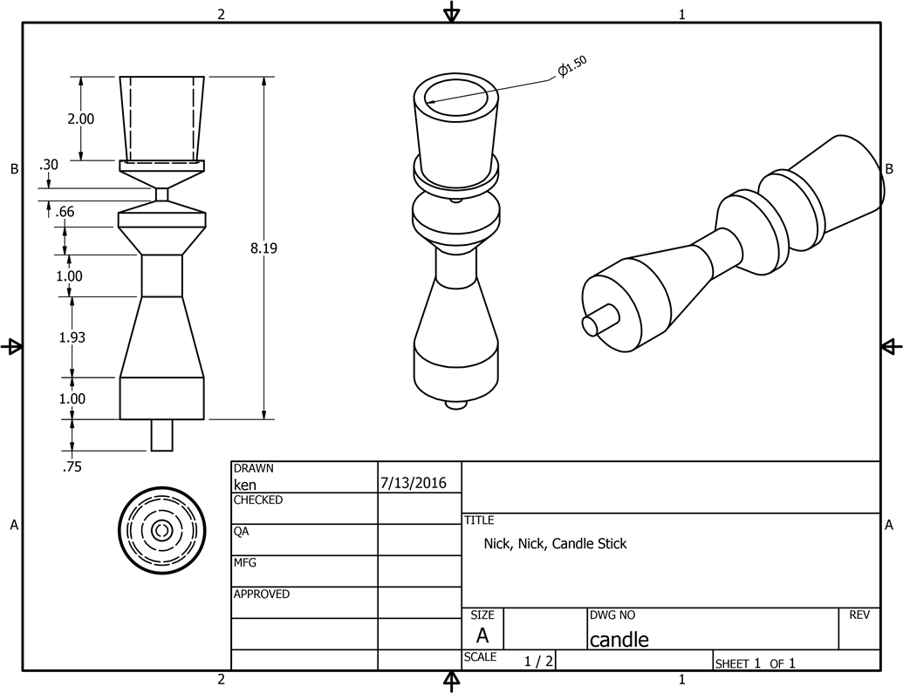
Sample Basic CAD Drawing
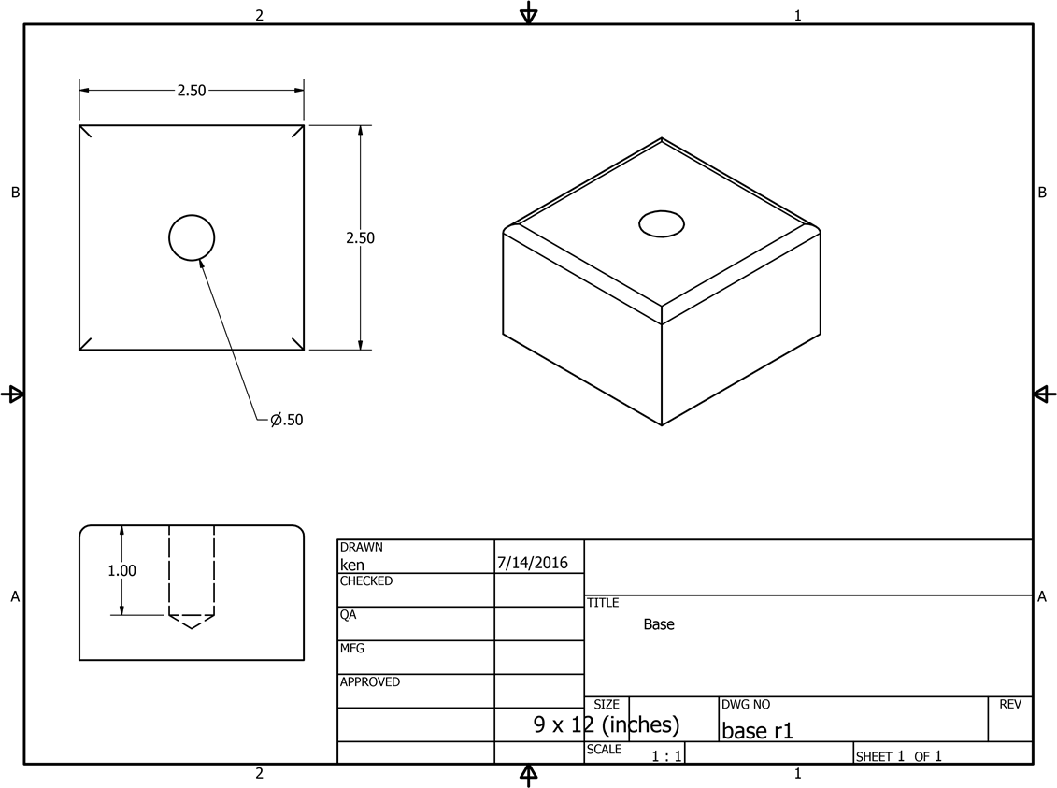
APPENDIX J – Sample Candle Holder Base CAD Drawing

