Appendix A

3D Computer Modeling Project

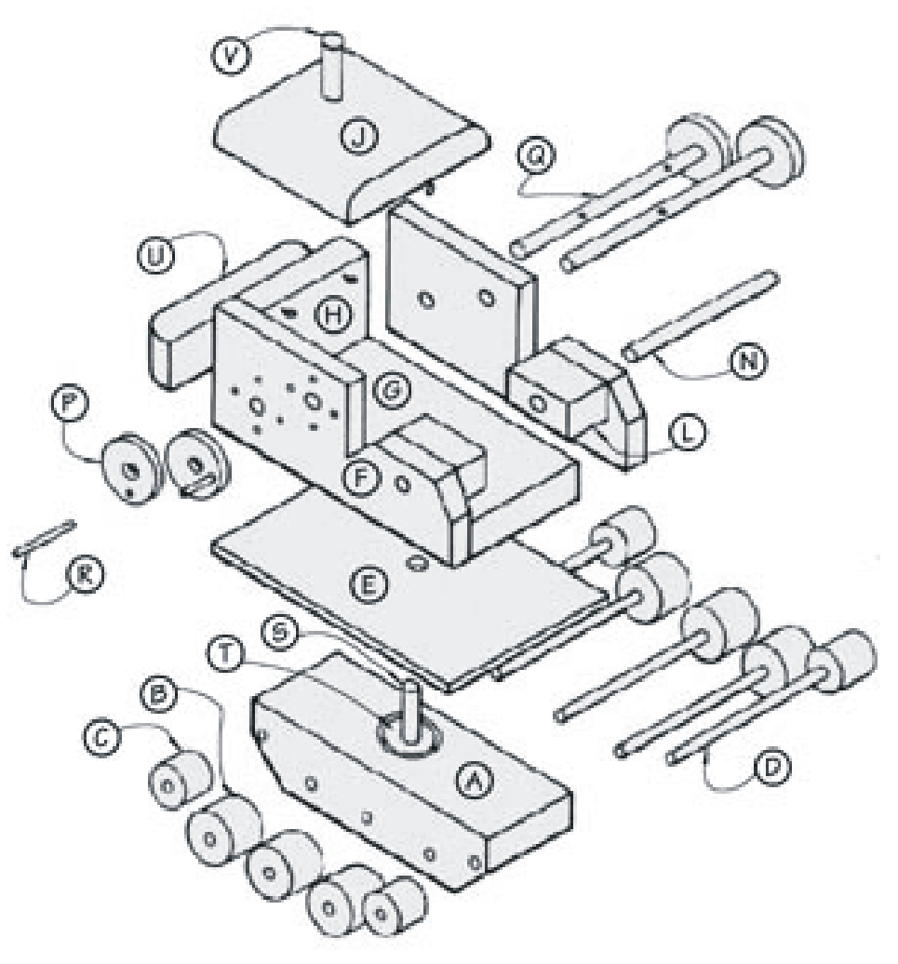
Scenario

International toy conglomerate “Toyz Iz We” believes that they have a new and exciting idea in children’s toys: wooden toy vehicles.

You are a toy designer at Toyz Iz We and have been asked to design a toy for the new line.

Design Brief

- Design and model a wooden toy vehicle representative of an actual vehicle, past or present. You can use books, magazines, and online designs as references, but your design should be unique.

- The model should be made primarily from wood, although a small amounts of other materials may be used (e.g. plastic for wheels, rubber for treads).

- The size of the vehicle must be such that a child of 3 to 6 years of age could easily pick it up and play with it.

- The vehicle should have no sharp edges or corners that could harm a child, nor should it have small pieces or thin pieces that could be broken off by a child. No piece should measure less than 3/16” or 5mm thick.

- Using Autodesk ‘Inventor’, create a 3D computer model of the vehicle,
an animation showing how the model is assembled, and a set of working drawings that could be used to build the toy in the shop.

- The vehicle must have multiple parts. The number of parts will depend somewhat on the degree of difficulty of your design.

- The parts of the vehicle should not just be simple extrusions (cylinders, rectangular prisms, triangular prisms, etc.). In addition to extrude, use Inventor tools such as revolve, sweep, loft, array, emboss, fillet, chamfer, mirror, and others to make interesting, complex parts.

- Model pre-made wheels and other pre-made parts where it makes sense to use them.

- The vehicle assembly must be fully constrained. That is, you should not be able to drag the parts of the assembled vehicle out of position.

- The design of the vehicle should be balanced, proportional, and aesthetically pleasing. Use colours and textures to enhance the appearance of your model.

- The design should be feasible and follow accepted woodworking practices. It should be possible for someone to build your design.

- You may use metric measure (millimeters) or Imperial measure (inches) in the design of your vehicle, but be sure to use regular “purposeful” sizes (e.g. 5mm, 20mm, 50mm, 275mm, ¼”, 5/8”, 2-3/4”, etc) and not just random dimensions (e.g. 14.76345mm, 127/256”, 0.865321 inches, etc).

