Teacher: Name: __________________

Create a relay board using the knowledge from previous classes and the following items.

You will require:
- Your drawing of the relay circuit
- Completion of the quiz
- Tool and supply knowledge
- To look over the marking rubric to know what is expected

Obtain the following from your teacher:
- An automotive or similar battery source
- 1.0-2.0 mm² (14-16 gauge) wire, preferably a few different colours
- Blue 1.0-2.0 mm² (14-16 gauge) wire ends with female, spade connection
- Piece of wood or similar to fasten your relay and wire connections to.
- Screws, glue, nails or similar to create connection points for the relay writing
- Fuse holder with a 15 amp fuse
- Switch (to control relay)
- Voltmeter (to measure source voltage and compare to your board Input voltage)

Items you will need from previous classes:
- 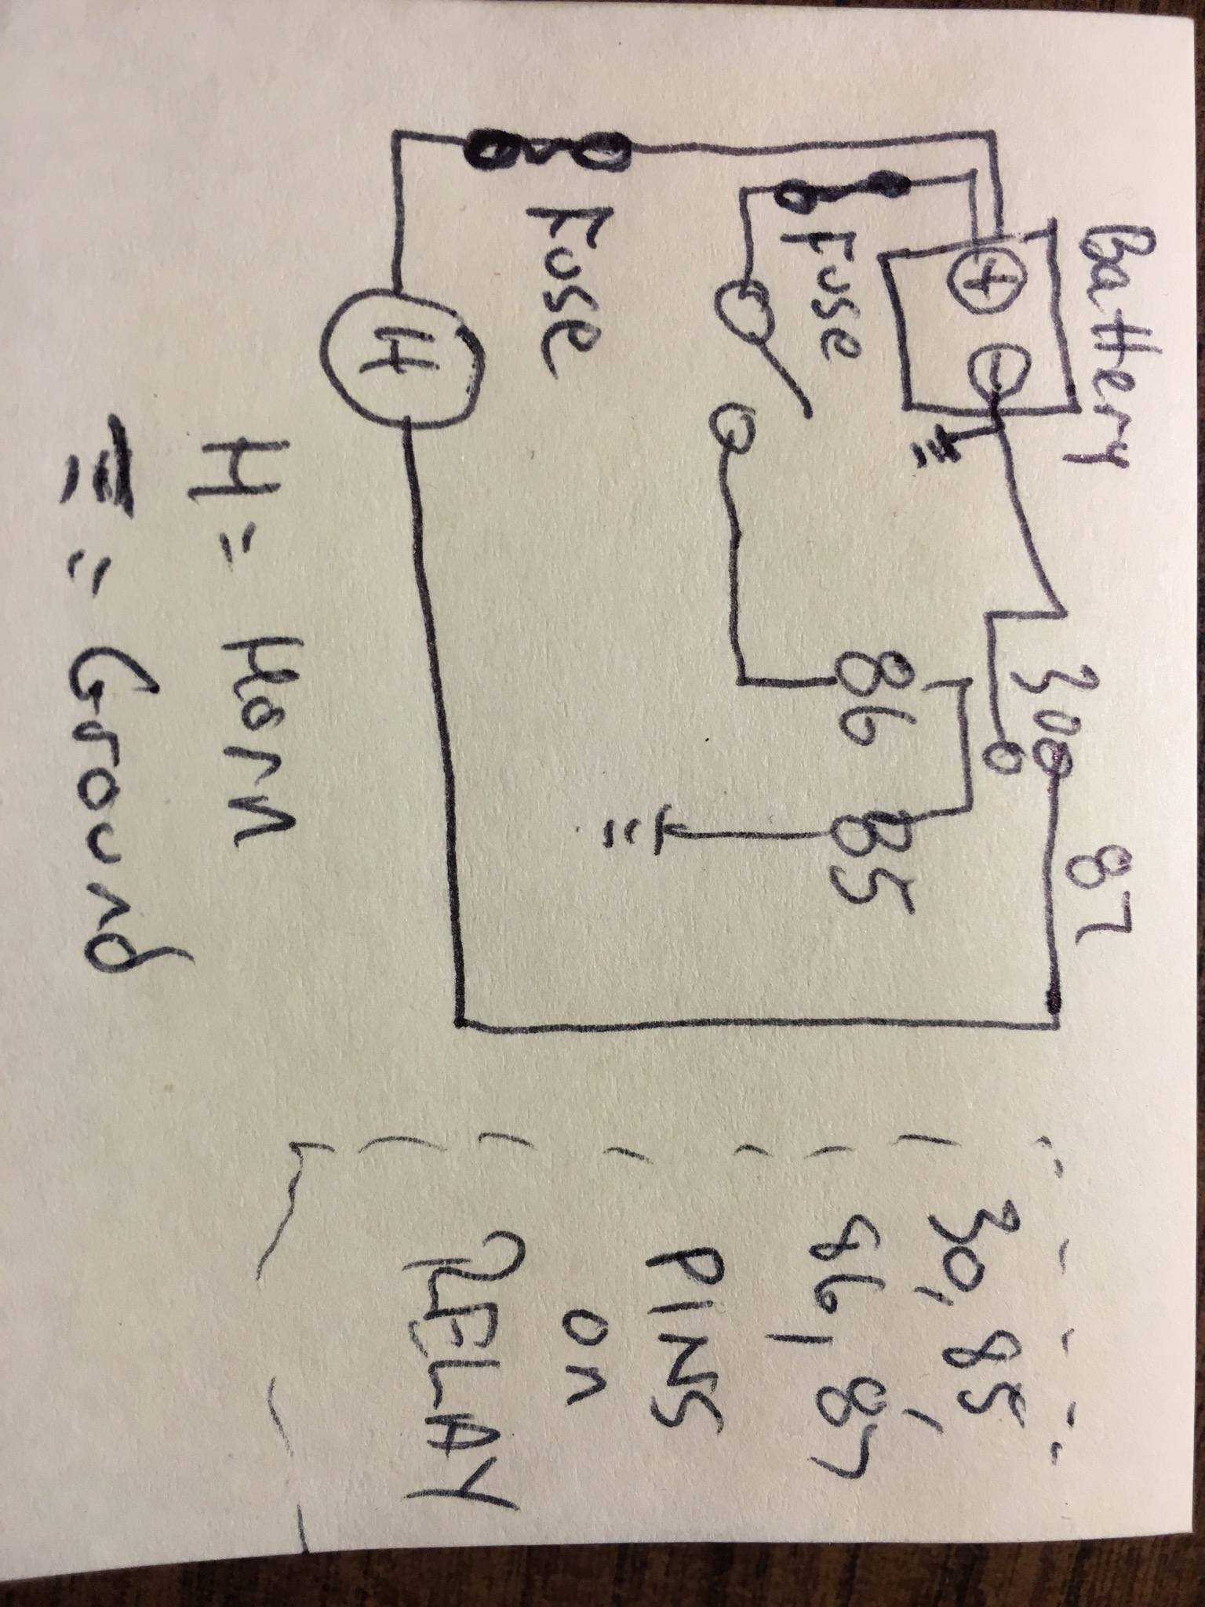Working drawing (teacher approved)
- 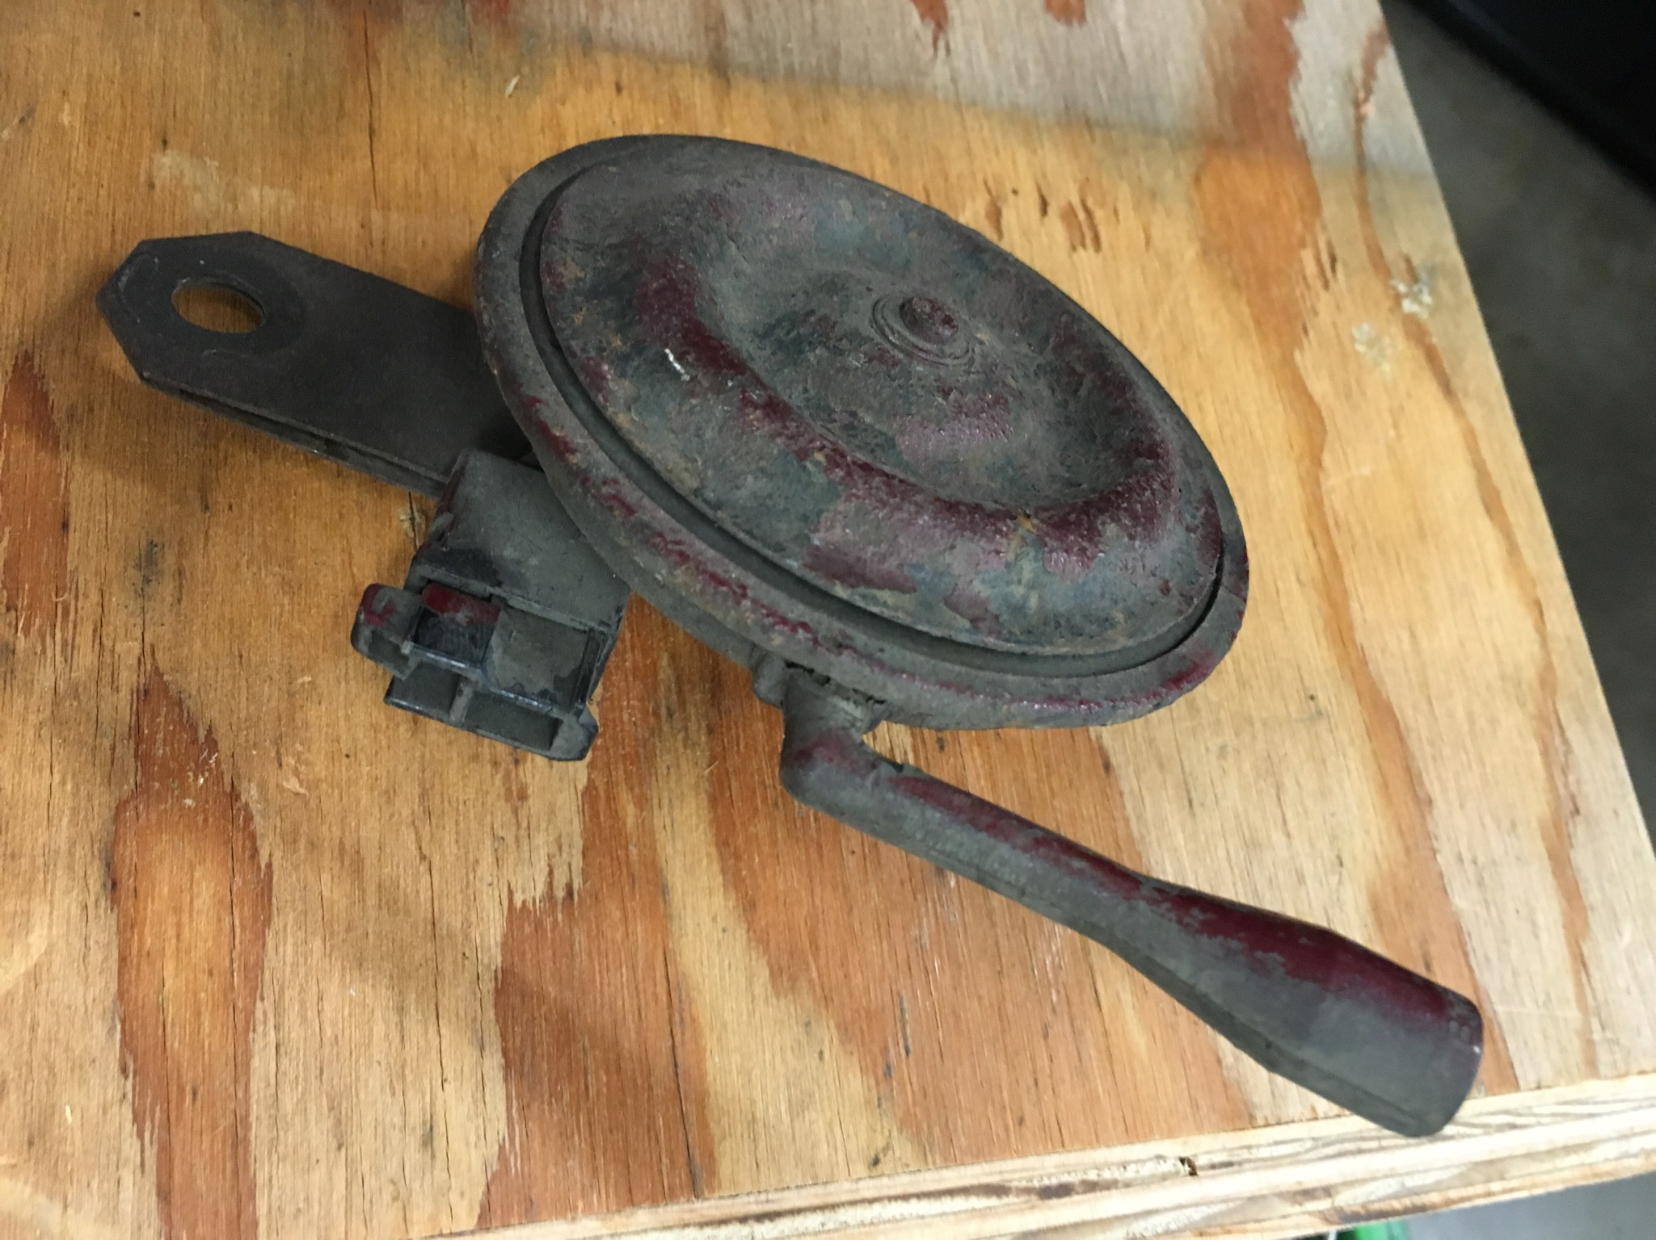Component (to be used in conjunction with a relay) removed from a vehicle or a component from separate resource
- 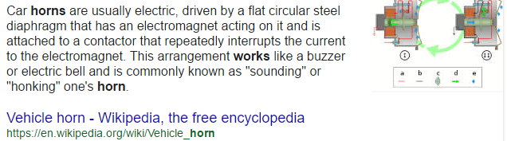Information on how the component is supposed to function when connected properly.
- 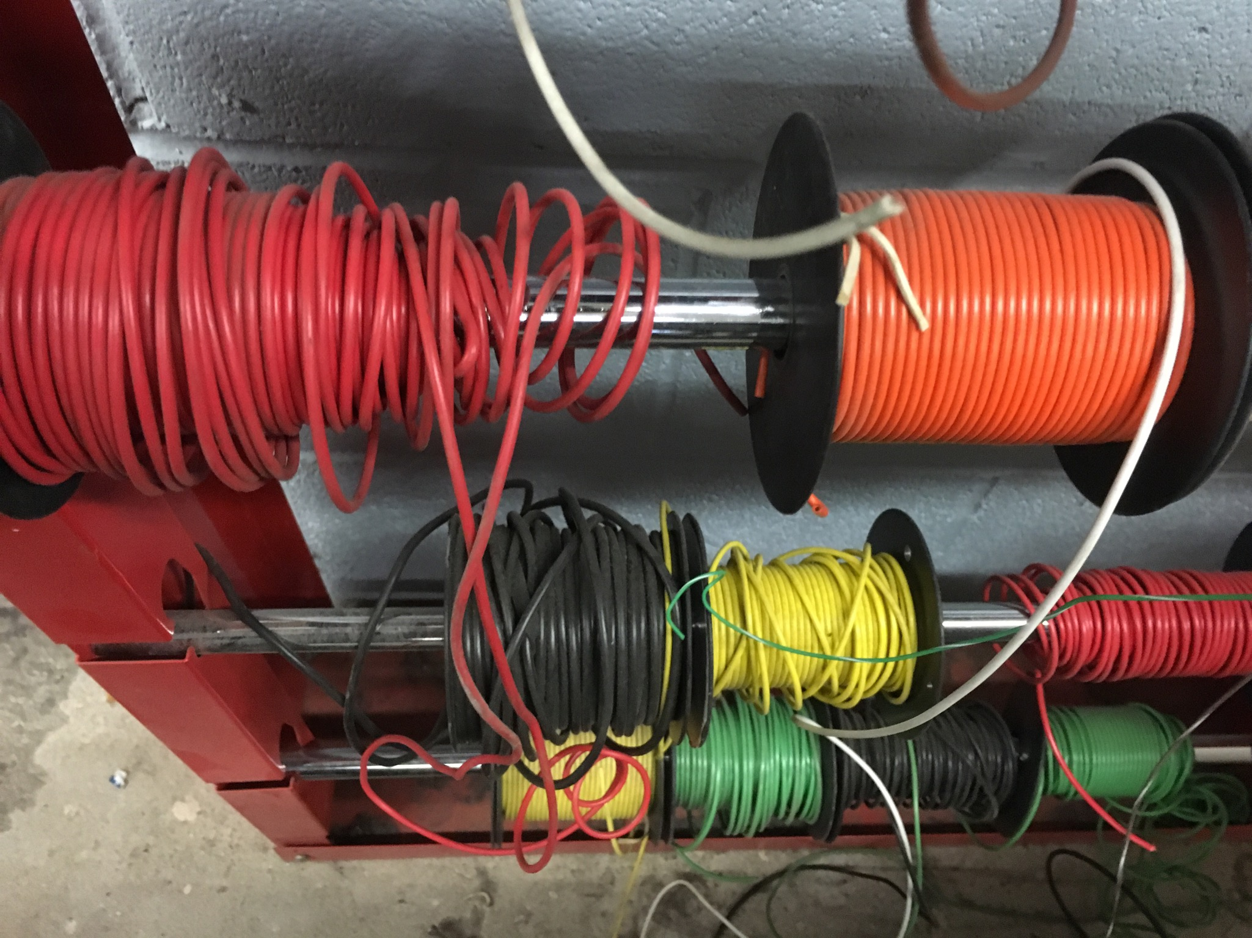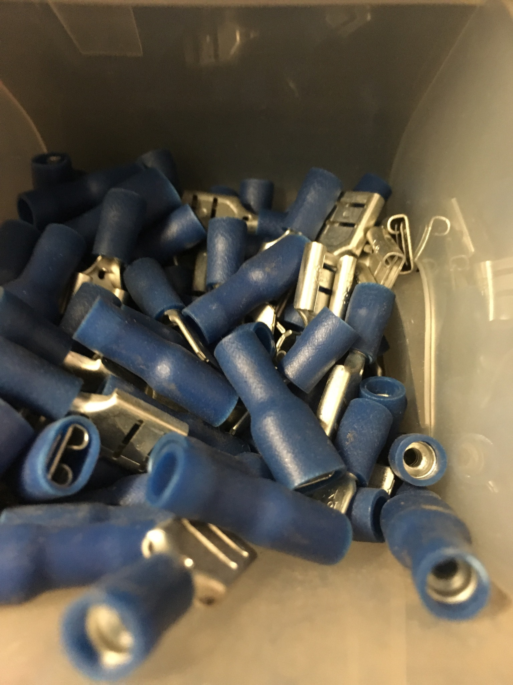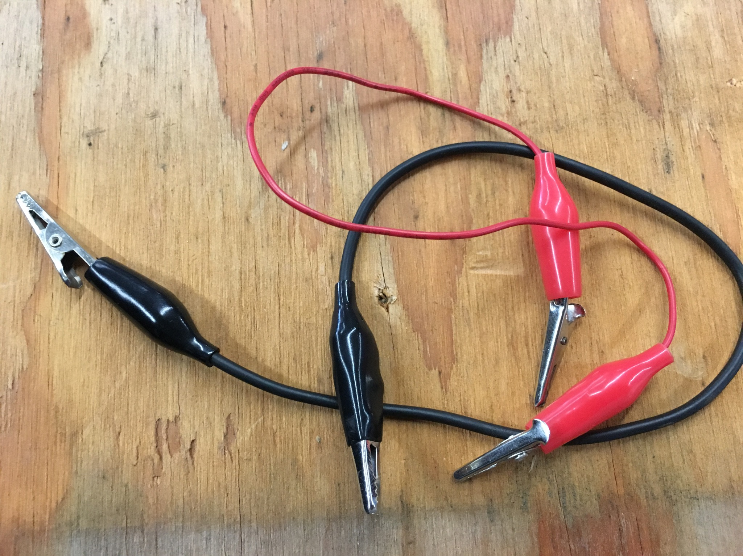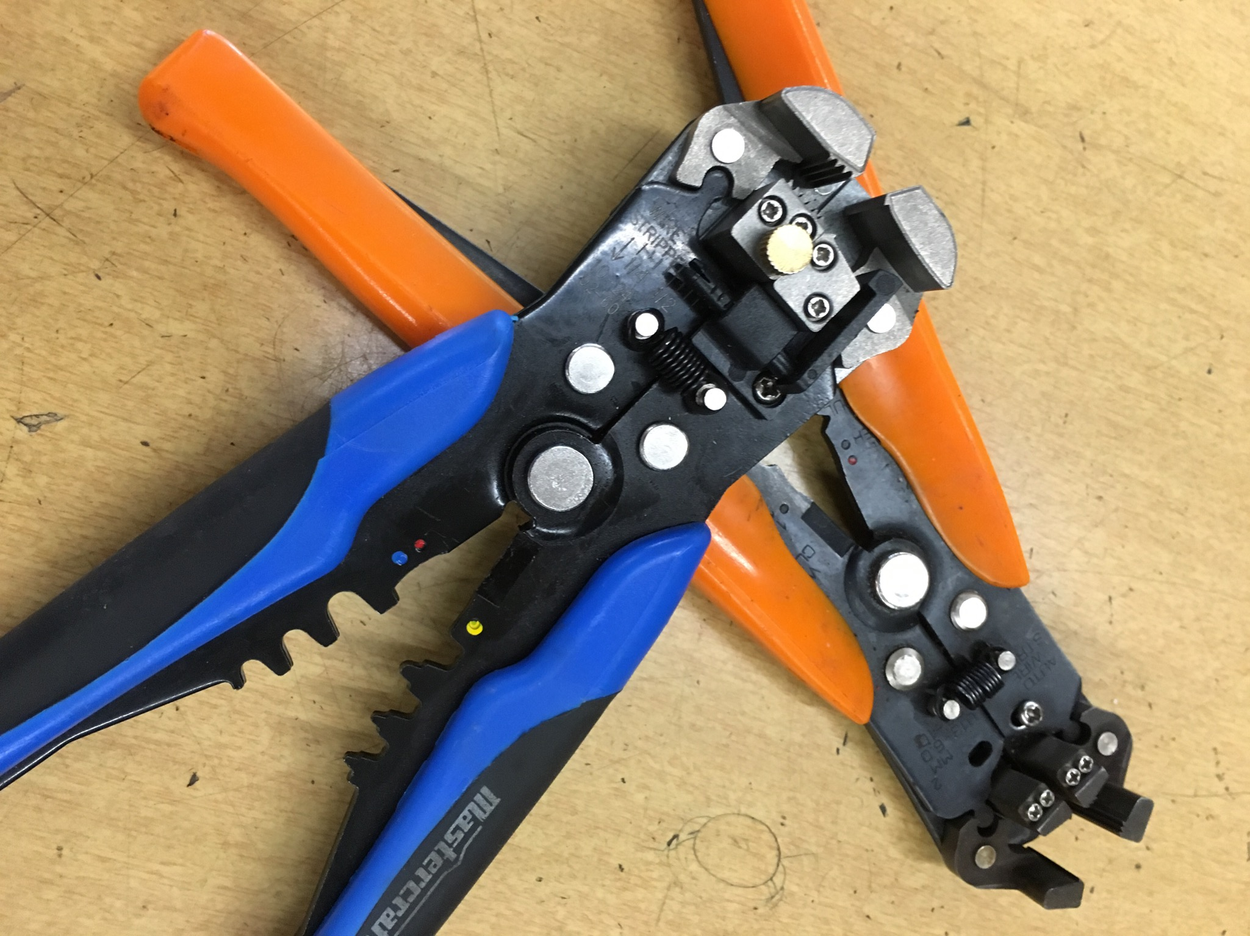Pre-cut wire, cut to length, with crimped connectors.
- 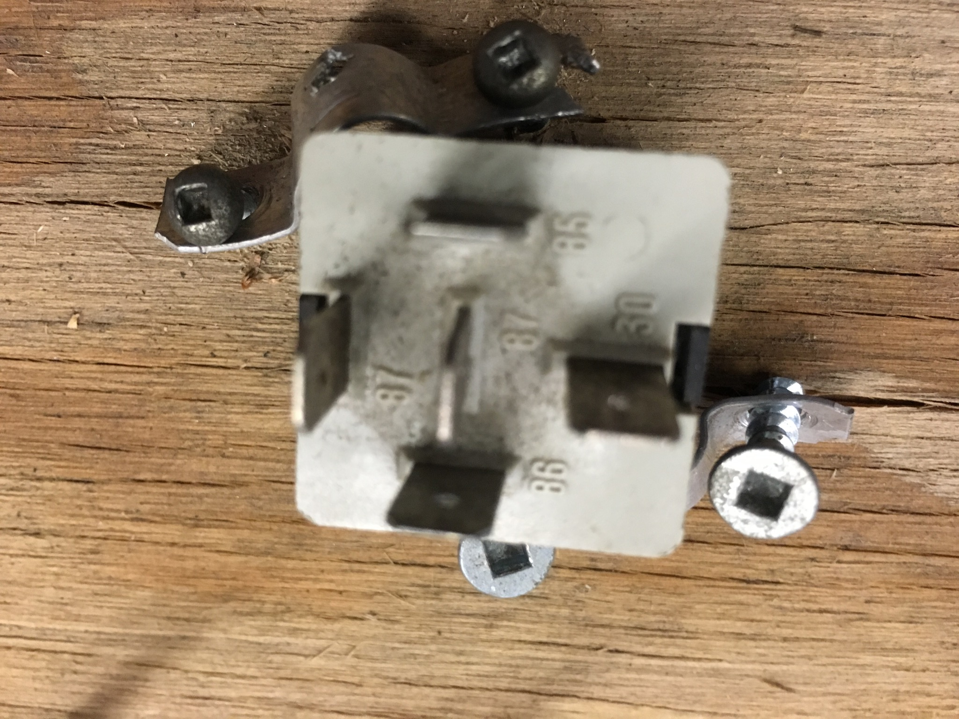Piece of wood or similar to attach your components to.
- 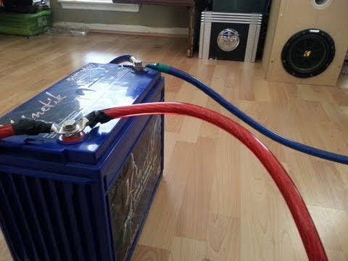A battery source.
- 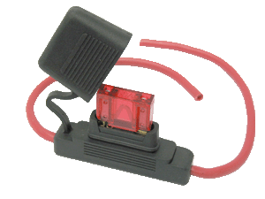A fuse holder and fuse.
- 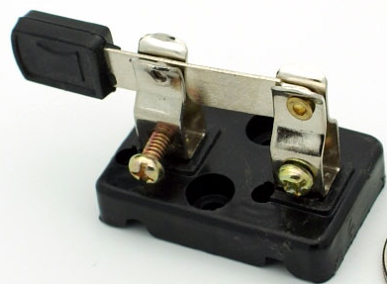A switch.

Once you have fastened your components to the board and connected your relay and fuse. You can go ahead and see if your relay will function and operate your component.

Once complete - take a picture of your work and save it to your Drive for future reference.

Teacher: Name: __________________

Thinking Section of of KTCA.

READ the following and complete the costing table assignment.

Create a costing sheet for your relay board and accessories. (Blank form follows this example).
Using the Internet look up the cost of the component you selected to use for your relay board.
This chart indicates how you should submit you information. Total the entire cost when complete.
ITEM | Number of ITEMS | Unit Cost (per ITEM) | Cost to Purchase | Cost with HST
Power antenna motor | 1 | $249.95 | $249.95 | $282.44
Nails to fasten items to relay board | 23 | $6.99 per box 100  $.0699 or $.07 per nail | 23x.07=$1.61 | $1.82
All Purpose Hot Glue Sticks | 1.25 | $9.48 per pack of 50 $.1896 per stick =$.19 | 1.25x.019=.2375 or $.24 | $.27
etc...

Teachers can supply a generic list of items and their cost (below). It may also be on a separate sheet or other source. Students can research items also. NOTE: The student will calculate exact costs - see above
Item | Cost per unit $ | Item | Cost per unit
Nails | $6.99 per box 100 | 16 gauge wire | $.60 per 30 cm
Wood back board | $8 per square metre | Relay (single) | $8.99 per pack of 1
Screws | $.12 | All Purpose Hot Glue | $9.48 per pack of 50
etc...

Teacher: Name: __________________

Student costing table.

ITEM | Number of ITEMS | Unit Cost (per ITEM) | Cost to Purchase | Cost with HST
Total

