

TTA3C1
Transportation Technology
Automotive Relay and 12 Volt Circuit

Abstract
This document was produced by the Ontario Council for Technological Education (OCTE).
It may be used in its entirety, in part, or adapted.

Disclaimer

This material was designed to assist teachers implement the Ontario Curriculum – Technological Education (revised Grade 10 -12). This material was created by members of the Ontario Council for Technology Education (OCTE) subject association and is intended as working guides for classroom, lab or shop activities. Permission is given to reproduce these materials for any purpose except profit. Teachers are encouraged to amend, revise, edit and adapt this material for educational purposes. Please acknowledge the source in all uses. Any references in this document to particular to commercial resources, materials or equipment reflect only the opinions of the writers of this material, and do not reflect any official endorsement by the Ontario Council for Technology Education, the Ontario Ministry of Education, or any other agency or government body.
All materials within these safety related documents are to be considered as suggestions and recommendations only. These are not legal documents and are not to be considered as legal requirements or as official policy. OCTE or the individual contributors makes no claim to the accuracy or the completeness of the enclosed documents and accepts no responsibility for any damages pertaining to their use. Users of this document should not assume all warnings and precautionary measures are contained herein, that additional information or measures are not required, or that local by-laws, regulations or Board policies are explicitly included.

© Ontario Council for Technology Education 2016

Table of Contents
Project Overview: Page 4
Project Challenge: Page 4
Connections: Page 4
Project Criteria: Page 5
Examples: Page 5
Project Synopsis and Timelines: Page 6
Activity 1 - Name of Activity: Page 7
Minds On (Engaging Prior Knowledge): Page 8
Activity 1 Project Research and Information Gathering: Page 7
Activity 1 Criteria and Instructions: Page 7
Activity 1 Prior Knowledge: Page 8
Activity 1 Planning Notes: Page 8
Action (Introduce or Extend Learning): Page 8
Activity 1 Instructional Strategies: Page 8
Activity 1 Assessment and Evaluation: Page 9
Activity 1 Accommodations: Page 9
Consolidation & Connections (Provide Opportunities for Reflection): Page 10
Activity 1 Review Questions: Page 10
Materials, Tools and Resources: Page 10
Activity 1 Websites: Page 10
Activity 1 Publications: Page 10
Activity 1 Computer Software: Page 10
Activity 1 Human Resources: Page 11
Activity 1 Other: Page 11
Activity 1 Appendices: Page 11
Activity 2 - Introduction to Relays: Page 11
Minds On (Engaging Prior Knowledge): Page 12
Activity 2 Project Research and Information Gathering: Page 11
Activity 2 Criteria and Instructions: Page 12
Activity 2 Prior Knowledge: Page 12
Activity 2 Planning Notes: Page 12
Action (Introduce or Extend Learning): Page 13
Activity 2 Instructional Strategies: Page 13
Activity 2 Assessment and Evaluation: Page 13
Activity 2 Accommodations: Page 13
Consolidation & Connections (Provide Opportunities for Reflection): Page 14
Activity 2 Daily Notes: Page 14
Materials, Tools and Resources: Page 14
Activity 2 Websites: Page 14
Activity 2 Publications: Page 14
Activity 2 Computer Software: Page 14
Activity 2 Human Resources: Page 15
Activity 2 Other: Page 15
Activity 2 Appendices: Page 15
Activity 3 - Activity 3 -Create an Automotive Relay and 12 Volt Circuit: Page 16
Minds On (Engaging Prior Knowledge): Page 18
Activity 3 - Create an Automotive Relay and 12 Volt Circuit: Page 16
Activity 3 Criteria and Instructions: Page 16
Activity 3 Prior Knowledge: Page 18
Activity 3 Planning Notes: Page 18
Action (Introduce or Extend Learning): Page 19
Activity 3 Instructional Strategies: Page 19
Activity 3 Assessment and Evaluation: Page 20
Activity 3 Accommodations: Page 20
Consolidation & Connections (Provide Opportunities for Reflection): Page 20
Activity 3 Daily Notes: Page 20
Materials, Tools and Resources: Page 21
Activity 3 Websites: Page 21
Activity 3 Publications: Page 21
Activity 3 Computer Software: Page 21
Activity 3 Human Resources: Page 21
Activity 3 Other: Page 21
Activity 3 Appendices: Page 22

Project Overview
During this unit students will: create a circuit containing an automotive relay, draw an automotive 4-pin relay circuit displaying the control and load sides, demonstrate an understanding of relay wiring diagrams and utilize a wire gauge chart, demonstrate crimping wire ends and creating a circuit on a display board which contains a relay, an automotive battery, a fuse, and a load/electrical device selected by the student. This circuit is intended to function correctly and the load should be controlled by the relay.

During this unit students will also: use their design skills, planning skills and access prior knowledge from: electricity flow, magnetism, battery safety, voltage reading, fuse purpose, random hand tools and safety. They will be using their Internet skills to source information regarding their choice of component/load device and finally use their math skills to complete a parts costing table.
Project Challenge | Connections
To understand and demonstrate many topics related to an automotive relay.  Students are to research, using the Internet, an automotive component that can be controlled by an automotive relay.  Students will create their own wiring diagram on paper to demonstrate knowledge and understanding on how to hook up a relay.  Students will complete an assessment quiz (here) confirming safety, use of tools and relay questions.  Students will use a 12 volt battery, fuse, wire and a relay to control a load. The component however, must be obtained from a vehicle located in their transportation shop and can be easily removed to be used in a display they create (or choose a component from a bin of selected parts supplied by your teacher).  Students will create a circuit on a wooden/or similar board whereas, to demonstrate the control of a load via the use of a relay. See assignment (here)  Student will finalize their assignment with the completion of a costing table to understand how math skills are important to calculate tax, quantity and estimates. | DI document/E&I document  Students can research a component and its wiring.  Choose a part to be removed from a vehicle or have one supplied to them.  SEF-Indicator 1.2 A variety of relevant and meaningful assessment data is used by students and educators to continuously monitor learning, to inform instruction and to determine next steps.  SEF-Indicator 1.1 Assessment is connected to the curriculum, collaboratively developed by educators and used to inform next steps in learning and instruction.  Accommodations: for students with limited access to the shop environment  Evaluation: A rubric can be provided before the final evaluation (Category of Instructional Strategies: 7 Setting objectives and providing feedback Rubrics or checklists with clear learning goals and previously established assessment criteria)  Curriculum Doc.:  A4. demonstrate accurate and appropriate use of technical and mathematical knowledge and skills in the study of transportation technology.
Project Criteria | Examples
- Must use proper PPE  - Must follow safety procedures  - A wiring diagram should be drawn on blank paper and submitted before assembly of the components to the wooden board. Fuse(s) should be in place and some type of switch (pigtail connection for example) should be included.  - Components must be mounted on a wooden board or similar (hot glue and wood screws for example) - opportunity for students to be creative in their design and planning skills.  - Components must be fused to protect from short circuits and potential fire (circuit breakers and fuses holders are recommended)  - Demonstrate proper wire diameter use (chart) and wire ends (colour).  - If pre-made wires are available and can be substituted in (note: larger wires are for loads - smaller for control - see photo example)  - Demonstrate the use of wire crimping tools and wire strippers.  - Students locate their own load/component (horn or light for example) and fasten to a wooden board.  - Connect wiring to the components as demonstrated in their wiring diagram.  - After confirmation from the teacher hook a battery to the circuit and check functionality.  - Complete a costing tables to demonstrate math skills and the cost of the project. | 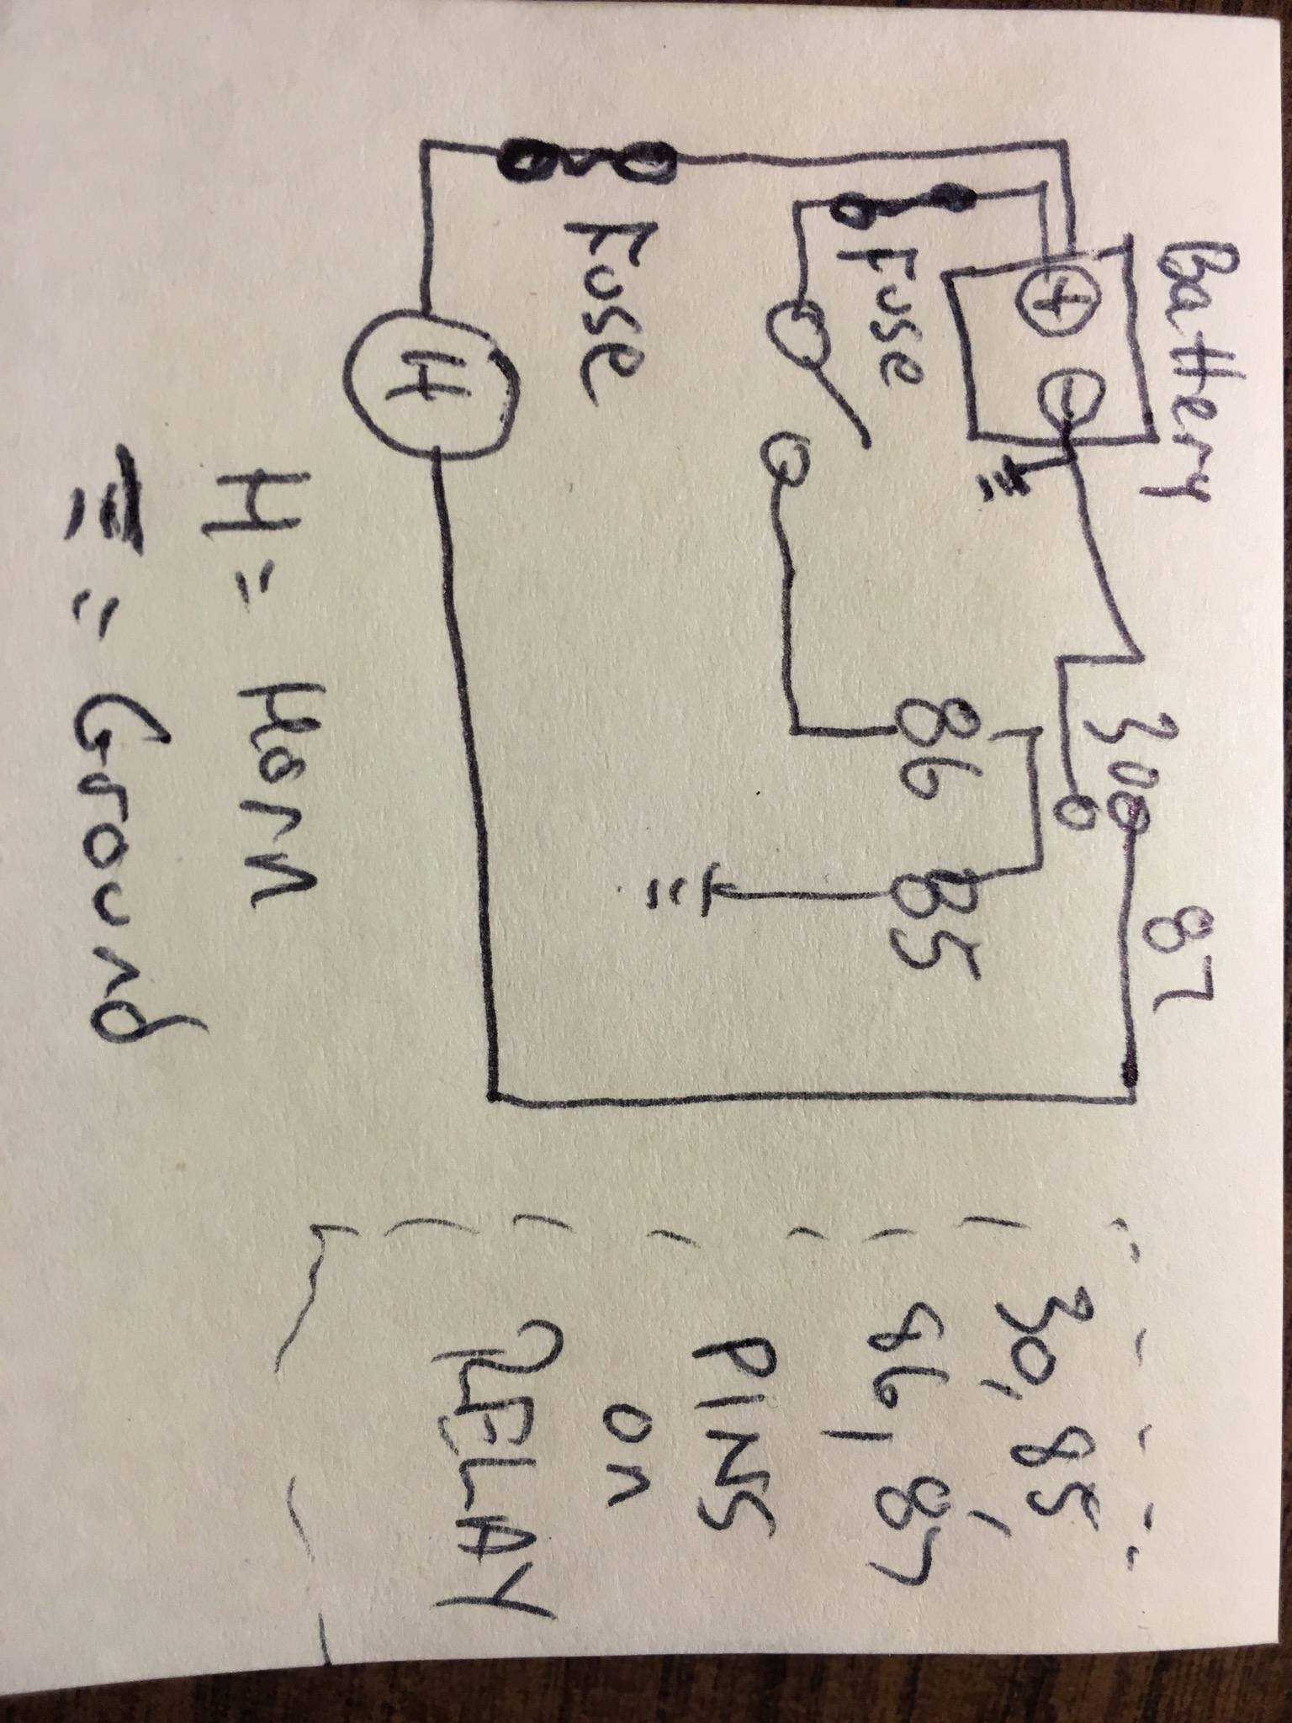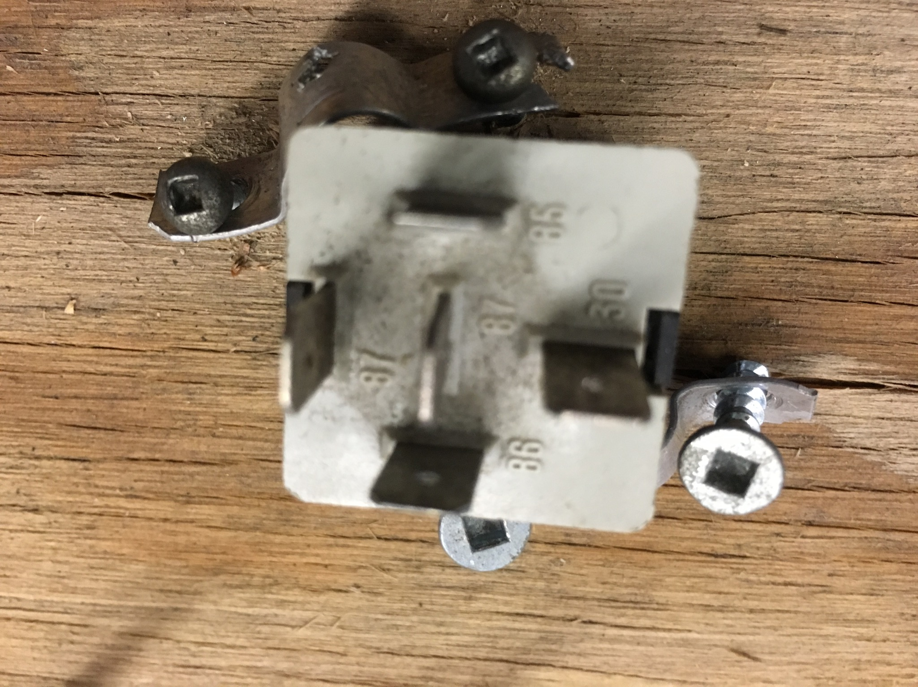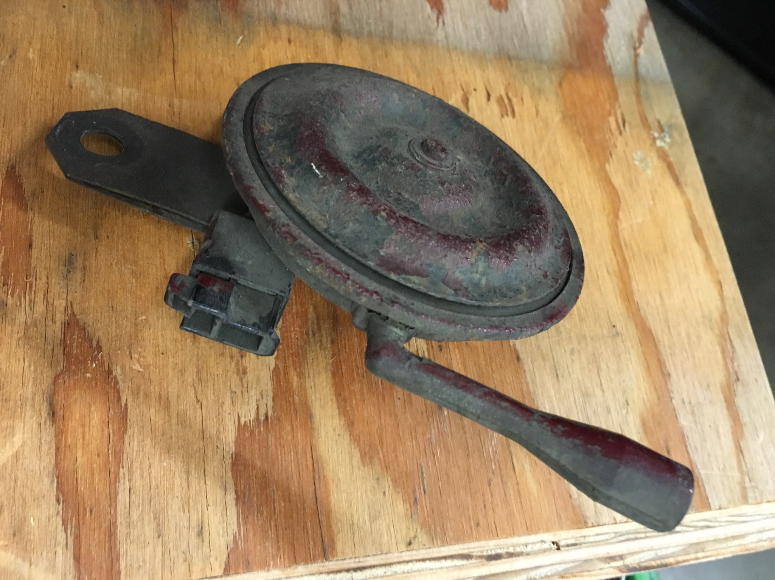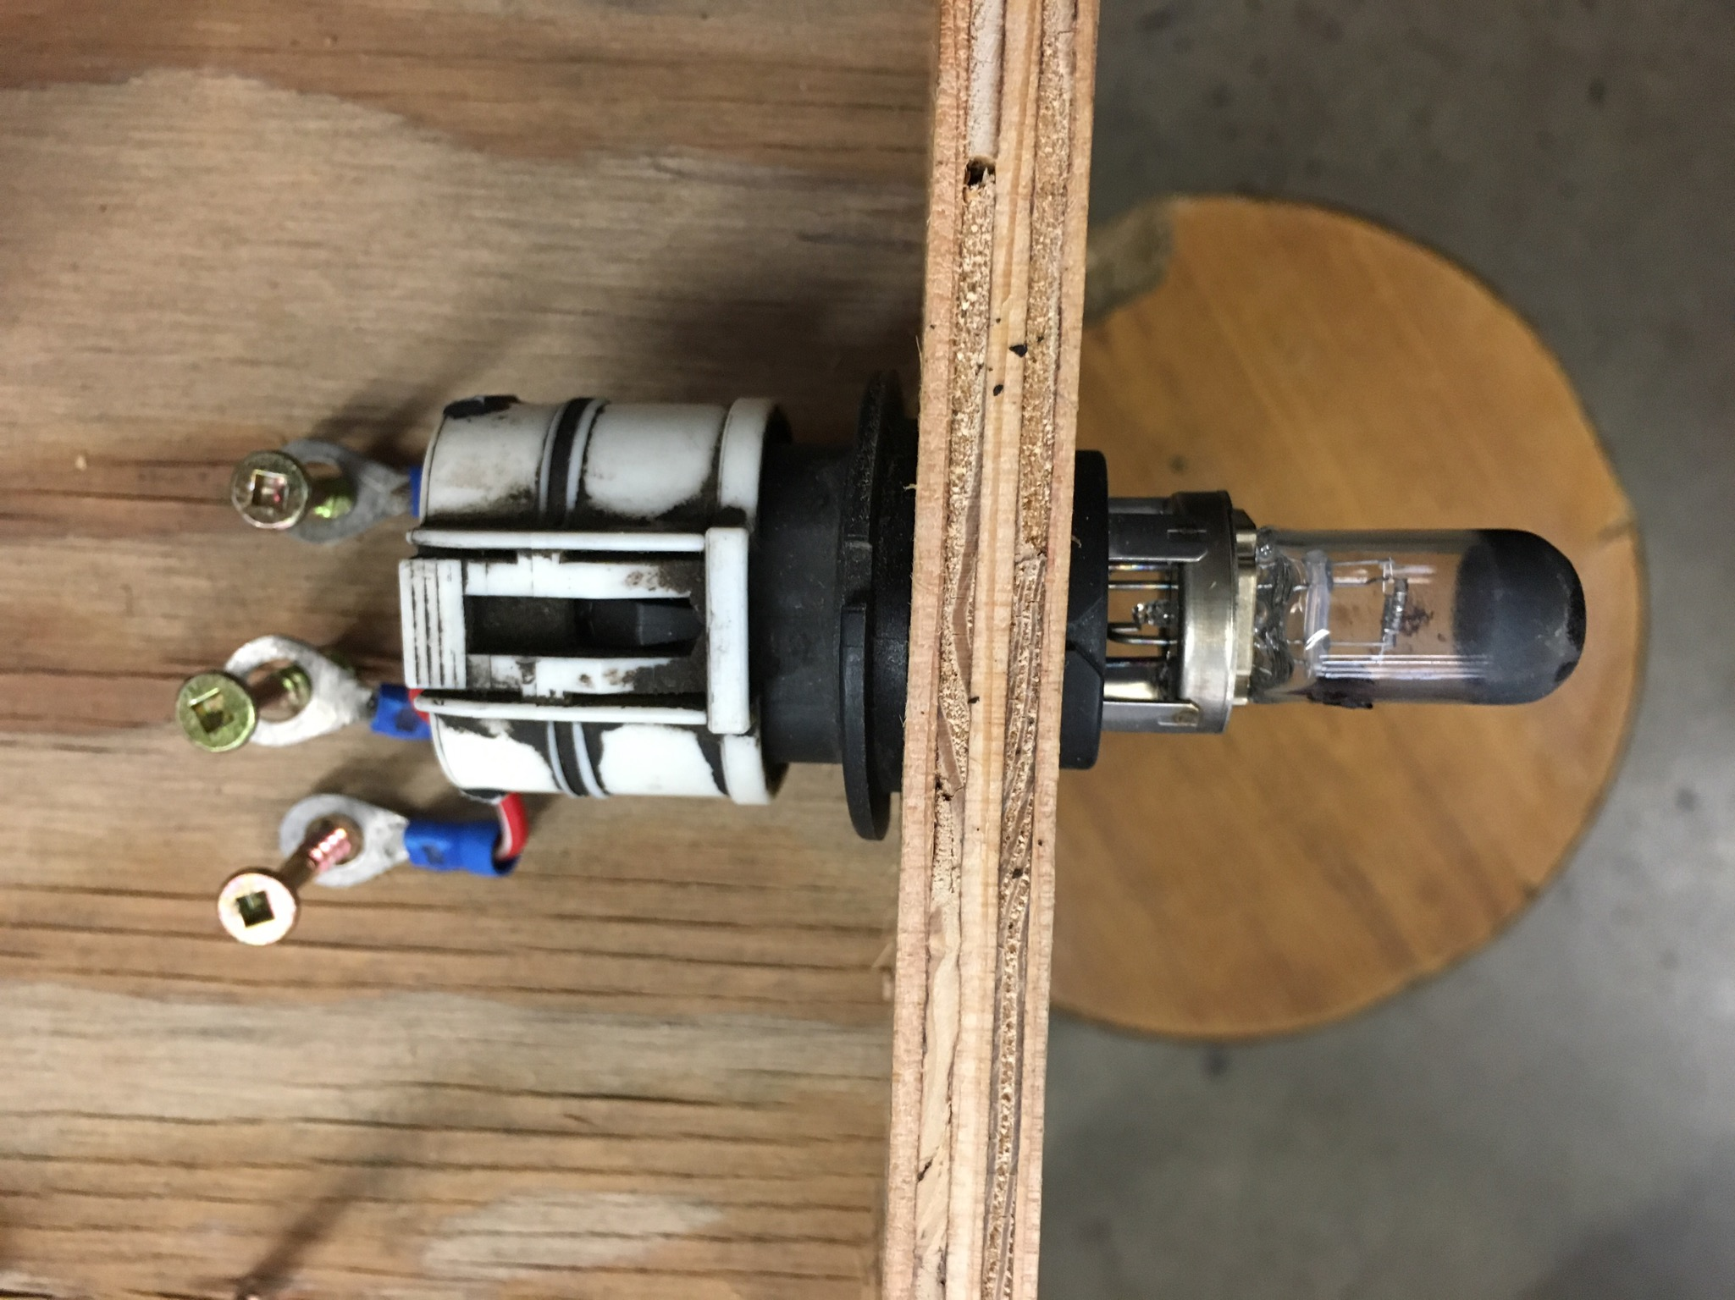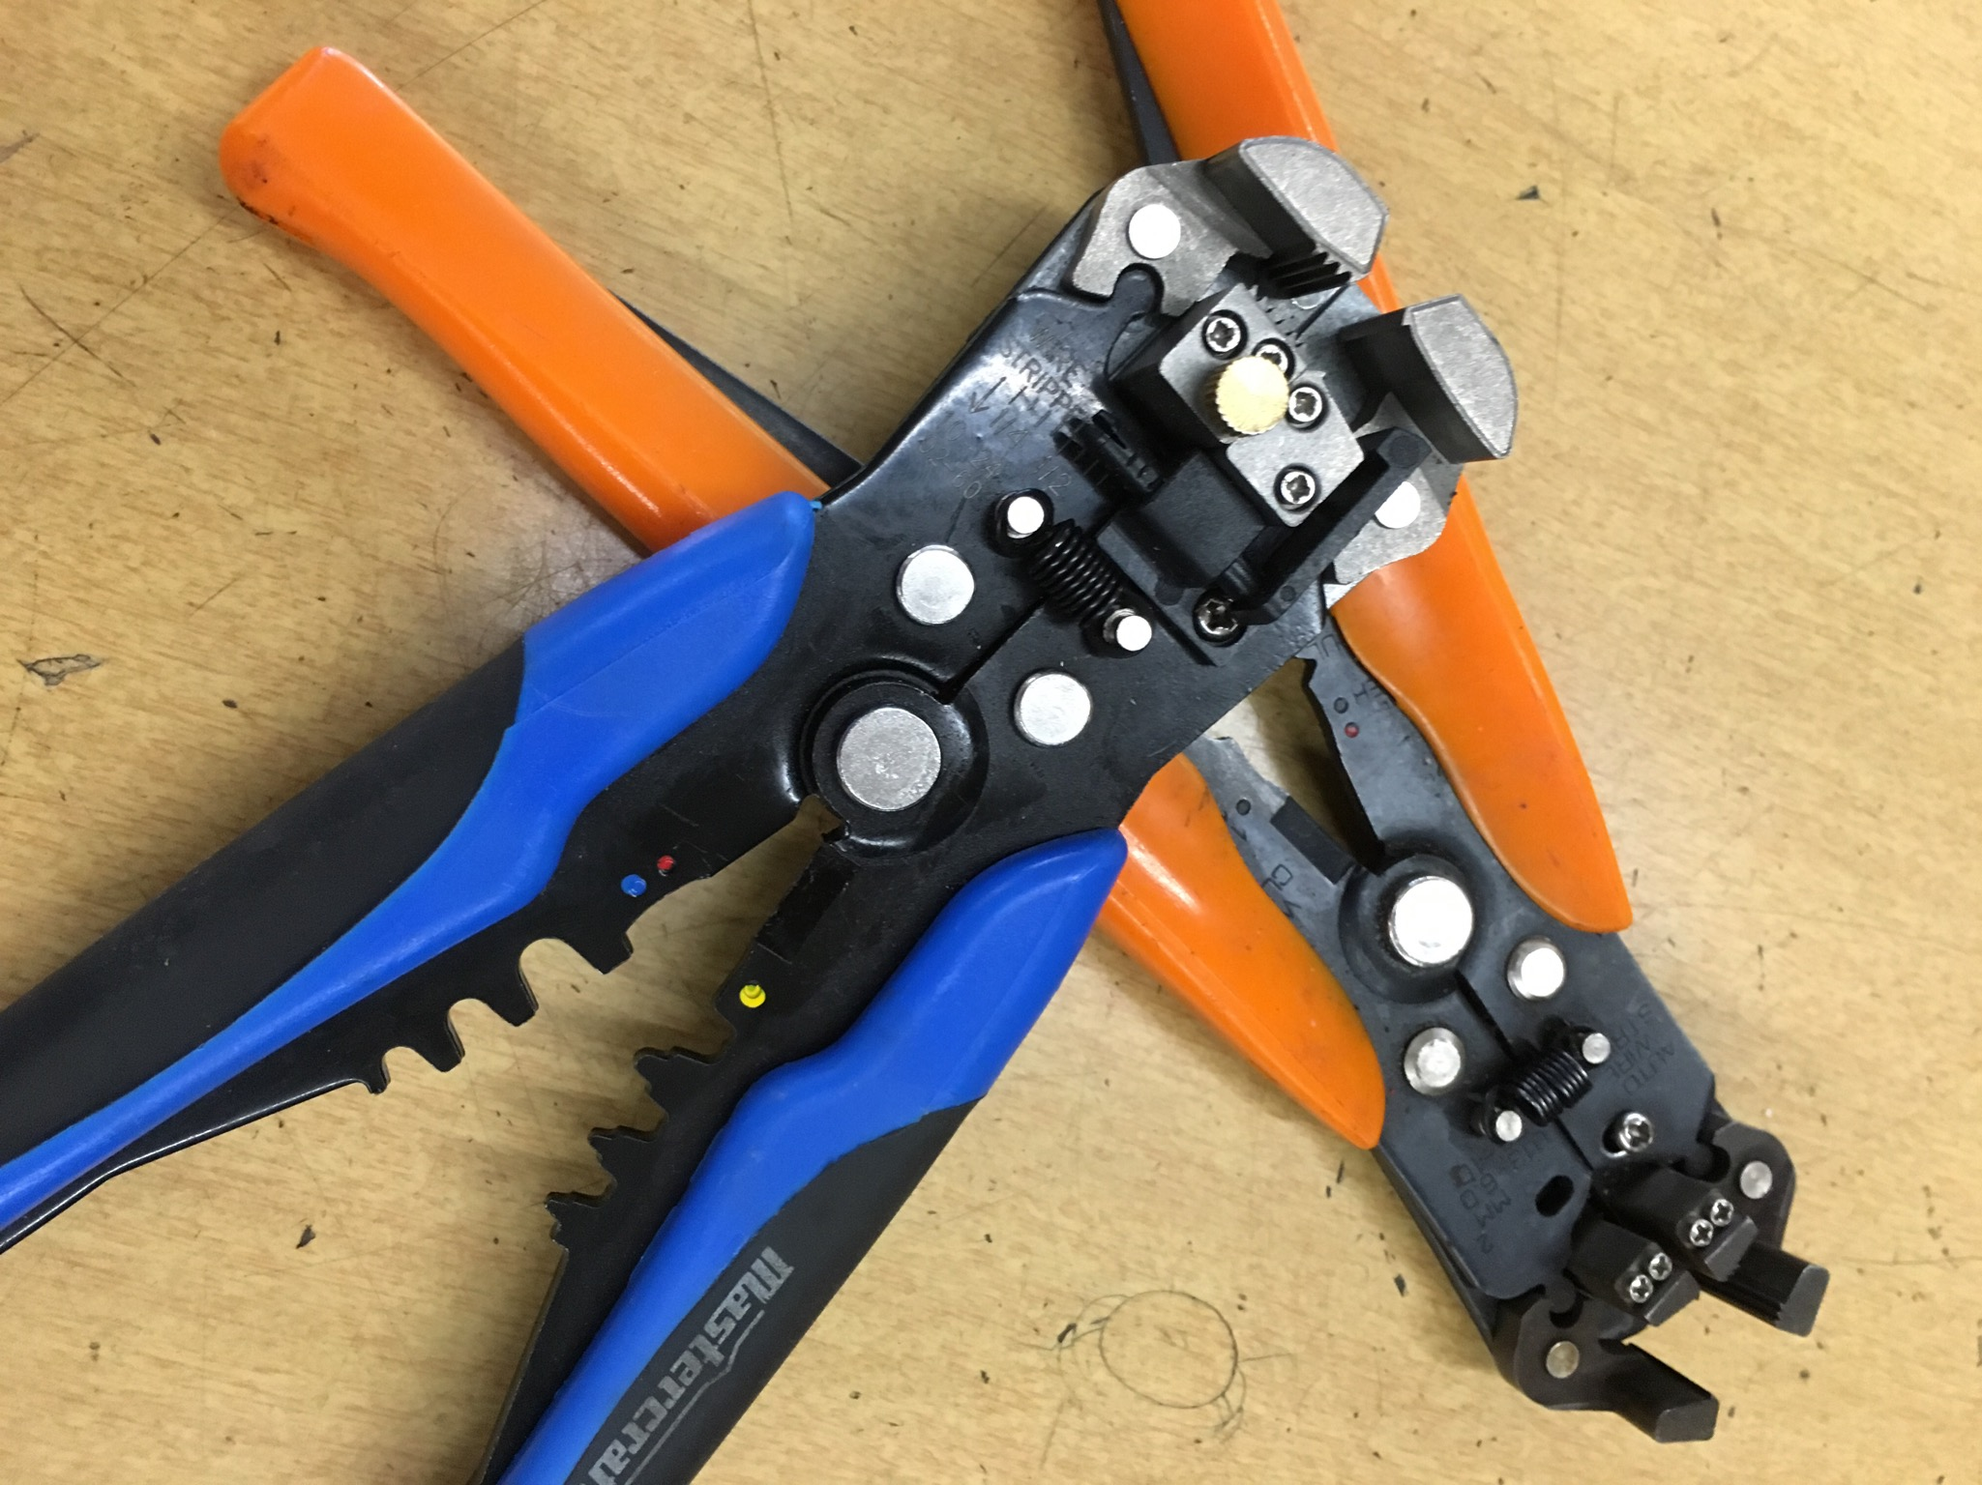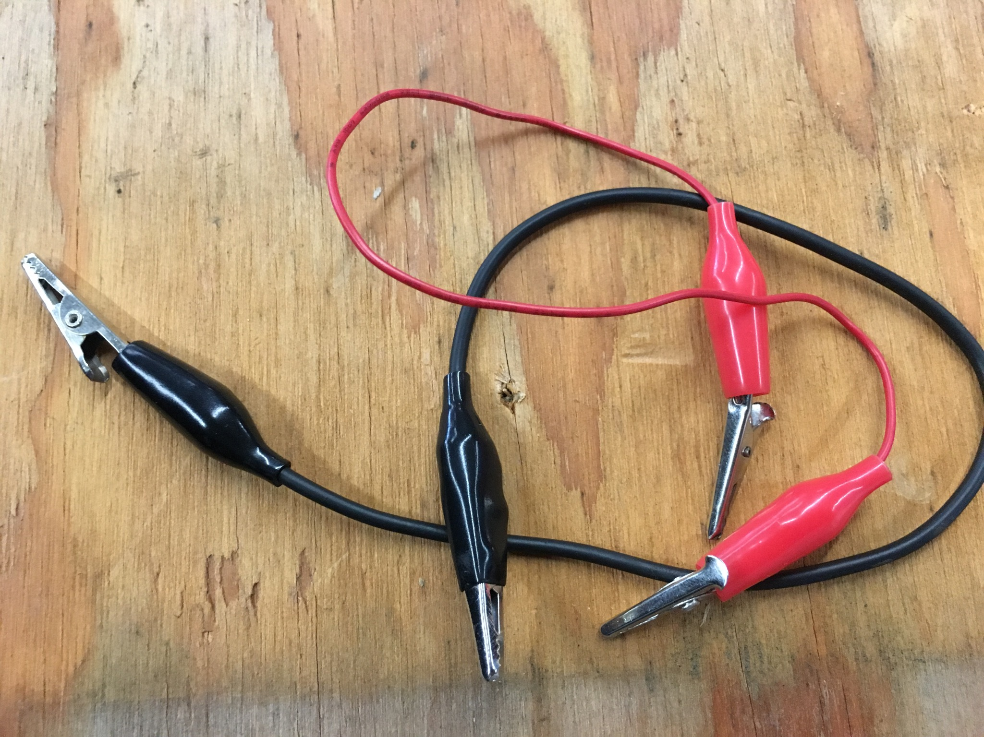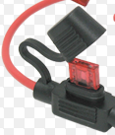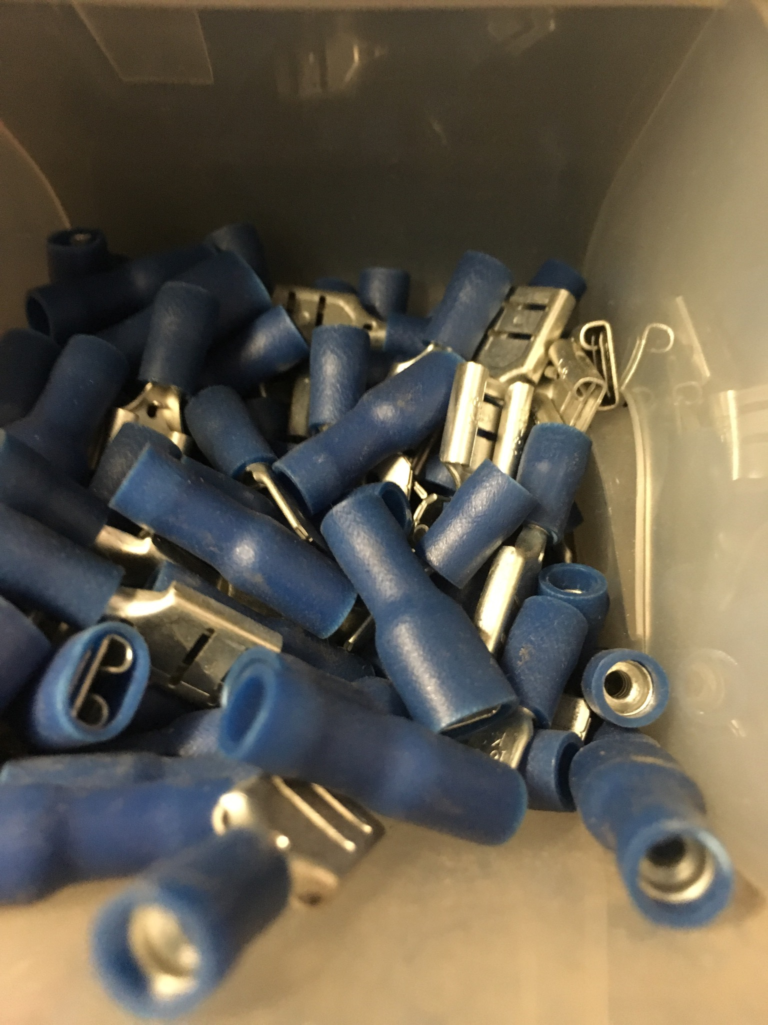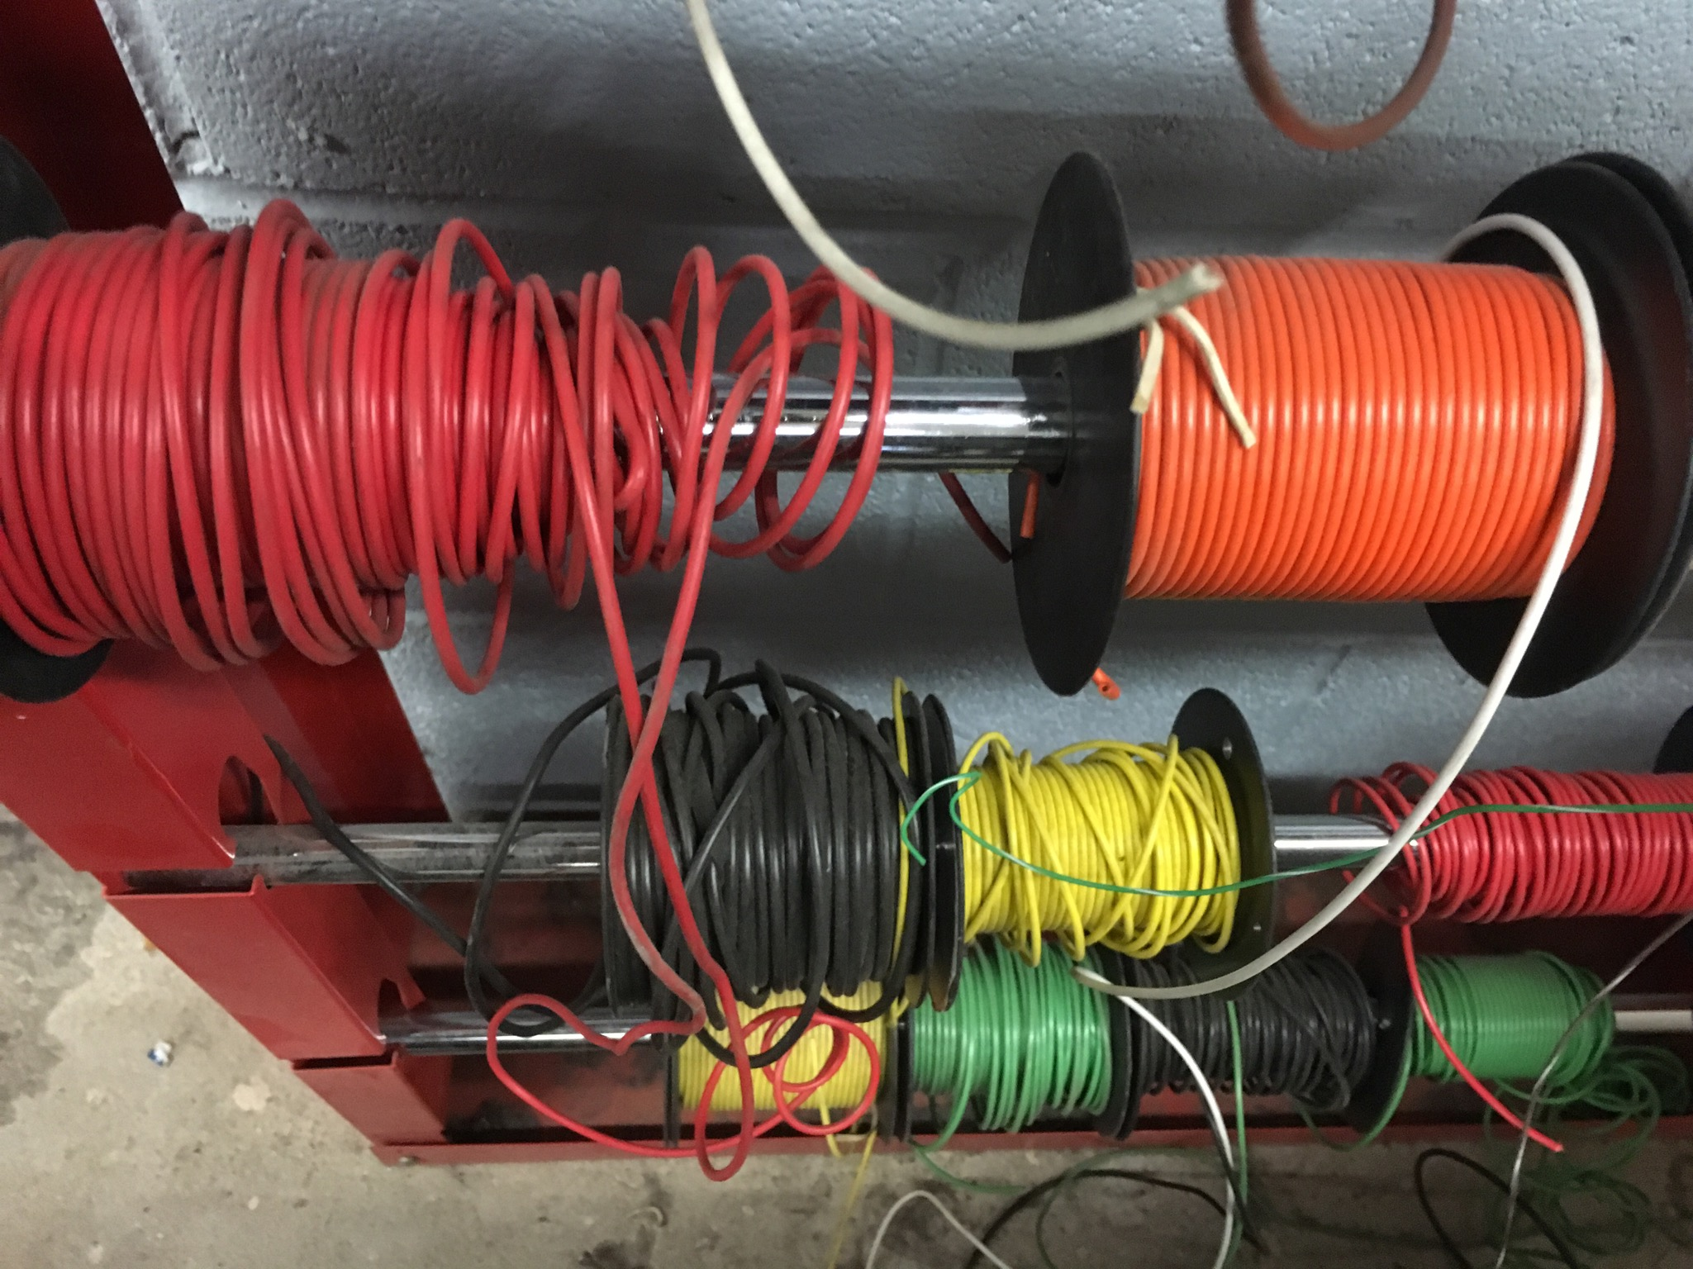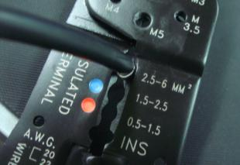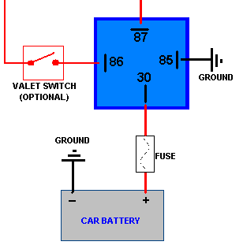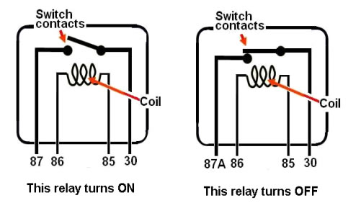

Project Synopsis and Timelines
Act # | Activity Title/Name | Time  (hrs.) | Curriculum Expectations | Assessment  & Evaluation | Connections?
1 | Automotive Relay: Previous Knowledge  Hand tool safety review | 2 | A2: demonstrate an understanding of basic electrical and electronic circuits and their components;  - A2.1  - A2.4  - A2.6  - A2.7 | - K/U  - T  - A  - C | - Ontario Curriculum  - DI  - SEF  - STEM  - Math Literacy  - Literacy
2 | Introduction to Relays - How they work.  What do relays control? | 2 | A2. demonstrate an understanding of basic electrical and electronic circuits and their components;  - A2.1  - A2.2  - A2.4  - A2.5  - A2.6 | - K/U  - T  - A  - C | - Ontario Curriculum  - STEM  - Math Literacy  - Literacy
3 | Create an Automotive Relay and 12 Volt Circuit | 10 | A2. demonstrate an understanding of basic electrical and electronic circuits and their components;  - A2.1  - A2.2  - A2.4  - A2.5  - A2.6  A4. demonstrate accurate and appropriate use of technical and mathematical knowledge and skills in the study of transportation technology.  - A4.2  - A4.3 | - K/U  - T  - A  - C | - Ontario Curriculum  - Growing Success  - DI  - SEF  - STEM  - Math Literacy  - Literacy  - Equity Inclusive

Activity 1 - Relay: Previous Knowledge & Safety Review
Activity Description:
This activity is designed to review safety and operation of hand tools and equipment, understand levels of prior knowledge on wiring diagrams, what a load is, and research an automotive component using the Internet. Students will be able to understand wire and relay circuits more by creating a diagram of their own and using this information to create a relay circuit board safely in Activity 3.

Activity 1 Criteria and Instructions
- During Activity 1 students should take notes about tools, equipment and any review from prior knowledge. Students should prepare for a group question and answer period before Activity 3. (quiz or verbal questions) Furthermore, students will be asked to hand in any notes from any lessons and students will be submitting the written notes for review before final Activity 3.
- Review safety on batteries and fuses.
- Review crimping tools, hand tools, equipment, screw types and how to fasten components to a wooden board display.
- Introduction to wiring diagrams with a relay (describe the circuit… not the relay at this point)
- Describe what a load is, wires (small and large), how to identify an engine, year make and model.
- Research a component on the internet that will be removed from a shop vehicle and save information to file for future reference and submission.
- Students can brainstorm about websites to retrieve/share information, and talk about how some electrical circuits are different from others seen on the internet.
- A wiring diagram should be drawn on blank paper (see photo example and web link) and be submitted before assembly of the components to the wooden display board. Fuse(s) should be drawn in place and some type of switch (pigtail connection is okay) should be included.
- Students should participate in a question and answer period before next assignment.
- See document TTA3C1 - Relay: Previous Knowledge & Safety Review for assistance on the lesson.

Minds On (Engaging Prior Knowledge)
Activity 1 Prior Knowledge | Connections
Hand tool safety, electric saw safety, use of hand tools, volt meter and saw, design skills, organizational skills, Internet skills, some electical skills (from science class for example will be helpful), magnetism if necessary (textbook reference - how to make an electromagnet.) | - Safety, IT standards in the classroom.  - Growing Success (Diagnostic assessment: • occurs before instruction begins so teachers can determine students’ readiness to learn new knowledge and skills, as well as obtain information about their interests and learning preferences.)  - DI Tip: create student/class profile of learning preferences based on individual students
Activity 1 Planning Notes | Connections
- Get out wire strippers, wire ends, fuse/fuse holders and wire for class demonstration.  - Prepare a car so students can see an example of how and where relays, fuse blocks and boxes are located on cars.  - Book computer lab/cart or have students bring their own devices.  - Have a website or similar to demonstrate how the wiring of a relay operates.  - Use of a projector/computer for presentations | - Literacy (CBC10 assess situations and identify problem)  - DI- (A reasonable number of well-constructed choices that address identify needs/ strengths of students

Action (Introduce or Extend Learning)
Activity 1 Instructional Strategies | Connections
Teacher:  Introduce activity and student learning goals  Discuss the final culminating activity  Introduce learning goals so students have a clear understanding  Pass around wire strippers, wire ends and wire: have students make one wire for use on their relay project board.  Visit a random web page displaying a circuit so students see the process or researching wiring diagram as indicated in the 1st assignment - tell students which vehicle in the shop they’re able to remove parts from - also mention how to look up - year make and model of a vehicle.  Student: Will be taking notes, discussing information they already know regarding shop tools, equipment and relays. They will participate in the viewing of tools or electronic components as they are passed around the class for observation and discussion. | - Growing Success (Diagnostic assessment: • occurs before instruction begins so teachers can determine students’ readiness to learn new knowledge and skills, as well as obtain information about their interests and learning preferences.)  - DI - (Category of Instructional Strategies: 7 Setting objectives and providing feedback Rubrics or checklists with clear learning goals and previously established assessment criteria)
Activity 1 Assessment and Evaluation | Connections
Knowledge and Understanding  Student-teacher: To assess students on their knowledge and understanding, teachers will evaluate students’ through discussion that occurs throughout the activity.  Thinking  To assess students on their thinking skills, teachers will evaluate students’ on their assignments and notes which are collected and assessed for correctness.  Communications  The work log report will be assessed in terms of format and content. (Appendix I)  Learning Skills  - Through observation and conferencing, students will be assessed formally or informally.  - Student’s daily classroom participation may also be logged.  - The teacher will document the following:  - the student’s skills pertaining to conflict management skills; | - Technological Education Curriculum Document - achievement chart (page 28-29)  - Growing Success (pg 22-23)  - DI- (Category of Instructional Strategies: 7 Setting objectives and providing feedback Rubrics or checklists with clear learning goals and previously established assessment criteria)
Activity 1 Accommodations | Connections
- Students may use their own devices to search.  - Students may use relays/load components from teacher supplied bin to help.  - Strategies may include:  - IEP review - add necessary accommodations  - Parent consultation  - Extra time  - Peer tutors  - Verbal and in class demonstration can be used for students with special needs  - Teacher assistance | DI•( Engaging and interesting tasks (that address the same skills) for all learning preferences, interests and levels of readiness).  Growing Success: modifications for students with special needs.

Consolidation & Connections (Provide Opportunities for Reflection)

Activity 1 Review Questions | Connections
- End of period review question examples:  - What do you think the most difficult part is going to be while completing this task?  - What are other ways of being safe in the shop for this assignment?  - Remind me how to identify a metric wire?  - Remind me how to describe an American Wire Gauge wire? | DI•( Engaging and interesting tasks (that address the same skills) for all learning preferences, interests and levels of readiness)

Materials, Tools and Resources

Activity 1 Websites
https://images.google.ca/

Activity 1 Publications
Glencoe-McGraw Hill Automotive Excellence (Volume 1) EL52 (ISBN 0-02-831363-1)

Activity 1 Computer Software
Google Suite
Word Suite
Internet
CDX Automotive
Youtube

Activity 1 Human Resources
Volunteers: Robotics Teacher, Electric Vehicle Society of Canada, EA Support Staff, Math teacher, Science teacher

Activity 1 Other
Have multiple colours of wire. Stock up on wire ends. Have multiple crimping pliers.
Provide envelopes or place to store student created wires etc.

Activity 1 Appendices
▪ Appendix A: TTA3C1 - Relay: Previous Knowledge & Safety Review
▪ Appendix B: TTA3C1 - Relay/Review Quiz (for assignment 2)

Activity 2 Introduction to Relays - How they work.
Activity Description:

This assignment allows students to further their information on relays and their circuitry. Students will learn how the internal parts and magnetism of a relay work to operate a load. Students will understand the different circuits within the relay and each circuit’s purpose. Students will use information from the prior researched automotive component and add this information to their notes.
This assignment allows students to add to their existing wiring diagrams, to better prepare themselves for the assembly of their relay project board (next lesson).

After this lesson students should be able to complete the following quiz
TTA3C1 - Relay: Previous Knowledge & Safety Review (relays and safety)

Activity 2 Criteria and Instructions
Students will take notes during a lesson and gain an understanding of how a relay functions as the teacher demonstrates and describes the pin numbers and hook up procedures of a relay. Students should listen as the teacher describes how a relay operates (e.g. using a small amount of current to operate a larger amount of current) which in turn controls a large load of the circuit.
Students should copy down the relay image included in this unit or one from a textbook to help them further understand. Students should add relay connection numbers or letters from the circuits to their existing relay drawing to help simplify hookup.
Teachers and students can discuss where the components are located on individual vehicles (or students can complete this in teams using the internet or similar software).

Minds On (Engaging Prior Knowledge)

Activity 2 Prior Knowledge | Connections
Previous days lesson, previous safety, students will be adding on to their relay diagram. | - Ontario Curriculum  - DI( Engaging and interesting tasks (that address the same skills) for all learning preferences, interests and levels of readiness)  - SEF(1.1 Assessment is connected to the curriculum, collaboratively developed by educators and used to inform next steps in learning and instruction.  - Literacy (CBC1 read and understand information presented in a variety of forms (e.g., words, graphs, charts, diagrams)
Activity 2 Planning Notes | Connections
Have a relay taken apart to show internals of a relay. Show the small coil of wire which is the electro-magnet. Show high current contact points.  Make sure students are aware of the two sides as seen on their own wiring diagram | - DI( Engaging and interesting tasks (that address the same skills) for all learning preferences, interests and levels of readiness)  - Flexible, short-term groupings that allow students to work with a variety of peers with the same or different strengths and interests

Action (Introduce or Extend Learning)
Activity 2 Instructional Strategies | Connections
Pass around relay so students can feel the moving contact points and see the relay coil  Have some students work in groups (if necessary) so more experienced students may be able to helps others.  Some students may want to stay for extra help after class. | - DI( Engaging and interesting tasks (that address the same skills) for all learning preferences, interests and levels of readiness)
Activity 2 Assessment and Evaluation | Connections
- An assignment quiz is given to determine student learning.  - Question and answer period before and after the quiz will help students with missed information to create their relay circuit board. | - DI( Engaging and interesting tasks (that address the same skills) for all learning preferences, interests and levels of readiness)
Activity 2 Accommodations | Connections
- Review questions and answers from previous day if there are anymore questions resolve before the quiz.  - Have some students work in groups if necessary.  - Students may use their own devices to search.  - Students may use relays/load components from teacher supplied bin to help.  - Modifications and strategies may include:  - Extra time  - Peer tutors  - Verbal and in class demonstration can be used for students with special needs  - Teacher assistance  - Have some relays available that are defective as some students may enjoy diagnosing them. | • Growing Success - Have a choice of ways to learn and/or ways to demonstrate their learning on an ongoing basis.  FNMI First Nations, Metis, Inuit A2.1 create appropriate research plans to investigate their selected topics (e.g., outline purpose and method; identify sources of information; develop research tools such as surveys or questionnaires), ensuring that their plans follow guidelines for ethical research

Consolidation & Connections (Provide Opportunities for Reflection)

Activity 2 Daily Notes | Connections
Students will be asked to write a daily notes of this activity. The notes will include a summary of the relay function.  The purpose of these notes are to allow students to practice the use of proper written language skills for the components etc. It will also help students reflect on their experiences throughout this unit. | - DI- (Category of Instructional Strategies: 7 Setting objectives and providing feedback Rubrics or checklists with clear learning goals and previously established assessment criteria)

Materials, Tools and Resources

Activity 2 Websites
http://www.r1200gs.info/howto/relay.html
http://electronics.howstuffworks.com/relay.htm

Activity 2 Publications
Automotive Technology (A Systems Approach) Chapter 14 (ISBN 13-978-0-17-650167-9)
Glencoe-McGraw Hill Automotive Excellence (Volume 1) EP48 EL51 EL52 (ISBN 0-02-831363-1)

Activity 2 Computer Software
Google Suite
Word Suite
Internet
CDX Automotive
Youtube

Activity 2 Human Resources
Volunteers: Robotics Teacher, Electric Vehicle Society of Canada, EA Support Staff, Math teacher, Science teacher

Activity 2 Other
Have some relays available that are defective as some students may enjoy diagnosing them.
Show the completed wiring diagram with the correctly wired relay.
Use the opportunity to ask students individually which part is the most confusing about relays or wiring diagrams?

Activity 2 Appendices
Appendix B: TTA3C1 - Relay/Review Quiz (for assignment 2)

Activity 3 -Create an Automotive Relay and 12 Volt Circuit
Activity Description:
Students will:
Use prior knowledge to create a relay circuit board.
Use their personally created relay wiring diagram and transfer the learning from it to the blank electrical display board.
Use their skills to cut a piece of wood that will contain their circuit and relay
Wire their component and relay onto a circuit board.
Students should consider how organized everything will be and use the rubric supplied to help make decisions on the outcome.
Complete a costing table (see appendix) once the relay display board has been completed.

Activity 3 Criteria and Instructions
- Create a relay board using the knowledge from previous classes and the following items.
- Remove a component from a vehicle that matches the research and prepare it for installation to your relay board. (If a vehicle is not available select a component from a supplied bin)
- Cut and prepare a piece of wood or similar to contain your wiring, component and relay.
- Wire your component onto your prepared circuit board and be creative in your design and planning to keep connections and circuits as neat as possible.
- Keep track of the items used as they need to be recorded into a table.
- Have a volt meter available to check for voltage supply to your fuse etc.

You will require:
- Your drawing of the relay circuit
- Completion of the quiz
- Tool and supply knowledge
- To look over the marking rubric to know what is expected

Obtain the following from your teacher:
- An automotive or similar battery source
- 1.0-2.0 mm² (14-16 gauge) wire, preferably a few different colours
- Blue 1.0-2.0 mm² (14-16 gauge) wire ends with female, spade connection
- Copy of costing table (here) and below.
- Piece of wood or similar to fasten your relay and wire connections to.
- Screws, glue, nails or similar to create connection points for the relay writing
- Fuse holder with a 15 amp fuse
- Switch (to control relay)
- Voltmeter (to measure source voltage and compare to your board Input voltage)

Items you will need from previous classes:
- Working drawing (teacher approved)
- Component (to be used in conjunction with a relay) removed from a vehicle or a component from separate resource
- 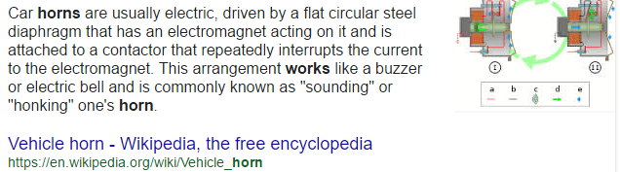Information on how the component is supposed to function when connected properly.
- Pre-cut wire, cut to length, with crimped connectors.
- Piece of wood or similar to attach your components to.
- 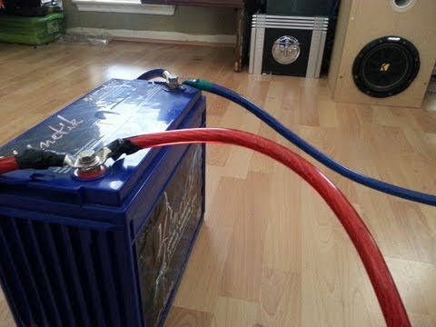A battery source.
- 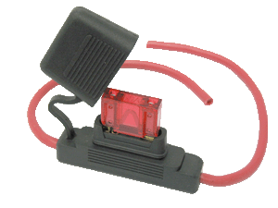A fuse holder and fuse.
- 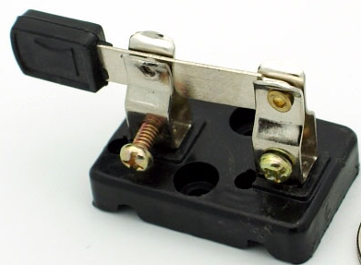A switch.

Once you have fastened your components to the board and connected your relay and fuse. You can go ahead and see if your relay will function and operate your component.

Once complete - take a picture of your work and save it to your Drive for future reference.

Complete the costing table to find out how much your display board has cost.

Minds On (Engaging Prior Knowledge)

Activity 3 Prior Knowledge | Connections
- Activity 1 and 2 of this Unit  - Hand tool safety  - Electric saw safety  - Design skills  - Organizational skills  - Electrical skills | - Ontario Curriculum B1.2 use a variety of hand, power, and specialty tools safely and correctly to perform basic maintenance and repair procedures (e.g., maintenance: oil change, tune up; repair: replace the timing belt, repair a fluid leak) on several types and styles of engines, to manufacturers’ specifications;  - B2.2 use a variety of test equipment (e.g., starter circuit tester, charging system analyser) to determine continuity and measure voltage, amperage, and resistance in various electrical circuits (e.g., starting circuits, charging circuits, lighting circuits);  - DI - (Category of Instructional Strategies: 7 Setting objectives and providing feedback Rubrics or checklists with clear learning goals and previously established assessment criteria)  - SEF(5.2 Opportunities for authentic learning experiences and experiential learning exist in all classrooms, schools and community programs.)  - STEM (5.1.2 Role of Mathematics in STEM Literacy)  - Equity Inclusive…  - ICE (question to pose: how could this circuitry be used in something from your everyday life)
Activity 3 Planning Notes | Connections
- Have all the supplies for students to start completing their relay board.  - Help students find a component or offer a student an previously removed component to speed up the process.  - Print costing tables prior if needed.  - Have an exemplar of a completed notes page or research page so students are reminded of what a research paper should look like before submission.  - Have an exemplar of a completed costing page to demonstrate and remind students to record parts used, and prepare a list for costing. | - DI- (Category of Instructional Strategies: 7 Setting objectives and providing feedback Rubrics or checklists with clear learning goals and previously established assessment criteria)  - SEF(5.2 Opportunities for authentic learning experiences and experiential learning exist in all classrooms, schools and community programs.)  - STEM (5.1.2 Role of Mathematics in STEM Literacy)  - Math Literacy: (FOUNDATIONS FOR ACTION Guiding Principles-1. Mathematical literacy is fundamental. It enables students to make life choices and participate productively in society. 2. All students can learn and be confident in mathematics, given appropriate support and time. 3. All students have the right to quality supports in learning mathematics to enable them to reach their potential.)  - Literacy  - Equity Inclusive…  - ICE  - FNMI First Nations, Metis, Inuit C1.1 analyse the effects that various manufacturing activities have on the environment

Action (Introduce or Extend Learning)
Activity 3 Instructional Strategies | Connections
Teacher:  Introduce activity and criteria. Discuss the relay board and how planning early is important to not crowd any area of their board.  Have a battery station safely set up so students one by one can go to it and hook up their completed circuit.  Describe what students are expected to learn and how their learning will help with the overall project.  Provide students a clear vision of where this activity will lead.  Remind students of the safety of the hand tools.  Remind students to incorporate the components and wiring from the previous lessons/research.  Remind students of the list needed to track individual components so a cost list can be made and submitted.  Student:  Become familiar with the components that are being hooked together.  Make sure to use safety components including glasses and gloves where necessary  Work together to create an electrical board sharing the work.  Use protection devices to prevent overheating of the circuit (fuses).  Keep items organized and the project may take a few periods. Keep a list of items used and their approximate cost.  Some students may decide to describe the impact of twentieth-century innovations in technology, including electricity, on Aboriginal communities either as an enrichment to the unit or an alternative to tracking the cost of individual components .- students are to track their sources and write a one page e=report on their research. | - Ontario Curriculum  - Growing Success  - DI  - SEF  - STEM  - Math Literacy  - Literacy  - Equity Inclusive…  - ICE
Activity 3 Assessment and Evaluation | Connections
- Assessment strategies and tools in this activity will include opportunities in monitoring students’ achievement levels as well as learning skills.  - Rubric Students will be evaluated using this Rubric | - Ontario Curriculum  - DI  - SEF  - STEM  - Math Literacy  - Equity Inclusive
Activity 3 Accommodations | Connections
- Modifications and strategies may include:  - IEP review - add necessary accommodations  - Extra time  - Peer tutors  - Verbal and in class demonstration can be used for students with special needs  - Teacher assistance | - DI- (Category of Instructional Strategies: 7 Setting objectives and providing feedback Rubrics or checklists with clear learning goals and previously established assessment criteria)  - SEF(5.2 Opportunities for authentic learning experiences and experiential learning exist in all classrooms, schools and community programs.)

Consolidation & Connections (Provide Opportunities for Reflection)

Activity 3 Daily Notes | Connections
Students will be asked to write a daily notes of this activity. The notes will include a summary of the relay function.  The purpose of these notes are to allow students to practice the use of proper written language skills for the components etc. It will also help students reflect on their experiences throughout this unit. | - Ontario Curriculum  - Math Literacy  - Literacy  - DI Developing the Routines, Habits and Skills for Differentiated Instruction Begin by providing a single alternative to standard assignment,making sure that each alternative is equally respectful,takes roughly the same amount of time,and satisfies the same expectations.

Materials, Tools and Resources

Activity 3 Websites
http://www.r1200gs.info/howto/relay.html
http://electronics.howstuffworks.com/relay.htm

Activity 3 Publications
Automotive Technology (A Systems Approach) Chapter 14 (ISBN 13-978-0-17-650167-9)
Glencoe-McGraw Hill Automotive Excellence (Volume 1) EP48 EL51 EL52 (ISBN 0-02-831363-1)

Activity 3 Computer Software
Google Suite
Word Suite
Internet
CDX Automotive
Youtube

Activity 3 Human Resources
Volunteers: Robotics Teacher, Electric Vehicle Society of Canada, EA Support Staff, Math teacher, Science teacher

Activity 3 Other
This assignment may take up to 8 days to complete. Have a place for every student to store their work.

Tools and Equipment: wire strippers, wire, wire connectors, wood for displays, screws to fasten items, relays, hand tools including screwdrivers and hammers, wire crimping tools, voltmeter, some automotive parts and accessories, saw or jig saw, nails, shrink wrap, tape and glue.

Activity 3 Appendices
Appendix C: Rubric Students will be evaluated using this Rubric
Appendix D: Assignment Sheet including Costing Table

