Introduce wire metric vs standard crossover chart. Note: one number increases as the other decreases.
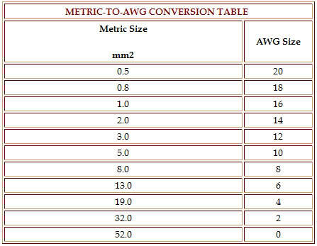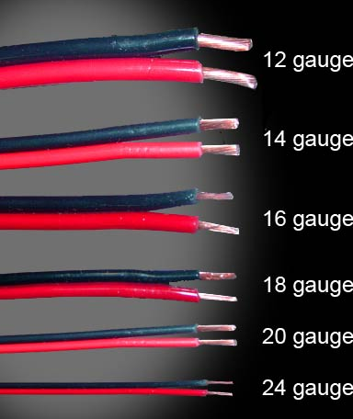

LOADS are: Headlamps, washer motor, starters... etc.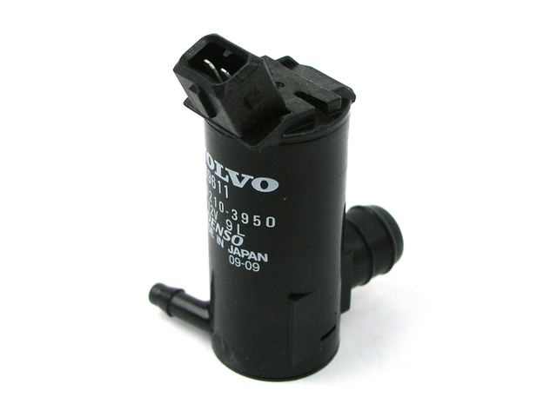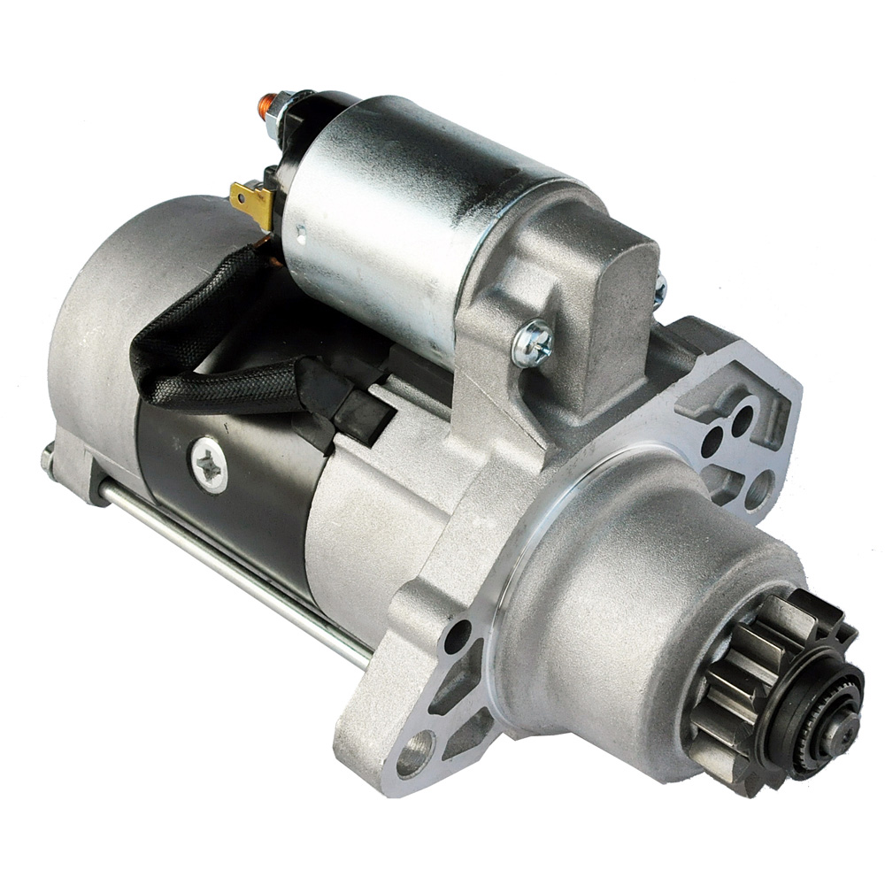

How to crimp and types of wire ends and their colour.
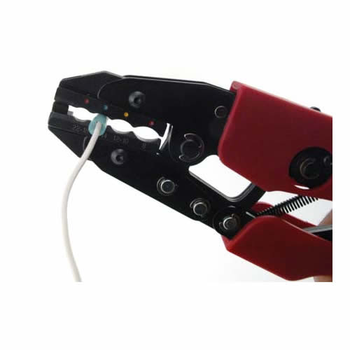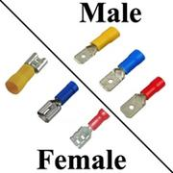
Safer to use Robertson Screws than flat screws. They don’t slip off near as easy and therefore, less chance to get hurt.
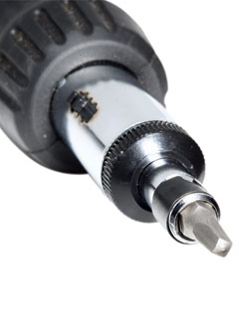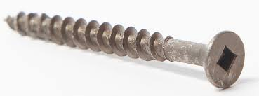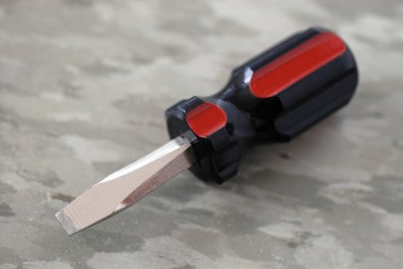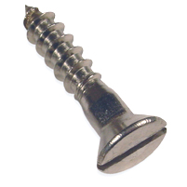

Drill a pilot hole in your work to make turning the screws in easier.

You may have used a voltmeter before to check a 9V battery. Car batteries are similar. A voltmeter may be needed to check and see if good connections are made on your circuit after it has been built.
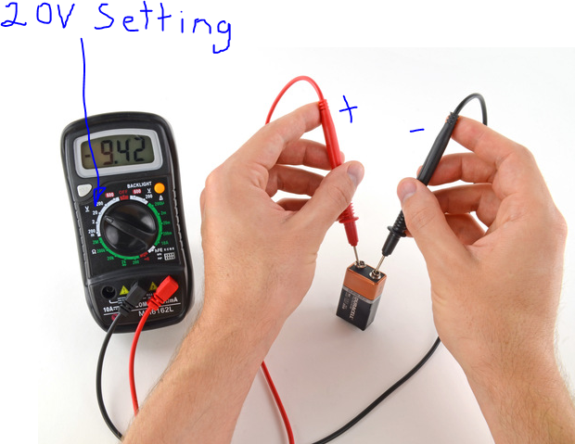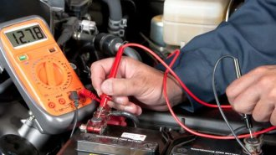
REVIEW: Battery hook up should be done safely. Hook the connection to the battery with solid connectors. Your first connection on your display board should be a fuse. Keep the battery on the floor so it won't drop, don't let the battery touch your skin, eyes, or cloths as batteries have corrosive acid in them. Don’t allow any sparks or open flame to come near the battery as batteries have the potential to explode.

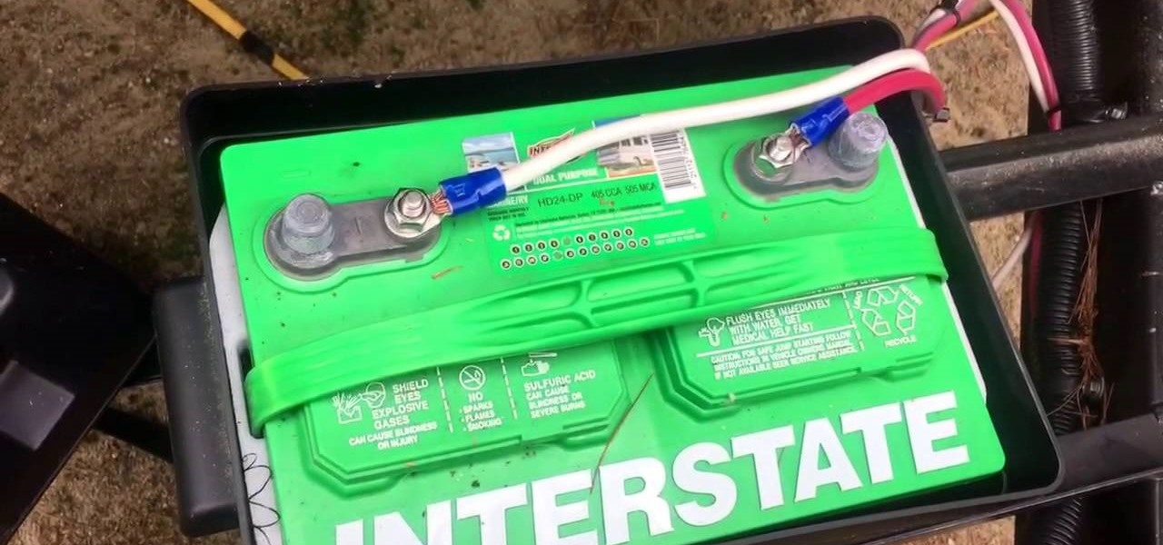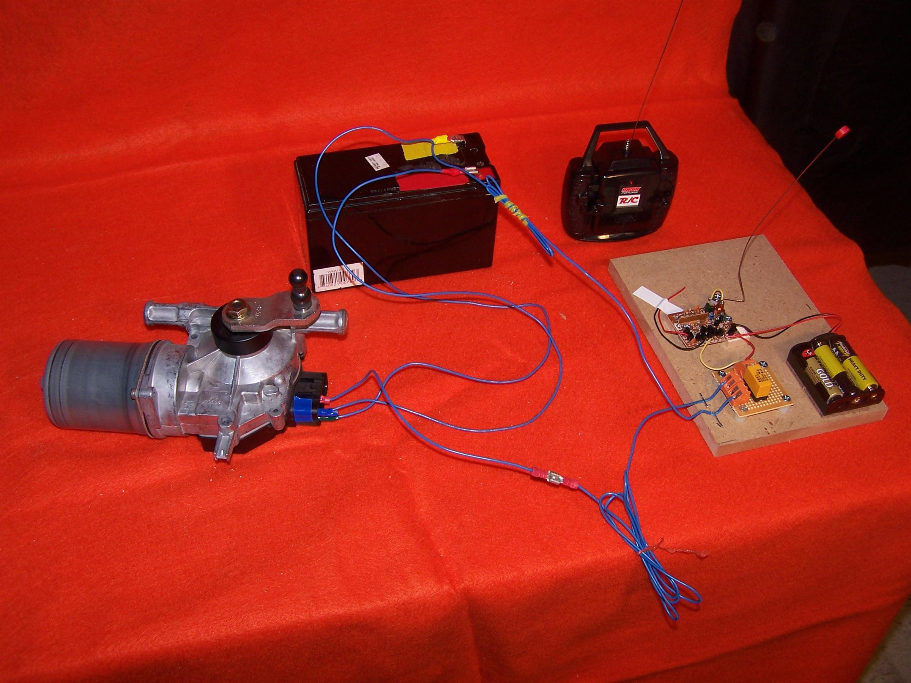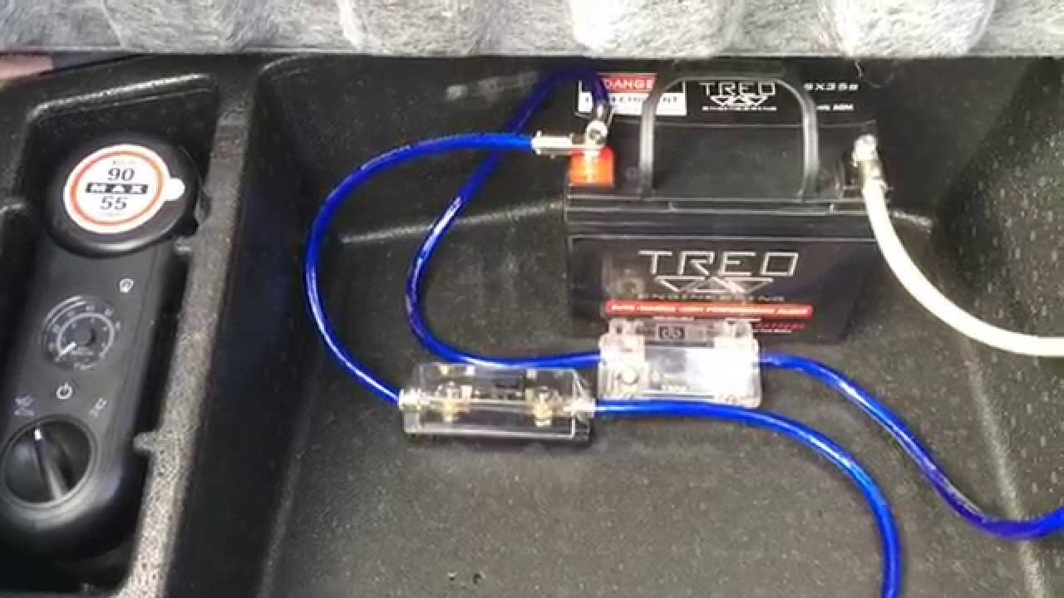

Exposure to battery acid can be very dangerous. From ruining your clothes to much worse. Be careful!
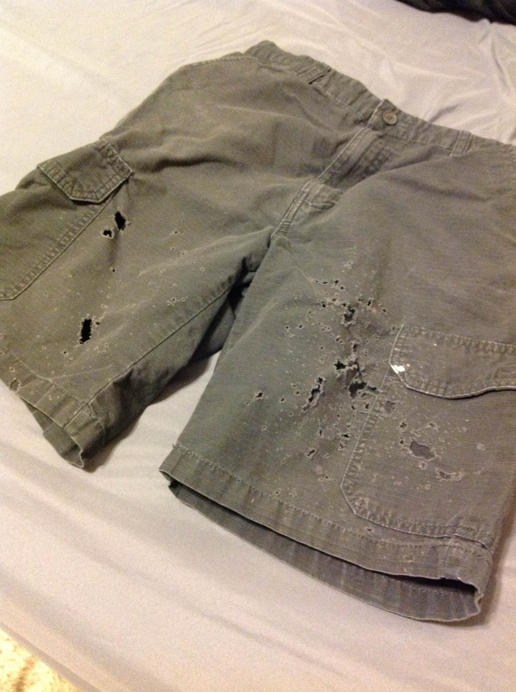

Fuses are designed to melt if excess current travels through them. They need to be at the beginning of your circuit.
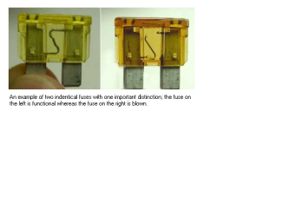
VEHICLE IDENTIFICATION

Year Make
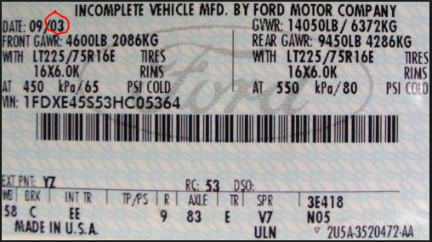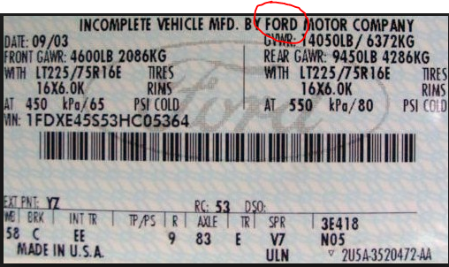

Make and Model Engine Size if needed.
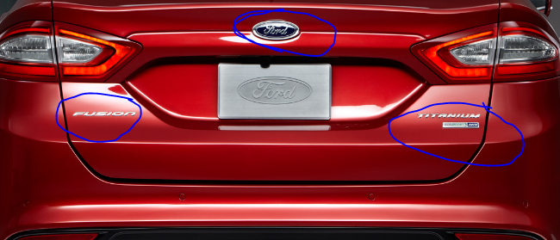.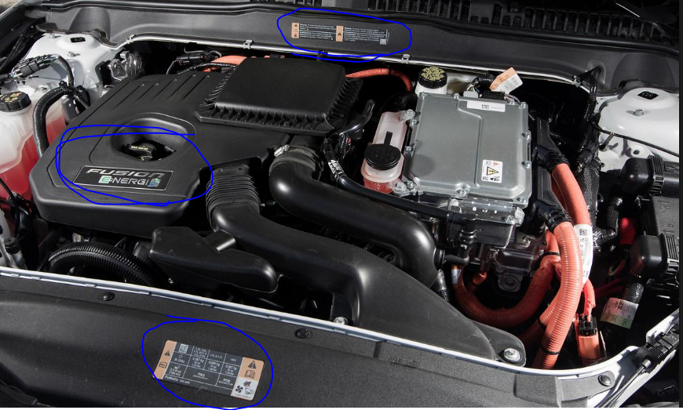

Saw (Jigsaw) safety (if used)
