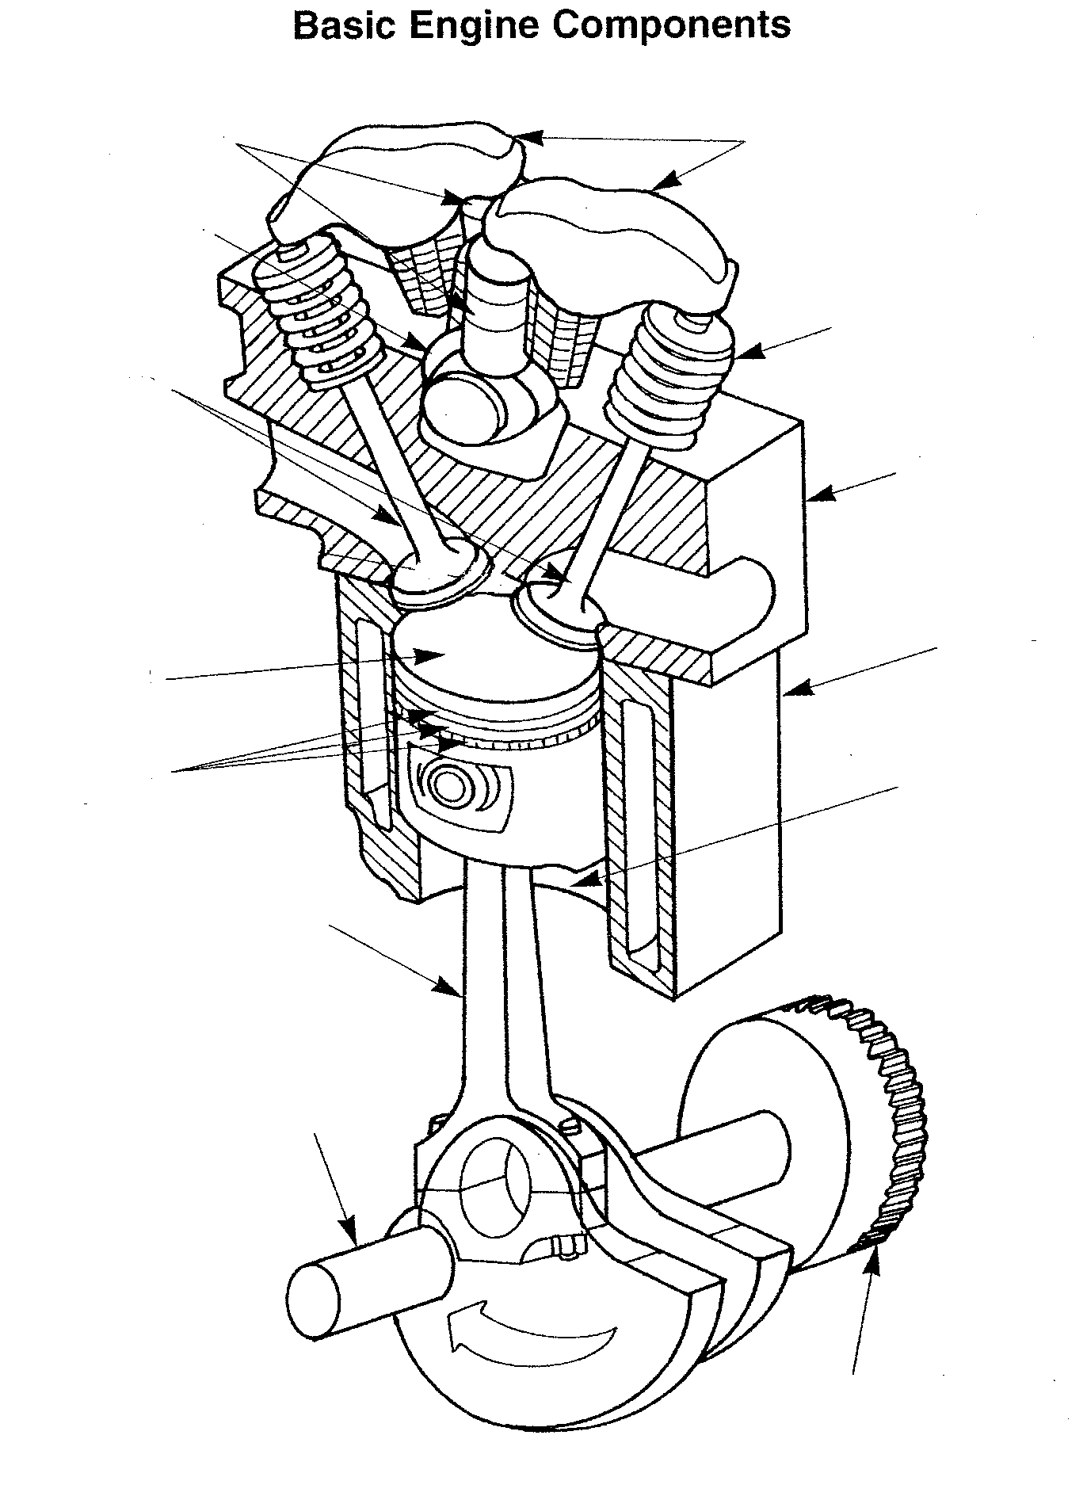
Word Bank
Crankshaft Piston Rings Flywheel Valve Lifters
Rocker Arms Cylinder Head Valve Springs Piston
Valves Connecting Rod Cylinder
Cylinder Block Camshaft

