Using the Lighting Control unit and Basic usage of lights
The lights in Comm. Tech have all been set up to aim at the green screen, in order to use them you should know how the lighting board works, and which lights will best suit your project’s needs.
First things first, the controller should be connected to power, and the 4-pin lighting control socket, without these, you will not be able to control the lights.
Next, the controller mode should be set to 1x16. You can cycle through the modes (2x8, 8x8 and 1x16) by repeatedly pressing the mode button. The controller is now ready to adjust the lights.
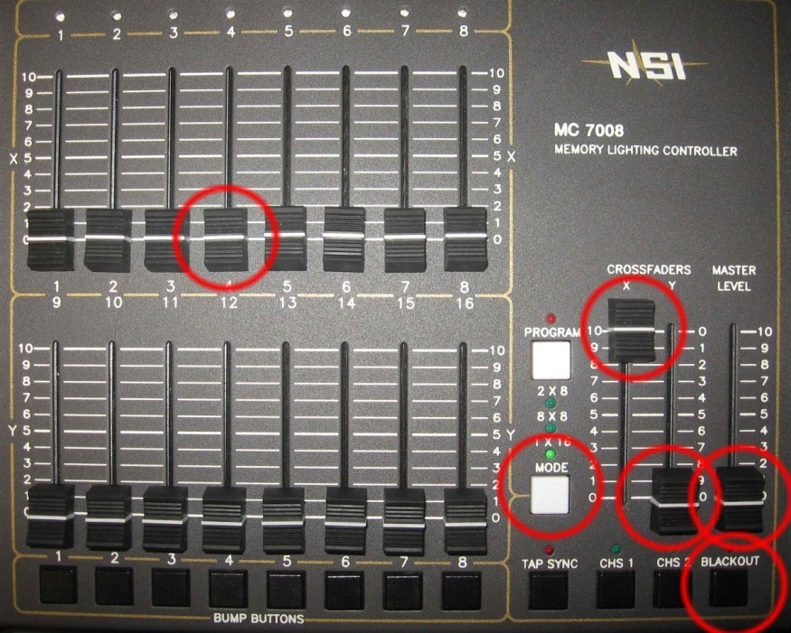
Controlled by X slider
Master Level Slider
Controls the collective level of the entire board

Channel Level Slider
Controls the brightness of one lighting socket
Blackout Button
Switches the lights between on and stand-by

Controlled by Y slider

Mode Button
Dictates how the sliders are split over the lighting sockets, best kept on 1x16

There are 3 ways to control the level of the lights. Firstly there are the channel level sliders, each one of these controls a power socket on the ceiling of the green screen studio. Next there are the X and Y channel group sliders. This will give you the power to assign a consistent level over the entire top or bottom half of the channel level sliders. The final step is the Master level slider, this controls the levels of all the sockets on the system, and it located on the very right hand side of the controller. Right below the Master slider is the Blackout button, when engaged, this button will turn off all the lights regardless of the Master level. When pressed a second time, the Master level dictated by the Master Level slider is restored to all the channels.
The Lights
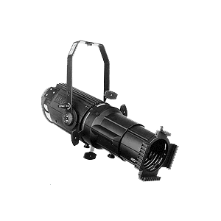
Our lighting grid is populated by 2 types of lights predominantly, the Fresnel and the Shakespeare. They have two very different characteristics and create very different looking properties of light. There are certainly pros and cons for each light depending on the situation.
The Shakespeare, also called the ellipsoidal, Shakespeare ellipsoidal or leko light, produces a powerful beam of light to a maximum of 750 Watts. The Shakespeares can be focussed, softened, and cropped to service many different applications. All of this flexibility comes from having an extendible barrel and a focussing lens within that barrel. These lights are at the back of the studio, and are used to light the actor.
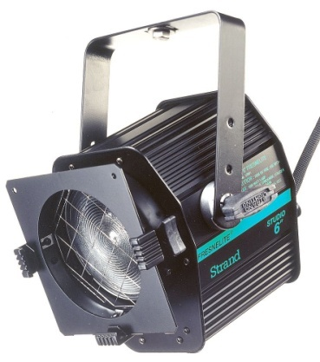
The light mainly responsible for lighting the green screen is the Fresnel (pronounced “fray-nell”) light.
There is some light spread control, but it’s very limited. A lever on the back can tighten or spread the light emitted, there is no other control over the light. The lens, invented by Augustin-Jean Fresnel, is designed to evenly spread the light, and eliminate the odd distribution that you might seen through an ordinary flash-light lens. This characteristic makes it ideal for lighting the back of our green screen.

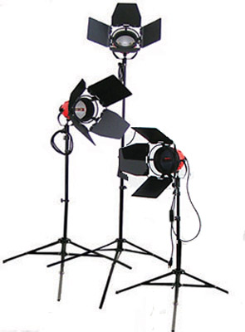
The most versatile light in your collection here in the TV studio is going to be the Halogen studio lamps, or Redheads. The term Redhead is used loosely, but could be defined as a general purpose lamp used in the film and television industry for the grunt work lighting in most shots. The term generally applies to lights with power between 650-1000 watts.
While shooting your footage, these lights will be the ones you want to reposition and adjust shot to shot, the wheels and easy extension of the stands makes this much more preferable to adjusting any hanging lighting.
Given that there are several lights available to you, a set up involving a key light and fill light should be all you need. Notice, the overhead incandescent lamps should be enough to give your talent a bit of back lighting, however should you desire more for a particular shot, a redhead could be placed off-camera behind the actor, and should provide sufficient illumination.
The Setup
6

8

4

3

2

7

5

1

5
4
7
10
11
8
9
6
Legend
6
Shakespeare Ellisoidal
Overhead Incandescent
(on clicker)
Fresnel Light
Lighting circuit socket
3

Socket number
Corresponding slider channel
Power cord extension mount

