Final Evaluation – Arduino based Digital Clock
Date: _________________ Name:___________________________

Objective: To build a digital clock using a multiplexed 7-segment display that shows time from Arduino. This is the final project of this course. All activities from today onwards including this project are worth 30% of your final mark in this course.

Description of the project: We will be using Arduino and a seven-segment display. Time will appear as HH:MM on the display. You are free to add more features such as blinking colon for seconds, alarm and snooze functions to make your clock unique. More the unique features your project has, more is your final marks!

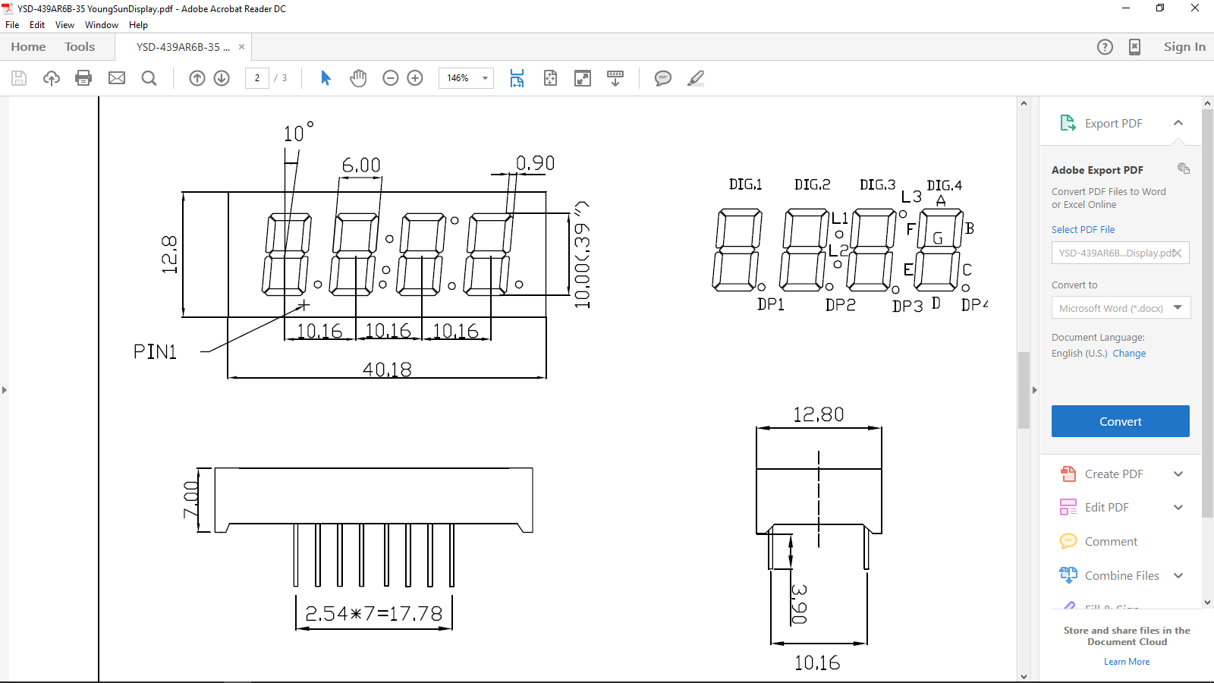
Multiplexing: Four separate 7-segment displays will have 4 x 7 = 28 segment pins and four power pins making it a total of 32 pins. Arduino does not have 32 pins. So, we need a way to multiplex the displays. That is, turn on a single display at a time and switch the displays really fast so they all four appear to be on. This technique is called multiplexing. Human eye cannot see the flickering, if the rate is more than 15 times a second. That is why TV and Movie screens, overhead fluorescent lights seem to be on. Since we turn on one display at a time, we need just 7 segment pins plus four power pins making it a total of 11 pins; much less than 32 that we needed earlier. We will be using a multiplexed display shown below that has 16 pins. This display has extra pins for right side decimal points, colons and apostrophe. Do some basic research on how to multiplex the display.

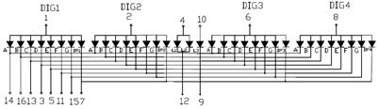

What you need to do and when:
- This is an individual project.
- We are going to build this circuit on a PCB (printed circuit board). And we will be using Fritzing software to layout the PCB. Download the software at home and use the software to create the layout. Due: _________________
- Code the Arduino to show time as 20:56 (24 hr format). You can set time yourself in your code or sync the time from the PC. This is the challenge part of this project.
Due: _________________
- Complete your project report. This is a typed report that should contain the following:
- PCB layout. Maximum size 3”x3”.
- Include picture of the solder side of your circuit board. Max 3”x 3”
- Arduino sketch – copy and paste the code into your report as plain text. Comment your code. You must be able to explain your code to your teacher.
c. List of activities in a sequence you followed to make the project.
d. Next steps or more features that would make your project stand out.
e. Your name on title page! Use footer with your name and page numbers as shown here. Due:_________________
5. Refer to the marking rubric to see how your work will be evaluated.
6. Here is the checklist:
- Title page with your name, course code, project name and date of submission.

- Pictures of: PCB layout, solder side of your PCB. All 3” x 3” max.

- Arduino sketch as plain text – not MSWord - single spaced with comments.

- List of activities, bullet point or paragraph format, maximum one page.

- Footer with your name and page number / total page on every page, see below.

Good Luck!

