Instrumentation Information Sheet
Picture of sensor
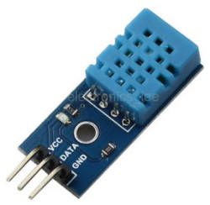
Pinout Diagram

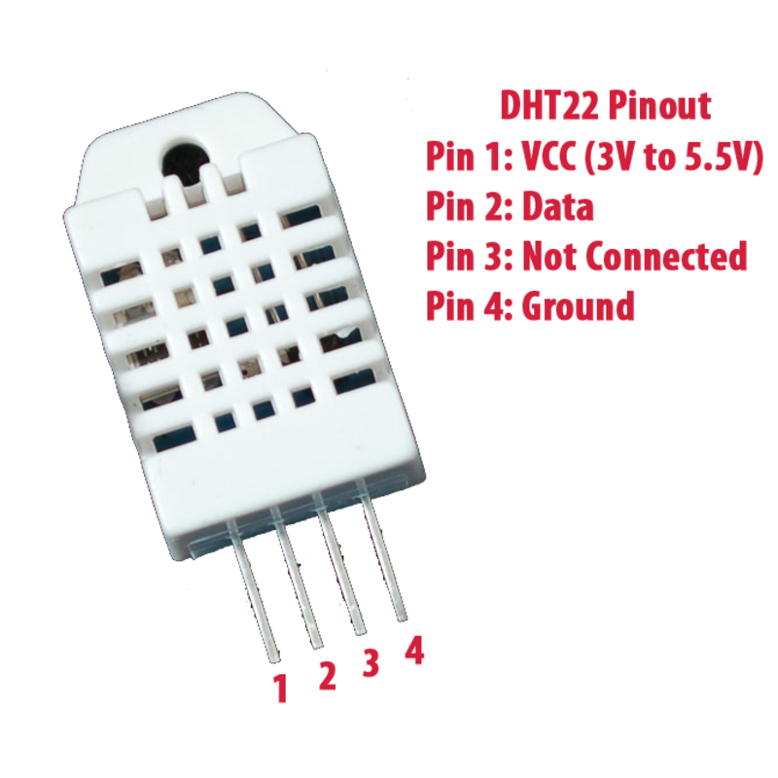
Instrument Name
Temperature-humidity sensor

Instrument Part Number/Component ID
DHT22 (also AM2302)

Used for measuring?
Air temperature, air humidity

Supply voltage (Vcc)
3.3V-6V DC

Communication type (digital, analog, IC2, etc.)
digital

Sensing Element
Thermistor and capacitive humidity sensor

Required engineering unit conversions
None…included in sensor

Measurement Range
Temp:-40C to 80C, Humidity: 0-100%

Accuracy
Temp +/- 0.5C. Humidity: +/- 2%

Additional library required (if yes, location)
Yes, dht.h, https://github.com/adafruit/DHT-sensor-library

Notes
DHT11 is lower cot, less sensitive sensor

