Appendix A:
Appendix Title – NIGHTSTAND PROJECT- ASSIGNMENT
The Assignment:
You have been asked to design a nightstand for a client’s home. Your task is to design, construct and finish a nightstand that will be no larger than 19” wide X 12” deep X 24”high which will include a drawer and door. The following instructions are outlined below to assist in you project.
- Research different type of nightstands and evaluate complexity.
- Use the Design Process to prepare sketches and orthographic drawing for the night stand. You can use the drawing provided as an example (See Appendix C).
- Prepare a cut list included the amount of board feet required for the project.
- The top, sides and bottom shelf will require you glue pieces together. Ensure you have square jointed edges to achieve a tight glue joint.
- Cut and glue the pieces together. Leave the pieces a little longer than required so they can be squared after the glue has dried.
- Cut the pieces for the drawer including a dado joint for the bottom panel. The dado should be ¼” deep and the blade width is 1/8” for the bottom panel. Masonite will be used for the bottom panel and will be installed while you assemble the drawer frame. The drawer frame needs to be ¼” smaller than the opening to allow for a smooth glide.
- Install the front panel of the drawer on the frame. Ensure you allow 1/8” at the top and bottom. You can use a shim to assist and maintain a constant height.
- Cut pieces for door panel. The design will depend on what is required (e.g., straight panel, raised panel, CNC pattern, etc).
- Square up the two sides and cut to length.
Sand all large pieces including the sides, shelf and top.
- Cut any dado and rabbet joints that may be required and assemble the sides, top, and bottom together. Ensure you have all the rail pieces install for the drawer prior to assembly.
- Use 400 grit sandpaper for the final light sanding.
- Finish the night stand with a water based urethane.
- Evaluate Product to ensure it met the client’s needs.

Appendix B
Appendix Title – COMPLEXITY CHART NIGHTSTAND PROJECT

Complexity | Least Difficult |  |  | More Difficult
Complexity of design | 1 | 2 | 3 | 4
Complexity of joinery | 1 | 2 | 3 | 4
Complexity to build door | 1 | 2 | 3 | 4
Complexity to build drawer | 1 | 2 | 3 | 4
Complexity to finish edges | 1 | 2 | 3 | 4
Complexity to Finish | 1 | 2 | 3 | 4
Complexity of the overall project | 1 | 2 | 3 | 4
Total

Feedback Notes: Provide brief notes below on findings to present to the rest of the class. Include URL’s for Nightstands of choice.
_____________________________________________________________________________________________________________________________________________________________________________________________________________________________________________________________________________________________________________________________________________________________________________________________________________________________________________________________________________________________________________________________________________________________________________________________________________________________

Appendix C
Appendix Title – NIGHTSTAND PROJECT - SELF ASSESSMENT EXIT CARD
Complete the self-assessment below. Circle a number in the Self-assessment column to describe your readiness for the Nightstand Project, based on past experience and your preferences for ways of presenting:
1) I do not think I am ready to do this because...
2) I could do this if...
3) I could do this with confidence because...
Explain three of your choices in the “My Comments” column by completing the statement for the number you chose (e.g., 3. I could do this
with confidence because I always do better in oral presentations). Submit this to your teacher as an Exit Card.

Nightstand Skills and Knowledge | Self-assessment | My Comments
Use CAD software to prepare a scaled drawing of the Nightstand including the thickness of materials and media supports | 1……….2………..3
Use mechanical pencil prepare a scaled drawing of the Nightstand including the thickness of materials and media supports | 1……….2………..3
Incorporate shelves or supports (e.g., thickness, dowels, etc ) into a scaled drawing for the Nightstand | 1……….2………..3
Prepare a materials cut list | 1……….2………..3
Explain your work in writing (e.g., through e-mail, point form on a slide, or in writing) | 1……….2………..3
Explain your work orally (e.g., using charts, sketches, or a projection screen) | 1……….2………..3
Complete each step of the design process | 1……….2………..3

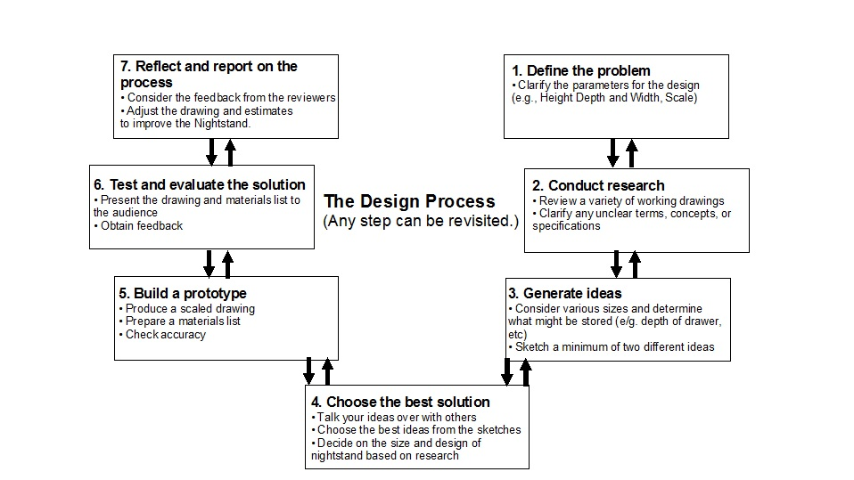
Appendix D
Appendix Title – STEPS IN THE DESIGN PROCESS – NIGHTSTAND PROJECT (TEACHER REFERENCE)
Steps in the Design Process

Appendix E:
Appendix Title: DESIGN PROCESS LOG

Step in the Design Process
Define the problem
Conduct research
Generate ideas
Choose the best solution
Build a prototype
Test and evaluate
Reflect and report

Appendix F:
Appendix Title: NIGHTSTAND COMPONENTS
1. Label each component with correct terminology on drawing below.
2. Add the dimensions (scale is1 inch = 1 ft) to the nightstand.
3. Prepare a materials list for the construction of this nightstand.
4. Prepare a tool list required to complete the project.

Appendix F Continued:
Appendix Title: NIGHTSTAND COMPONENTS

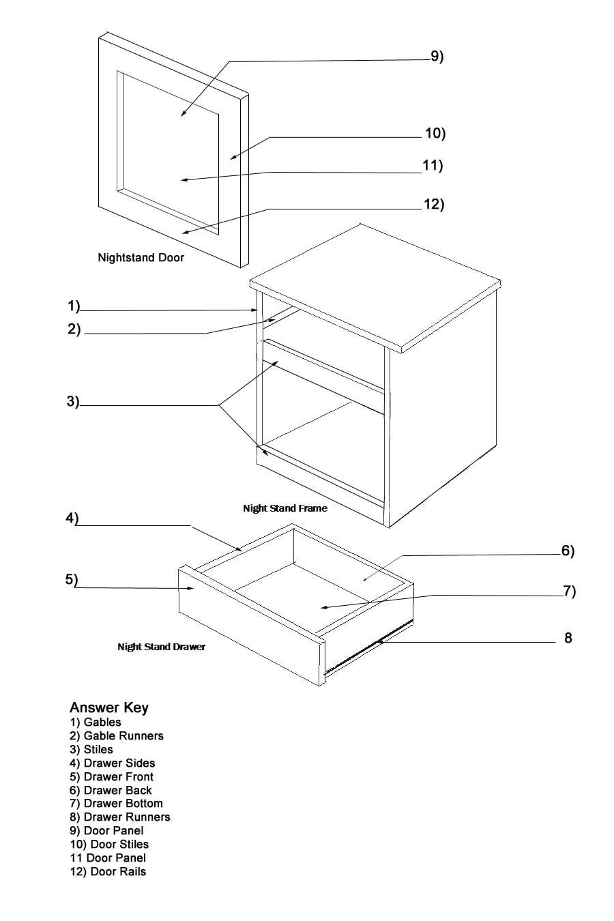

Appendix G :
Appendix Title: NIGHTSTAND CHECKLIST

Criteria/Categories | ✓ | Peer Comments/Suggestions
The student designer:
Knowledge and Understanding
- Uses terminology of the nightstand components during the construction process
Thinking
- Uses the design process to produce a scaled drawing of a nightstand
within the stated parameters
- Keeps a complete and thorough log
- Provides evidence of ideas, sketches, possible solutions, etc
Application
- Uses the imperial system to do scale and design
- Draws dimensions accurately
- Considers nominal vs. actual lumber size
- Completes a materials list for the Nightstand Project
- Makes reasonable estimates
Makes accurate calculations
Applies construction knowledge of components to produce technical drawings
Complies with construction parameters and standards (e.g., tight joinery, material thickness, etc)

Appendix H:
Appendix Title: NIGHTSTAND MATERIAL CUT LIST

Item (e.g., gable, etc) | Material | Number of pieces | Thickness | Width | Length

Appendix I:
Appendix Title: NIGHTSTAND EVALUATION RUBRIC

Categories | Level 1 | Level 2 | Level 3 | Level 4
Knowledge
Knowledge of content  (e.g., facts, equipment, terminology, materials) | Demonstrates limited knowledge of content  (use and terminology of tools, Nightstand components, etc) | Demonstrates some knowledge of content  (use and terminology of tools, Nightstand components, etc) | Demonstrates considerable  knowledge of content (use and terminology of tools, Nightstand components, etc) | Demonstrates thorough knowledge of content (use and terminology of tools, Nightstand components, etc)
Thinking
Use of planning skills  (e.g., identifying the problem ,selecting strategies and  resources, scheduling) | uses planning skills with limited effectiveness | uses planning skills with some effectiveness | uses planning skills with  considerable effectiveness | uses planning skills with a  high degree of effectiveness
Use of processing skills  (e.g., analysing and interpreting information, reasoning, generating and evaluating solutions, forming conclusions) | uses processing skills with limited effectiveness  (e.g. use of pencil or software to develop orthographic drawings, and cut list to construct the Nightstand Project) | uses processing skills with some effectiveness  (e.g. use of pencil or software to develop orthographic drawings and cut list to construct the Nightstand Project) | uses processing  skills with considerable  effectiveness  (e.g. use of pencil or software to develop orthographic drawings and cut list to construct the Nightstand Project) | uses processing skills with a high degree of effectiveness (e.g. use of pencil or software to develop orthographic drawings and cut list to construct the Nightstand Project)
Application
Application of knowledge  and skills (e.g., concepts, processes, use of equipment and technology) in familiar contexts | applies knowledge and skills in familiar contexts with limited effectiveness  (e.g. joinery, assembly, finishing, etc) | applies knowledge and skills in familiar contexts with some effectiveness  (e.g. joinery, assembly, finishing, etc) | applies knowledge and skills in familiar contexts with considerable  effectiveness (e.g. joinery, assembly, finishing, etc) | applies knowledge and skills in familiar contexts with a high degree of  effectiveness (e.g. joinery, assembly, finishing, etc)

Appendix J:
Appendix Title: LEARNING SKILLS ASSESSMENT RUBRIC

The Learning Skills are based on Responsibility, Organization, Independent Work, Collaboration, Initiative and Self - Regulation. You can determine where to fit any of these Learning Skills within the Essential Skills listed below. As an example, students who are researching (Reading Text) can be either in Independent Work, Collaboration or Initiative depending how you let the student conduct the research.

Rubric | Level 1 | Level 2 | Level 3 | Level 4 | Level 5
Essential Skill(s)
Reading Text -  Part of Research | • Reading relatively short, simple texts (e.g., memos, notes) to find a single piece of information  • Following simple written directions (e.g., directions on bottles) | • Reading simple texts (e.g., letters, memos) to find several pieces of information  • Reading more difficult texts to find a single piece of information  • Interpreting simple pieces of information from a single source | • Choosing and integrating various pieces of information from one source or several sources (e.g., reports, manuals)  • Interpreting several simple pieces of information from several sources  • Distinguishing between relevant and irrelevant information | • Integrating and synthesizing information from various sources or from relatively detailed texts (e.g., reference books)  • Interpreting complex texts (e.g., regulations) | • Synthesizing information from various sources or from very detailed texts (e.g., specifications)  • Interpreting very complex texts, using specialized knowledge (e.g., professional or technical journals)
Oral Communication | • Communicating orally in simple ways (e.g., responding to everyday inquiries, obtaining specific information)  • Dealing with facts involving few details  • Communicating, usually with one person at a time, in an everyday and predictable context using an established format and style | • Communicating orally in moderately demanding ways (e.g., exchanging detailed information, reassuring a client, explaining procedures)  • Dealing mostly with facts that are moderately complex and detailed, and also with opinions  • Communicating with one or more people at a time in an everyday and largely predictable context (e.g., in a familiar setting), using a range of formats and styles, and dealing with minor conflicts | • Communicating orally in demanding ways (e.g., persuading, counselling)  • Dealing with complex and detailed matters involving facts, concepts, and opinions  • Communicating with one or more people at a time in occasionally unpredictable contexts (e.g., meetings with unfamiliar people), using a wide range of formats and styles, and dealing with conflict when necessary | • Communicating orally in very demanding ways (e.g., solving complex problems)  • Dealing with very complex and detailed matters, using language that is conceptual and/or technical  • Communicating with one or more people at a time in quite unpredictable contexts, adapting a wide range of formats and styles to suit the person or group, and dealing with significant conflicts or differing points of view (e.g., leading negotiations)
Scheduling - as it relates to the student’s project | • Monitoring schedules or budgets and reporting shortages or surpluses | • Determining the number of workers required and amount of time needed to complete a job, using production rates per person as a basis | • Adjusting established budgets and schedules to incorporate new information | • Planning and monitoring schedules and budgets for small or short-term projects | • Planning and monitoring schedules and budgets for large or multi-phased projects
Numeracy
Measurement and Calculation | • Taking measurements in a one-step process and recording results  • Measuring out quantities  • Setting instruments to particular angles and other numeric settings | • Calculating areas and volumes of simple, familiar shapes  • Converting between measurement systems or converting quantities by doubling, halving, etc. | • Calculating areas that are a combination of simple, familiar shapes  • Making scale drawings  • Taking precise measurements using specialized equipment | • Calculating areas and volumes of complex irregular shapes | • Devising estimates and making calculations of measurements that cannot be taken directly
Numerical Estimation | • Providing an estimate in a situation in which errors can be easily and quickly corrected with minimal expense  • Taking into consideration only one factor about which all relevant information is known  • Using a given formula and procedure in making the estimate | • Providing an estimate in a situation in which errors can be corrected but at some inconvenience and expense  • Taking into consideration only a few factors about which most relevant information is known  • Using a given formula and procedure in making the estimate, while taking into consideration other factors | • Providing an estimate in a situation in which errors have significant consequences but can be corrected  • Taking into consideration many factors about which some information is not known for certain  • Using a procedure that has been developed for making the estimate (no formula available) | • Providing an estimate in a situation in which errors have significant consequences and cannot be corrected or can only be corrected at great expense  • Taking into consideration many factors about which a lot of information is not known  • Developing a formula or procedure for making the estimate
Thinking Skills
Job Task Planning and Organizing | • Performing tasks that are done in an established order  • Performing tasks that are rarely disrupted  • Performing tasks that do not require coordination with the work of others | • Planning and organizing their work within a limited framework  • Performing tasks according to the priority assigned to various categories of tasks by someone else  • Performing tasks that may be disrupted but the day’s work plan is not changed  • Coordinating some of their work with the work of others | • Planning and organizing their work following general guidelines  • Establishing the order in which their tasks are completed, subject to the supervisor’s approval  • Making adjustments to the order in which their tasks are done, or rescheduling tasks or people  • Coordinating and integrating their work with that of others | • Planning and organizing their work with complete authority  • Establishing the order in which tasks are completed  • Frequently making adjustments to the order of tasks, rescheduling tasks or people, or setting new priorities  • Creating and maintaining links with the work of others
Decision Making | • Making a decision in a situation in which all relevant information is known; in which limited judgment is needed; and in which decisions can be easily reversed  • Following a standard procedure in which exceptions are clearly defined  • Using similar decisions from the past as models | • Making a decision in a situation in which most relevant information is known; in which some judgment is needed; in which errors have minor consequences; and in which decisions can be reversed with only some inconvenience and/or expense  • Following a standard procedure in which exceptions require some interpretation  • Using comparable decisions from the past as models | • Making a decision in a situation in which some information is uncertain; in which considerable judgment is needed; in which errors have significant consequences but can be corrected; and in which decisions can be reversed only with considerable difficulty  • Following a standard procedure that allows a lot of room for personal interpretation  • Using somewhat similar decisions from the past as models | • Making a decision in a situation in which important information is not known; in which excellent judgment is needed; in which errors have significant consequences and either cannot be corrected or can only be corrected at great cost; and in which the decision cannot be reversed or can only be reversed with great difficulty and/or at great expense  • Making the decision in a situation in which there are no established procedures or models of similar decisions to guide decision making
Problem Solving | • Dealing with simple problems that are easily identified and have a limited number of factors  • Selecting the prescribed solution for a problem  • Checking that the problem has been solved | • Dealing with problems that are of moderate difficulty and that have several factors, most of which are clearly defined  • Identifying the problem and selecting the most appropriate solution  • Determining whether the solution was successful | • Dealing with difficult problems that have a broad range of factors, some of which are difficult to define  • Selecting the best procedure for identifying the problem, and modifying an existing solution, if necessary  • Determining whether the solution was successful, and identifying the need for any further action | • Dealing with very difficult problems that have a broad range of factors, some of which are unpredictable or conflict with other factors  • Designing the procedure for identifying the problem, and providing an original solution  • Identifying criteria for determining whether the solution was successful, and assessing the solution in relation to these criteria
CRITICAL THINKING | • Judgments based on a few, simple criteria  • Criteria is either at hand or is easily obtained  • Minor consequences associated with the judgment | • Judgments based on several well-defined criteria  • Effort required to select, organize and evaluate information from a limited number of sources  • Consequences associated with the judgment may affect the individual and those close to them | • Judgments based on criteria reflecting many points of view and many interests  • Effort required to select, organize and evaluate information from a limited number of sources  • Consequences associated with the judgment are significant; they may affect an organization or extend beyond an organization  Level 4 | • Judgments based on different and sometimes conflicting points of view and public interests  • Major effort required to identify, interpret, organize, synthesize and evaluate information  • Consequences associated with the judgment are significant, are typically on a large-scale, and have the potential to affect many people and multiple interests

