Appendix 1: Whiteboard frame drawings (front and side view without joints) 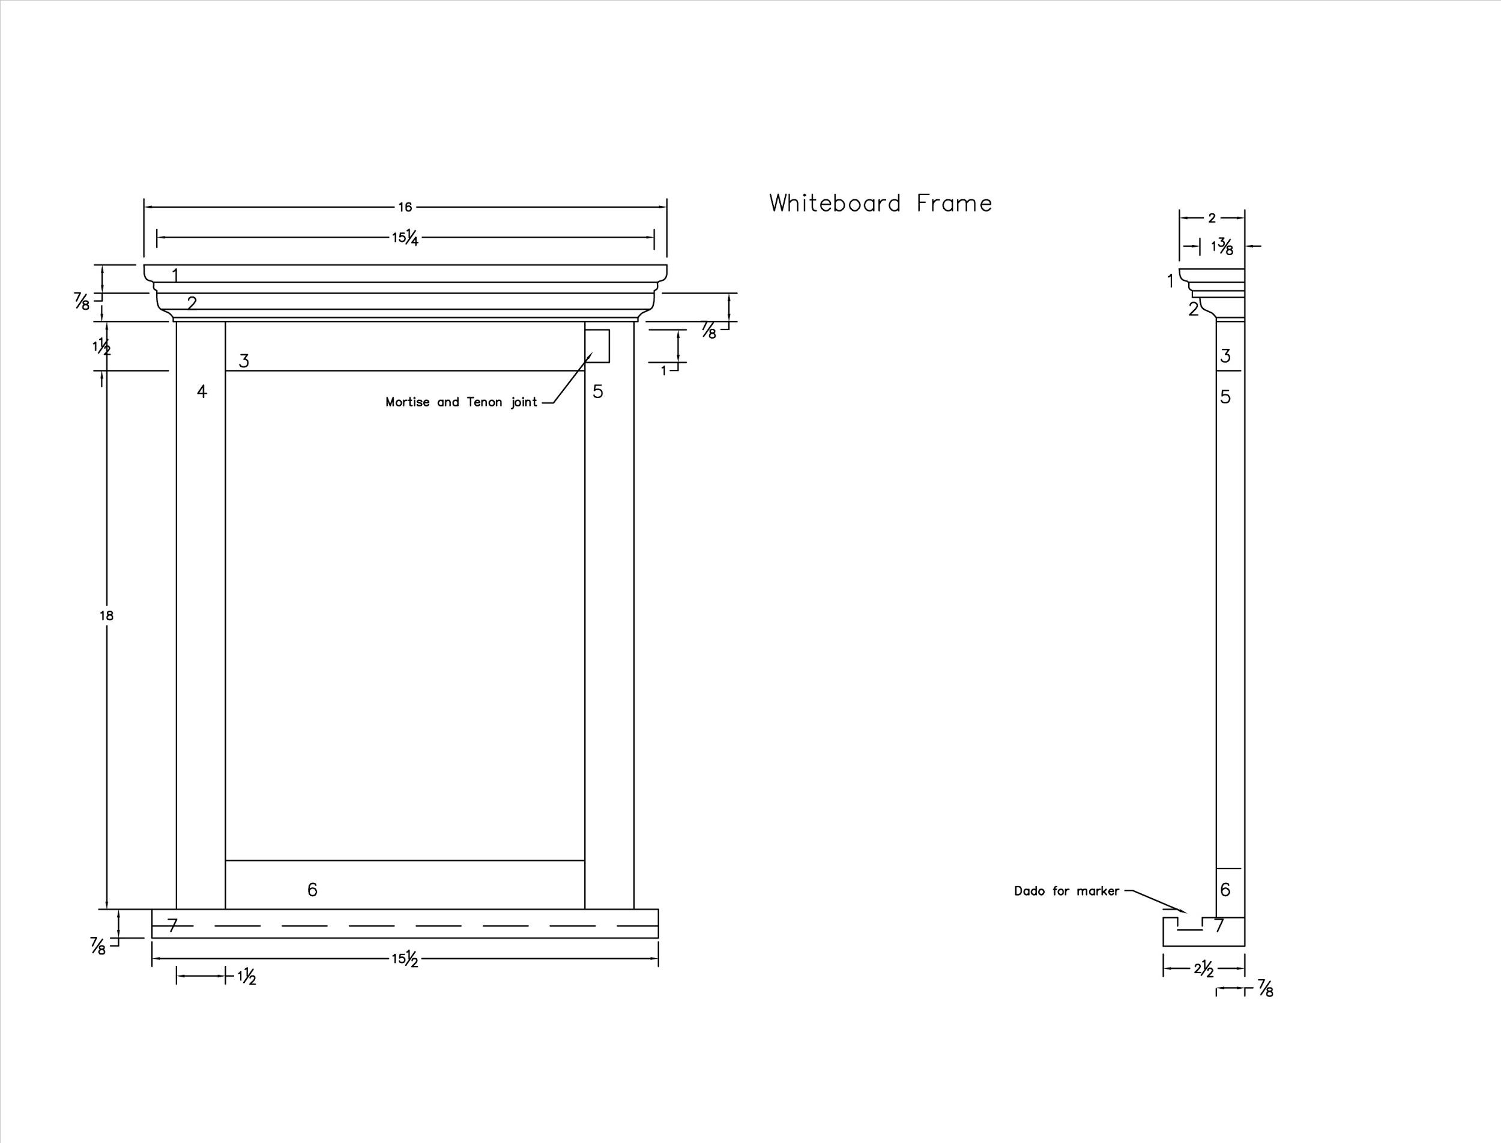

Appendix 2: Sketch checklist

Criteria/Categories | Level 1 | Level 2 | Level 3 | Level 4 | Comments/Suggestions
Knowledge and Understanding
- Describes a variety of joint options based on their research
Thinking
- Uses the design process to produce a sketch of the joints within the stated parameters
- Works as a team
- Analyze their research and select the 3 joints they will use for their frame

Application
- Uses the imperial system to put basic dimensions on the sketch
- Produce a sketch of the joints within the stated parameters
- Sketch is neat and lines are clear.
- Dimensions are present, accurately placed and correct
- Team members make an effort to be inclusive and listen to each others ideas

Appendix 3: Whiteboard Frame Bill of Materials

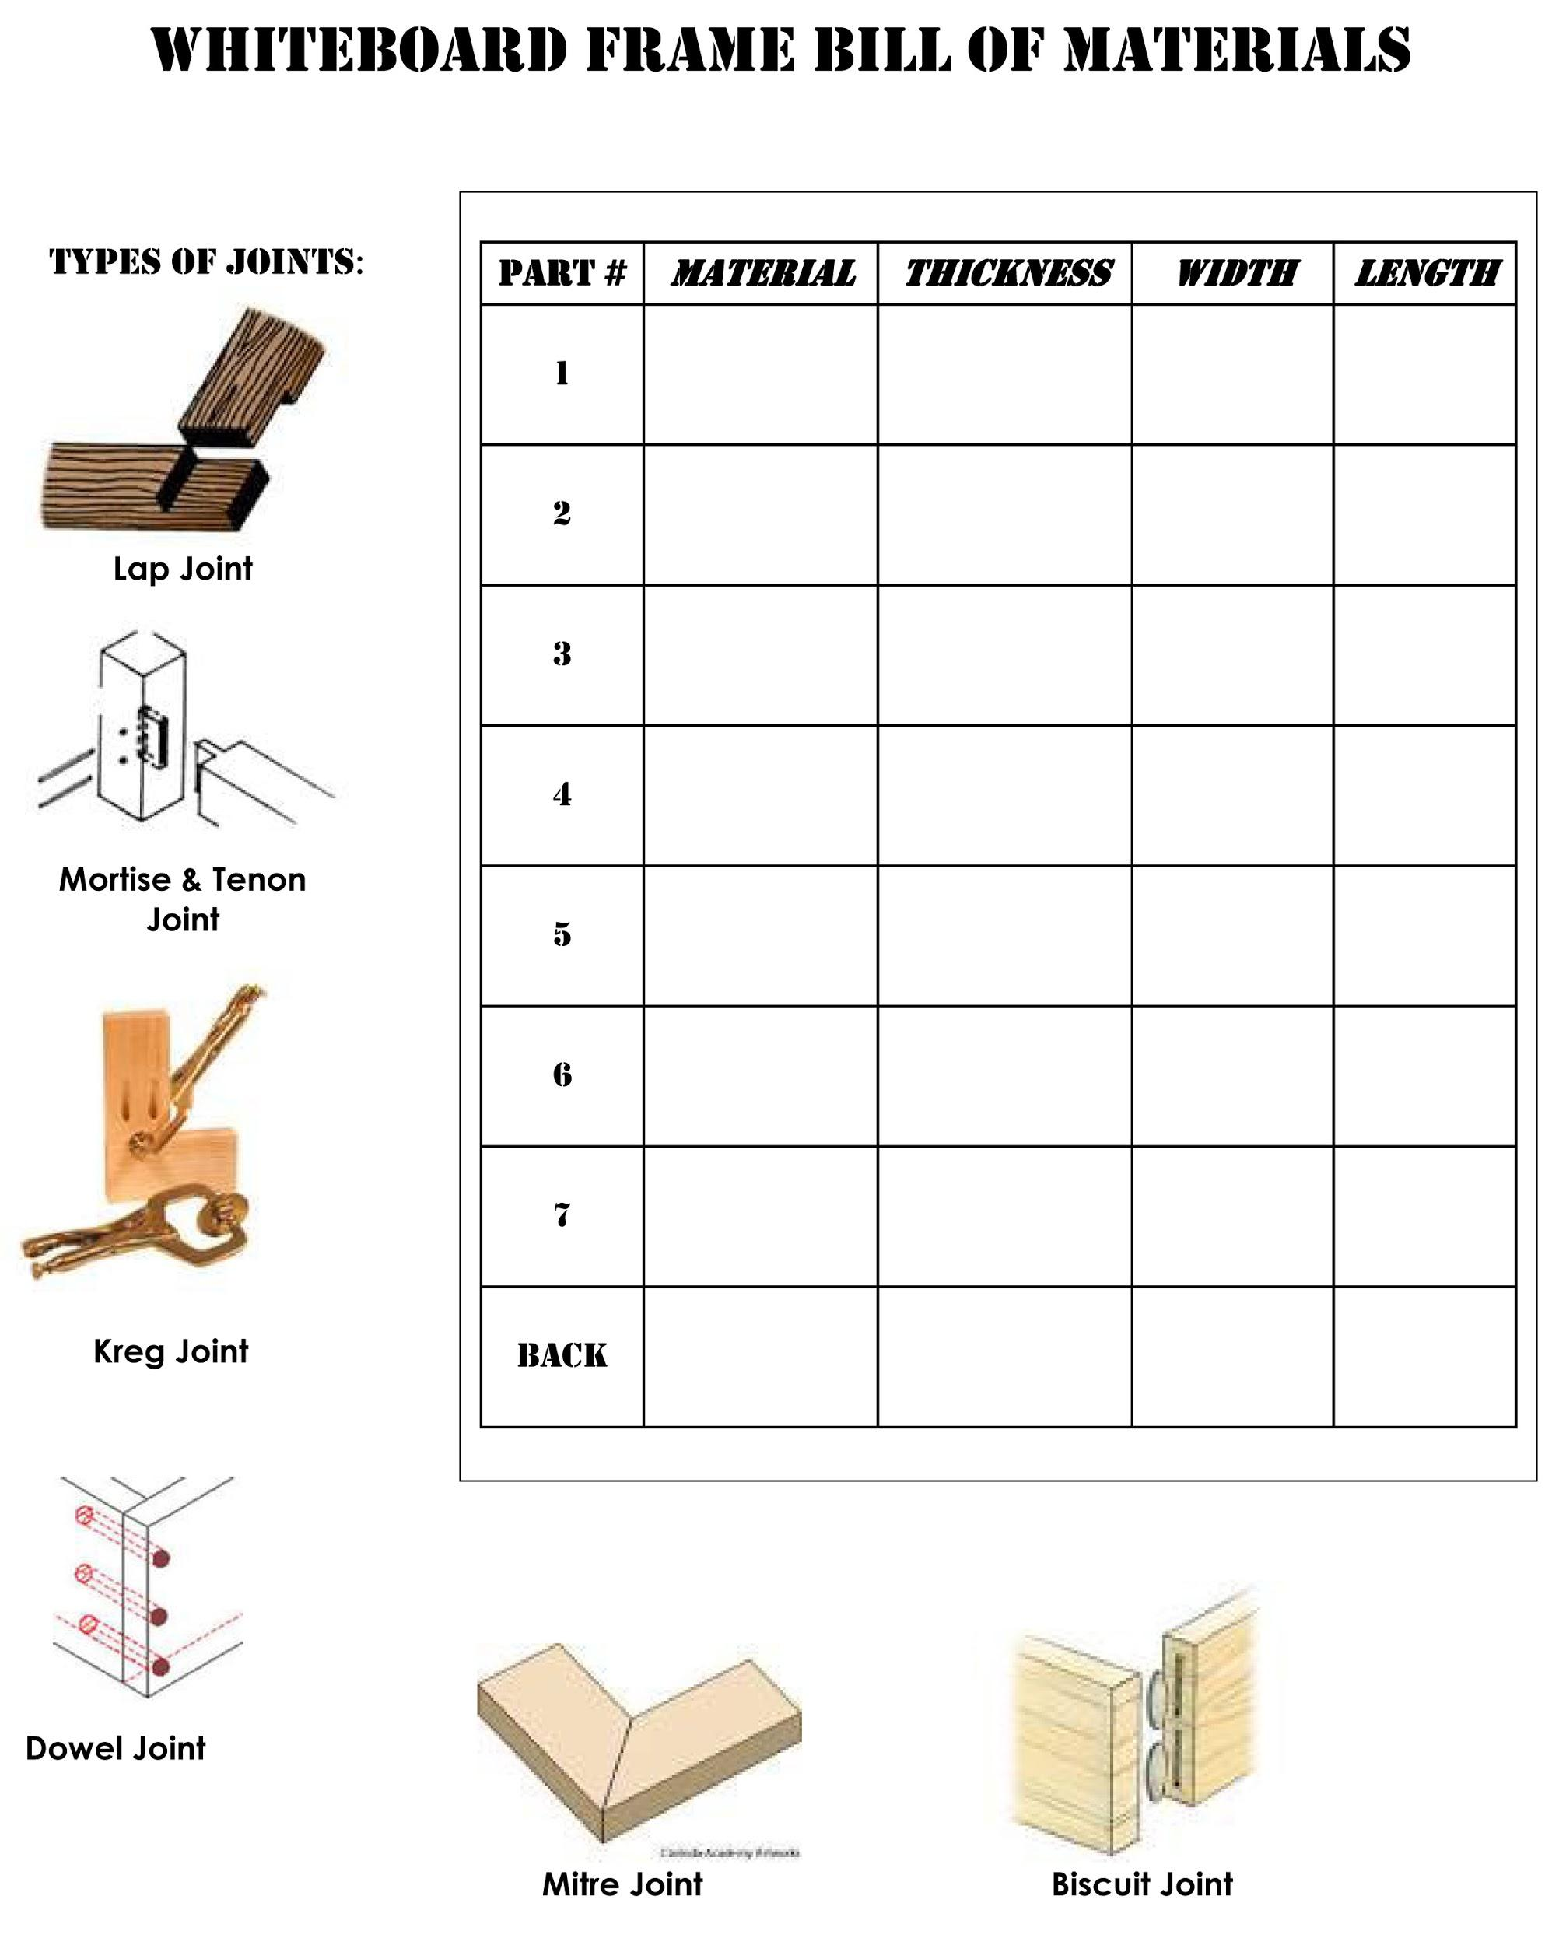
Appendix 4: Orthographic Drawing and Bill of Material checklist
Orthographic Drawing and Bill of Material Checklist
Assessment Criteria | Weak  (1mark) | Good  (2marks) | Excellent  (3 marks)
APPLICATION
My orthographic drawing is
complete?

I used the correct orthographic format and all of the drawings line up with each other?

My drawing is to proper scale?

All joints are labeled correctly?

Joints are easy to understand and correctly drawn?

My ‘Bill of Materials’ is complete

THINKING
All relevant dimensions are on the drawing?

All measurements are correct?

Total (sub-total 1+2+3) = ______  24 | Sub-total #1 | Sub-total #2 | Sub-total #3

Appendix 5: Orthographic Drawing Rubric

ORTHOGRAPHIC DRAWING RUBRIC

Student Name:_______________________________

Criteria | Incomplete  (below 50%) | LEVEL 1  (50-59%) | LEVEL 2  (60-69%) | LEVEL 3  (70-79%) | LEVEL 4  (80-100%)
Applications
Drawing Standards | most views not properly selected or properly located OR  lack of content to assess | several views not properly selected or properly located | some views not properly selected or properly located | most views properly selected and appropriately placed | all views properly selected and appropriately placed | 20
Drawing Standards | most object features not shown on all views  OR  lack of content to assess | many object features not shown on all views | some object features not shown on all views | a few object features not shown on all views | all features properly represented in each of the views | 20
Drawing Standards | most linetypes not properly shown  OR  lack of content to assess | many linetypes not properly shown | some linetypes not properly shown | most linetypes properly shown | all linetypes properly shown | 20
Dimensioning Standards | most dimensions not properly located  OR  lack of content to assess | many dimensions not properly located | some dimensions not properly located | a few dimensions not properly located | all dimensions properly located | 20
Dimensioning Standards | most dimensions not completely and accurately detailed  OR  lack of content to assess | many features not completely and accurately detailed | a few features not completely and accurately detailed | a few features not completely and accurately detailed | all features details (L x W x H/D) | 20
Dimensioning Standards | no evidence of appropriate use of construction lines to develop drawings  OR  lack of content to assess | little evidence of appropriate line weight/(contrast and representation | some evidence of appropriate line weight/(contrast and representation | obvious evidence of appropriate line weight/(contrast and representation | obvious and substantial evidence of appropriate line weight/(contrast and representation | 20
Communications
Drawing | little to no specified format requirements as per criteria  OR  lack of content to assess | some specified format requirements as per criteria | most specified format requirements as per criteria | All specified format requirements as per criteria | All specified format requirements as per criteria with added details and formatting are beyond expectations | 10
Drawing | most drawing formatting items missing or inaccurate  OR  lack of content to assess | many drawing formatting items missing or inaccurate | some drawing formatting items missing or inaccurate | a few drawing formatting items missing or inaccurate | appropriate title block, border and drawing balance | 10
TOTAL: |  |  |  |  |  | __  40

Appendix 6: SAFEdoc CONSTRUCTION

OCTE SAFEdoc

Safe Activity Foundations in Education Document

(SAFEdoc)

Construction/Custom Woodworking:
TCJ2O, TCJ3C/4C, TWJ3E/4E

SAFEdoc for Construction

Appendix 7: Whiteboard Frame Sample Drawing
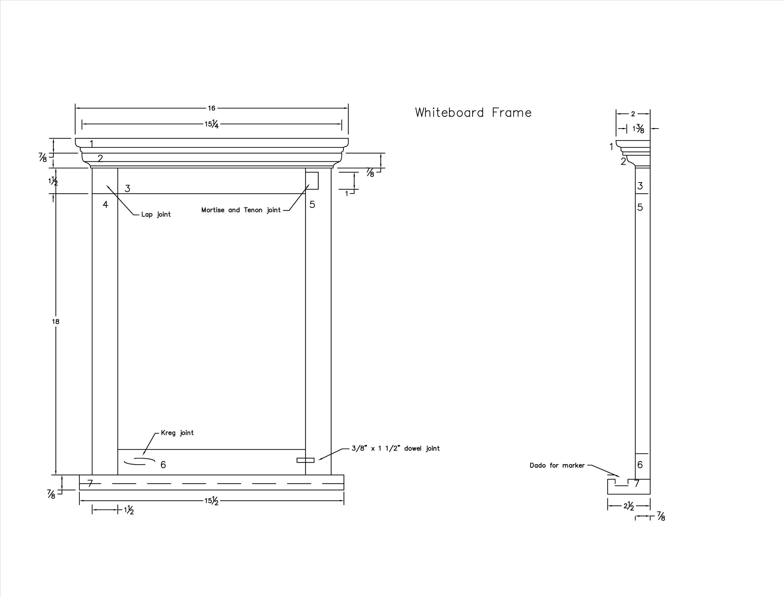

Appendix 8: WHITEBOARD FRAME EVALUATION RUBRIC

WHITEBOARD FRAME EVALUATION RUBRIC
Application
Assessment Criteria | Level 4 | Level 3 | Level 2 | Level 1 | Level 0
Size of Components Match Plan Dimensions | ALL components match plan perfectly. | MOST components match plan perfectly. | SOME components match plan perfectly. | FEW components match plan perfectly. | NO components match plan perfectly.
Square Cuts | ALL cuts are square with crisp, not rounded, corners. | MOST cuts are square with crisp, not rounded, corners. | SOME cuts are square with crisp, not rounded, corners. | FEW corners have tight matching fit and are crisp, not rounded. | NO corners have tight matching fit and are crisp, not rounded.
Special Joinery (Mortise and Tenon joint, Lap Joints, etc.) | ALL joints have tight matching fit with smooth surface transition. | MOST joints have tight matching fit with smooth surface transition. | SOME joints have tight matching fit with smooth surface transition. | FEW joints have tight matching fit with smooth surface transition. | NO joints have tight matching fit with smooth surface transition.
Glue Joints | ALL joints are neat, even, and smooth with no visible drips or runs. | MOST joints are neat, even, and smooth with no visible drips or runs. | SOME joints are neat, even, and smooth with no visible drips or runs. | FEW joints are neat, even, and smooth with no visible drips or runs. | NO joints are neat, even, and smooth with no visible drips or runs.
Sanded Surfaces | NO surfaces are rough, NO surfaces have rounded corners, and NO surfaces have sharp/ rough edges or holes. | NO surfaces are rough, NO surfaces have rounded corners, but there is 1 sharp/rough edge or hole. | NO surfaces are rough, but there is 1 rounded corner or 1-2 sharp edges, including holes | There is 1 rough surfaces and/or 2 rounded corners and/or 3 sharp edges, including holes. | There are 1 or more rough surfaces and/or 2 or more rounded corners and/or 3 or more sharp edges, including holes.
Putty/Wood Filler Use | Filler is neat, even, and smooth with NO visible halos. | Filler has FEW visible halos. | Filler has SOME visible halos. | Filler has MANY visible halos. | Filler is full of visible halos.

Appendix 9: Group Work Assessment Checklist

Group Work Assessment
Checklist

Assessment Criteria | Weak  (1mark) | Good  (2marks) | Excellent  (3 marks)
I am not late for class!

I am in class every day!

I work well with my partner and I listen to his/her suggestion.

I do not rely on my partner to do all the work for our group.

I do not goof around in class and I try to get a fair amount of work done.

I always take part in clean-up!

Total (sub-total 1+2+3) = ______  18 | Sub-total #1 | Sub-total #2 | Sub-total #3

