APPENDIX E
Green Industries - Imperial measurement worksheets

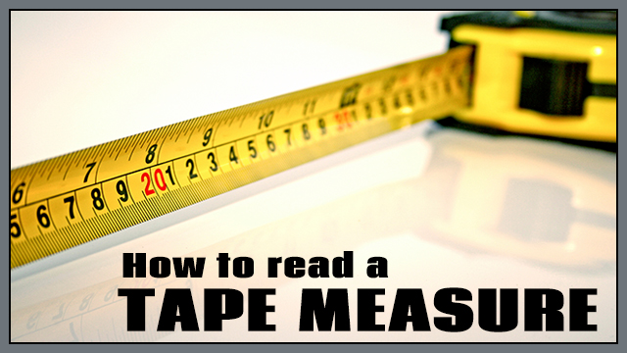

In most of the green industries sectors like Horticulture and Landscaping, we usually use imperial measurements. Today we will be doing measurements using a tape measure.

Tape measures are broken down into these increments.
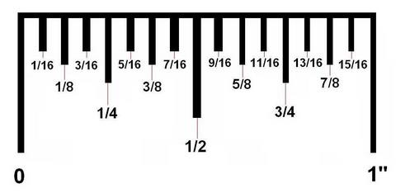

Watch the presentation and YouTube videos and complete the worksheets.
https://www.youtube.com/watch?v=4YF6Zz0krXA
https://www.youtube.com/watch?v=89NU3iefcAM

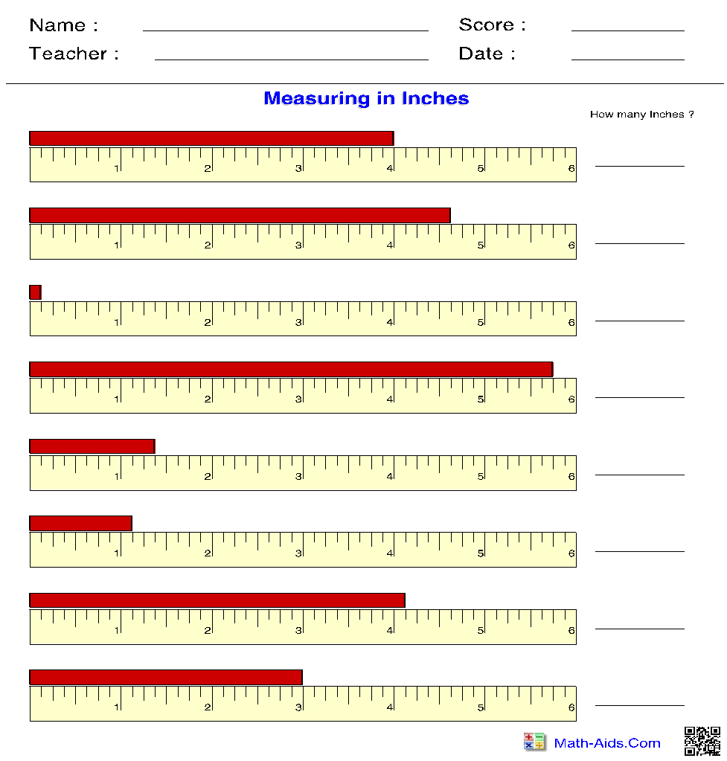

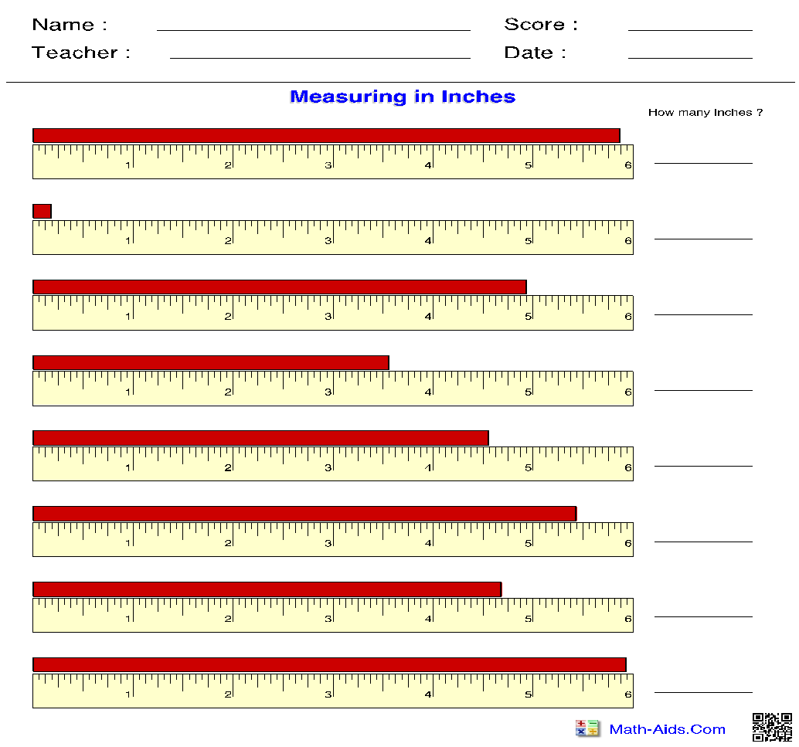

FEET & INCHES
Remember to use:
' = feet
" = inches

If you are 5 feet, 7 inches, your answer would be 5'7".
