Landscape ConstructionProject GRADE 9 Winter 2016
NAME:________________________

Procedure for Installing a Retaining Wall and Pavers
Starting from a compacted ¾ crushed stone base, we apply a 1 – 2 inch layer of HPB (High Performance Bedding).
Step 1. Safety glasses and gloves first. Using the hard rake, spread the limestone HPB as level as possible in the general area of the retaining wall.
Step 2. With the level check the back and front side of the retaining wall area. Make sure the bubble is in-between the lines for accuracy.
Step 3. Be very careful you do not step in the levelled area of the HPB.
Step 4. Gently place a levelling pipe along the back side and one on the front side area (pipes are parallel) of the retaining walls on top of the HPB.
Step 5. Once again use the level, gently placed on top of the pipes, to make sure they are level. Gently adjust the pipe into the HPB if levelling is needed. Once both pipes are ok, place the level from one pipe to the other in an X fashion and then check in opposite direction. Again adjust the pipes gently until they are level on both sides of the X.
Step 6. Place more HPB with the shovel between and sides of the pipes. Make sure it is at a higher level.
Step 7. With the screed board, place the narrow flat edge across one end of the two pipes and pull it towards you. This will level the extra HPB with the pipes.
Step 8. Gently remove the pipes from the HPB without disturbing your hard work.
Step 9. With the trowel, pick up some HPB and place it along the grooves the pipes left. With your hands gently cover the groove until it is flat with the rest of the HPB.
Step 10. Make sure, before lifting any stones, you know how to lift properly. Stand in front of the object and make sure your shoulders are parallel with the stone. Bend your knees, not your back, and grab the stone with both hands. Lift with your legs and turn your body with your feet (not your back)!
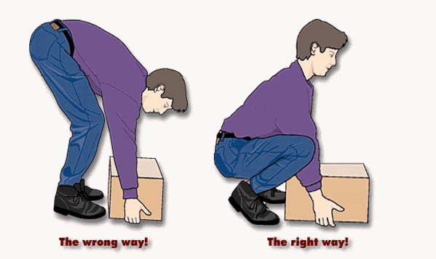
Step 11. Starting from one end that the retaining wall finish faces you, start to install each stone in a flat levelled manner (your hands should be on the sides of the stones not underneath, so you do not disturb your HPB by accidentally touching it) with the groove on the back side facing downward. Each stone should be touching each other as they are placed along the course. Make sure the vertical lines, between each course, do not end up on top of each other because this creates a weaker wall and does not look as nice. Look at all brick buildings to see this pattern. Once first course is completed, check if level, use rubber mallet to adjust.
Step 12. On the top of the completed courses, place the caps tightly beside each other, and make sure the back lip is tight against the back side of the retaining wall.
Step 13. Once the retaining wall has been completed it is time to prepare for the pavers. Repeat steps 1 to 9 and where it states retaining wall replace with pavers.
Step 14. Start to place the paver against one end of the retaining wall, following the shown pattern. Same as the wall, each paver is placed level-flat-touching each other along the complete retaining wall. Complete the proper amount of courses needed.
Step 15. To cut a paver, once you have measured the cut, use the square to mark the stone on all 4 sides.
Step 16. Place paver on unused screening area. With the chisel and mini sledge, line up chisel on the line and strike it with the mini sledge gently following all markings. Repeat with a bit more force until the paver splits along the line.
Step 17. The Guillotine is another method. Place the marked paver on the cutting edge of the jaw. Adjust the spindle until it is very close, but not touching, to the paver. Lower the handle until it contacts the brick, now pull the handle downward with some force until the paver s

After reading the procedure, use the word bank to complete the sentences:
- Make sure the ____________ bubble is located between the lines.

- Always _____________ your knees when picking up objects.

- Before starting put on your _____________ and _____________ _______________.

- Your hands should be on the ______________ of the pavers and not _______________ .

- Adjust the _______________ until it is close but not touching the __________________.

- Place more ________________ with the _________________ between the pipes.

- Use the _________________ to mark the ________________ on all 4 sides of the paver.

- Be careful _____________ to step in the _________________ screening.

- Use ________________ ________________ to adjust retaining wall course and pavers.

- The _______________ ________________ is used to spread and level the screening.

- You use the _______________ _____________ to spread the screening along the pipes.

- To split the paver you need the ______________ and the ____________ ___________.

- With the _____________ spread screening into the grooves left by the ____________.

- Get the screening from the ________________ _________________.

- Make sure the levelling pipes are ____________________ to each other.

- All ________________ and _________________ must be touching each other.

Word Bank: levelled, level, not, hard rake, back, sides, parallel, safety glasses, trowel, wheel barrel, HPB, rubber mallet, screed board, underneath, bend, gloves, chisel, pavers, spindle, mini sledge, pipes, paver, line, stones, square, shovel.

/31
Use the word bank, on the next page, to label the tools used:
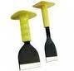
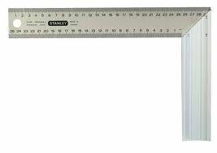

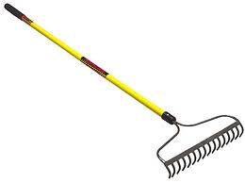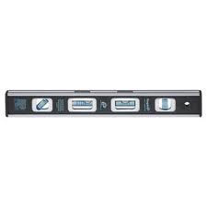

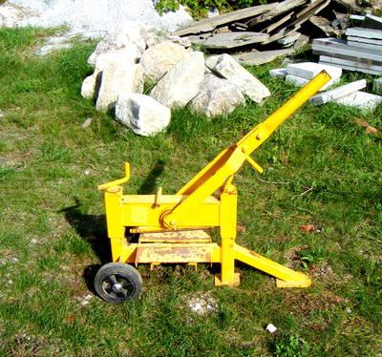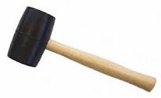

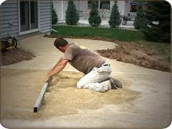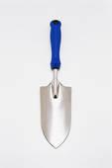

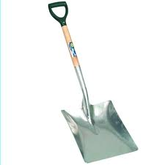

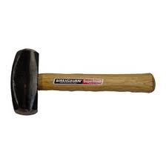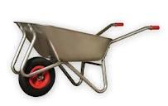

Word Bank: shovel, rubber mallet, level, safety glasses, screed board, guillotine, cornflakes, blue, hard rake, chisel, house, mini sledge, trowel, square, wheel barrel.
/12

