Employability Skills and Work Habits Assignment

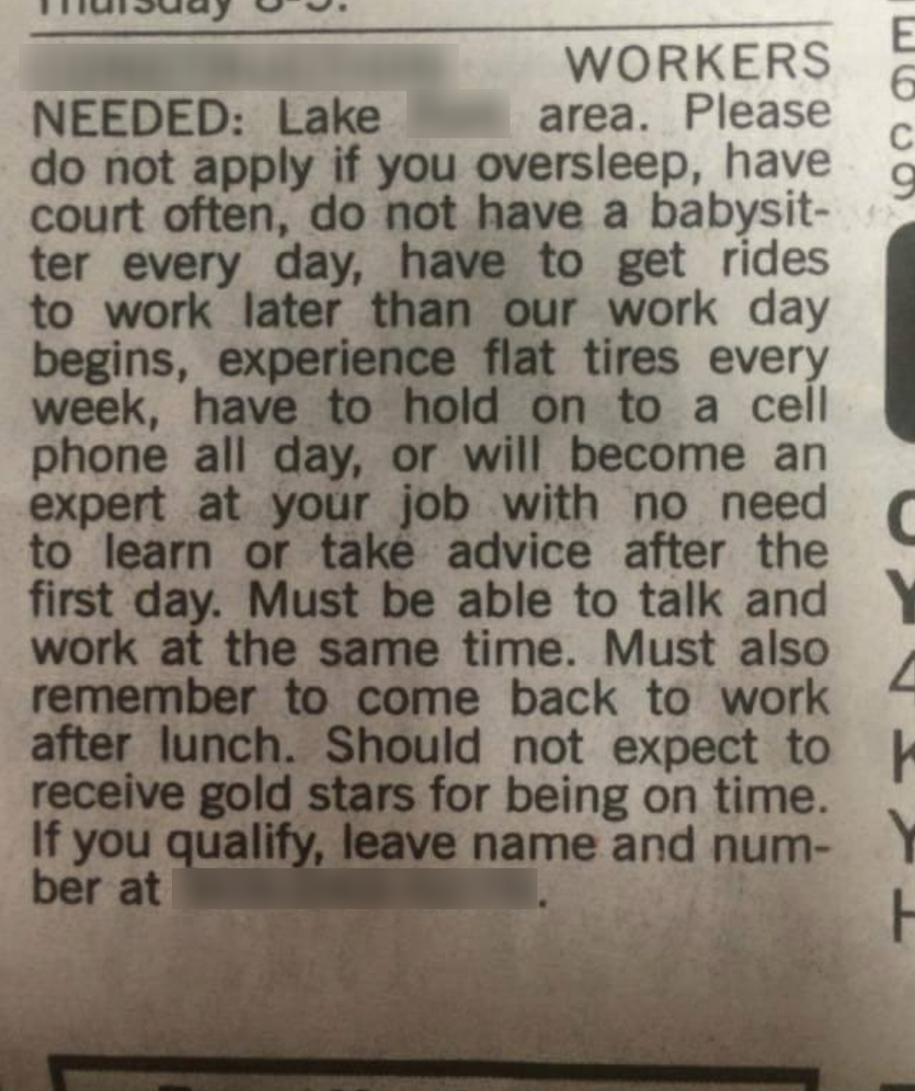

Please read the job ad above and this link to the Conference Board of Canada Employability Skills 2000+: http://www.conferenceboard.ca/topics/education/learning-tools/employability-skills.aspx
Though the tone is meant to be facetious or joking, there is seriousness to the qualities the employer is seeking in the the ad. Please answer the following questions. Please support your answers with information found in the Conference Board of Canada link.

- Why was the job ad written? (1 I/T)

- What employability skills and work habits is the employer seeking? Please list them in your own words. (10 K/U)

- Punctuality is important in the workplace because…: (1 K/U)

- Name five employability skills (other than punctuality) that you will be required to demonstrate while on placement or while working? (5 K)

- Which of these employability skills (name two) do you consider to be the most important and why? (2 K/U, 2 I/T)

- Is it safe for a health care worker to work and text or talk on the phone at the same time? Why? Where should your phone be kept while you are working? When is it acceptable to use your phone while at the workplace? (2 K/U, 1 I/T)

Knowledge/Understanding (K/U) ___/20 Inquiry/Thinking (I/T) ___/4

