Client Consultation Form
Name: ___________________________________________________________________________
Address: _________________________________________________________________________
City, Province and Postal Code: _____________________________________________________
Work Phone: _____________________________________________________________________
Cell Phone: ______________________________________________________________________
Email: ___________________________________________________________________________
Health History
Are you currently taking any prescribed medications? 􏰀 􏰀Yes 􏰀 No If yes, what medication(s)? ______________________________________________________________________________________
Are you currently taking any vitamins or hormones? 􏰀Yes 􏰀 No If yes, what vitamins or hormones? ______________________________________________________________________________________
Have you ever been treated by a doctor for hair loss or a scalp problem? 􏰀Yes 􏰀 No If yes, when were you last treated? ______________________________________________________________________________________
Hair History
Please select any of the following hair services you’ve received within the past year.
􏰀 Chemical Relaxing or Straightening Treatment 􏰀 Perm 􏰀 Texturizing Treatment 􏰀 Highlighting or Lowlighting 􏰀 Full Color
Do you presently have any breakage, thinning areas, or bald spots? 􏰀Yes 􏰀 No If yes, where? ____________________________________________________________________________
Do you suffer from a dry and/or itchy scalp? 􏰀Yes 􏰀 No
Have you ever had dandruff? 􏰀Yes 􏰀 No
Face Shape
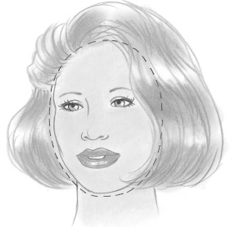 | 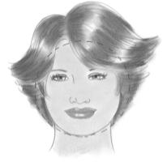 | 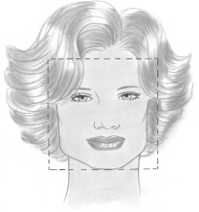 | 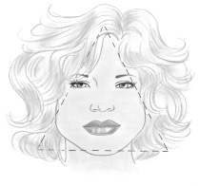 | 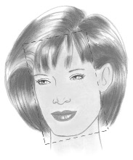 | 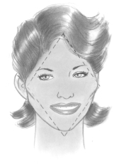 | 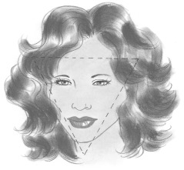
􏰀 Oval | 􏰀 Round | 􏰀 Square | 􏰀 Triangle | 􏰀 Oblong | 􏰀 Diamond | 􏰀 Inverted Triangle

Hair Analysis
What is the density of your hair?
􏰀 Thin 􏰀 Medium 􏰀 Thick
What is your natural texture?
􏰀 Fine 􏰀 Medium 􏰀 Coarse
What is your natural wave pattern?
􏰀 Straight 􏰀 Wavy 􏰀 Curly 􏰀 Kinky
Are there any unusual hairlines and/or growth patterns?
􏰀 Cowlicks 􏰀Whorls 􏰀 Other __________________________
Desired Look/Style Information
How long does your current style last?
􏰀 1-2 months 􏰀 3-4 months 􏰀 Other ____________________
How do you like to style your hair daily?
􏰀 Straight 􏰀 Curly 􏰀 Wavy 􏰀 Other ____________________
How much time do you want to spend on your hair each day? ___________________________________________________
Describe your desired look. What about the look is most appealing to you? _____________________________________________________________________________
How often do you shampoo and condition your hair?
􏰀 Daily 􏰀 Every other Day 􏰀 Twice per Week 􏰀 Once per Week
Please list any hair products you currently use on a regular basis. _____________________________________________________________________________
Are you satisfied with your current products? 􏰀Yes 􏰀 No If no, why not? _____________________________________________________________________________
What tools do you use at home to style your hair? Select all that apply.
􏰀 Blow-dryer 􏰀 Flat Iron 􏰀 Curling Iron/Wand 􏰀 Round Brush
Is there any additional information you would like to share about yourself or your hair? ____________________________________________________________________________________________________________________________________________________________________________
Recommendations ______________________________________________________________________________________________________________________________________________________________________________________________________________________________________________________________________________________________________________________________________________________________________________________________________________________________________________

