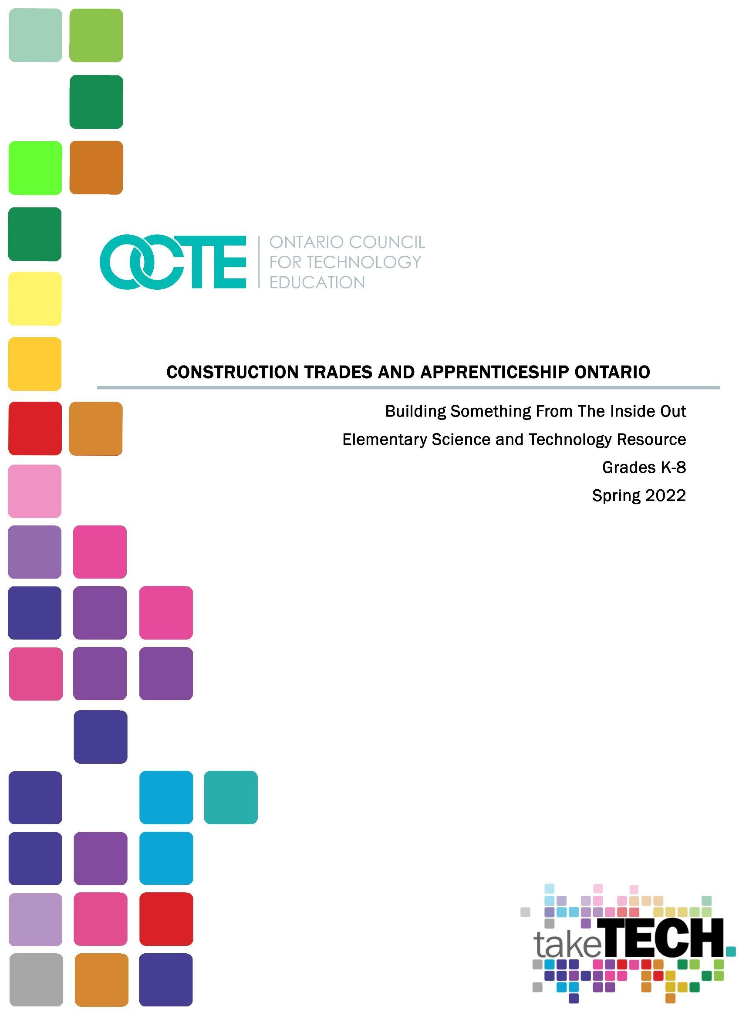

Table of Contents
Table of Contents 2
Introduction 2
Project Outline 2
Prior Knowledge 2
Student Activities 3
Activity 1 – Concrete Forms, Molds or Castings (or Building Something from the Inside Out) 3
Planning Notes 3
Skilled Trades and Apprenticeship Opportunities 4
Skills Continuum 4
Career and Industry Extensions 5
Resources 5
Lesson Plans 5
Materials 5
Tools/Equipment 5
Websites for Teachers 6
Instructional Strategies 6
The Hook / Motivational Strategies 6
Learning Goals and Success Criteria 7
Overall and Specific Expectations in Support of Ontario Curriculum Grade 7 Science & Technology 7
Overall Expectations 7
Specific Expectations 8
Safety Concerns (including PPE if required) 9
Applicable SAFEDocs and ToolSAFE videos 9
Project Challenges 9
Differentiation of the Project / Activity 9
Assessment and Evaluation 10
Assessment Of Learning 10
Ethical Considerations 11
Environmental Considerations 11
Reflection or Design Report 11

Appendix A - Concrete Forms, Molds and Castings - DIY Planters 12
Appendix B – Types of Structures 43
Appendix C – Building Something From The Inside Out Rubric 48
References 51

Introduction
Course Code: Grade 7 - Strand D Structures & Mechanisms Form, Function, and Design of Structures
Broad base Technology: Science & Technology
Grade Level: Grade 7
Project Name: Building Something From The Inside Out

Project Outline
Students will learn about the process of creating, designing and building structures and in particular their stability.

Prior Knowledge
It is important for students to have prior experience/exploration in science & technology terminology from Grade 6. There isn’t a direct link between this strand of the elementary curriculum to a previous one, however, the overall expectations and STEM learning do connect.
Prior Skill Sets: This Grade 7 exploration is based on the form and function strand of the Ontario Curriculum which is based on students’ prior knowledge in Science & Technology from previous grade levels in terms of scientific investigation skills, safety in the science classroom and making hypothesizes and inferences on phenomena around them. The concepts in this strand are fairly new to the students.
Prior Knowledge: Similar to the prior skill sets, students should have a foundation knowledge of how to use scientific vocabulary and investigation skills in order to explore the activities provided in this resource.

Student Activities

Activity 1 – Concrete Forms, Molds or Castings (or Building Something from the Inside Out)

Design & Create: planters, bottle holders, candle holders, bowl/dish, paper weight etc.
Grade 7 - D. Structures & Mechanisms
D2.1 Classify structures as solid structures, frame structures, or shell structures
Exploring / examining different types of structures in terms of clarifying them into one or more than one based on functionality and effectiveness
Build/explore creating different types of structures and coming to the conclusions of what they are used for.
Making molds out of some kind of casting material, wood, etc.
Building something from inside out

Planning Notes
This project resource has been developed to assess the impact of various technologies on the environment, the interactions of systems, networks and materials, provide reflective practices and perspectives on sustainability, ecosystems and approaches to agriculture. The project can also expand our evaluation practices on the impact of the ergonomic design of various tools, objects, and workspaces on a user’s health, safety, and ability to work efficiently, and use this information to describe changes that could be made in their own spaces and activities.
Students will explore structures as solid structures, frame structures, or shell structures. Students can learn to describe factors that can cause a structure to fail and identify instances of design that strengthen or provide symmetry in various structures. Furthermore, you are encouraged to evaluate environmental, social, and economic factors that should be considered when designing and building structures to meet specific needs for individuals and communities.
Teachers are invited to see Appendix A for a detailed lesson plan and step-by-step activities.

Skilled Trades and Apprenticeship Opportunities
Each task/lesson has a component to see how the overall concept is applied in the real world to be connected to skilled jobs, trades and apprenticeships.

Skills Continuum
We all have different moments in our lives where we are affected by an experience. This can include learning a new concept or skill, experiencing something for the first time, taking a new course, developing a talent through practice and hard work, or even calling upon a skilled tradesperson to fix, repair, design, construct, maintain, build, bake, and create innovative solutions. The continuum of influence is a graphic representation of how those experiences can lead to developing a passion and talents in areas of technology and skilled trades.
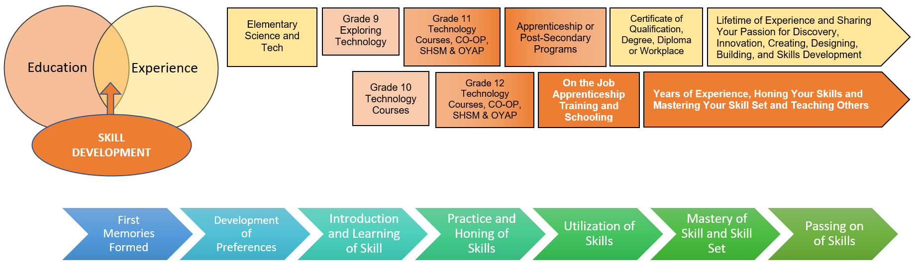
In this resource, teachers and students will be asked to explore concepts and foundations for any of the following, structures, stability, forces, designing, buildings, mass structure, frame structure, shell structure, base, lower/higher, centre of gravity, heavy/light, symmetrical/asymmetrical, Tower of Pisa, middle ages, campanile, structural failure, engineers, engineering, foundation, failure by torsion, bending, fatigue, safety, Tacoma Narrows bridge, internal & external forces and can extend to relief efforts, natural disasters, and helping others in emergent situations.
Key Concepts: The concept of stability and how it is important to consider this when designing and building structures for the safety of the individuals who will occupy it.

Career and Industry Extensions
Teacher to discuss careers and job opportunities with students, such as, bricklayer, carpenter, concrete finisher, concrete pump operator, crane operator, electrician, elevator mechanic, heat & frost insulator, heavy equipment operator, ironworker, labourer, painter & decorator, plumber, precast concrete erector, reinforcing rodworker, sprinkler & fire protection installer, steamfitter, architect/designer, mechanical and civil, engineer, etc.

Resources

Lesson Plans
Teachers are invited to see Appendix A for a detailed lesson plan and step-by-step activities.

Materials
There are no specific materials that are required for the implementation of this exploration beyond handouts and audio-visual equipment. However, it is highly recommended that there is either a small budget set aside or that the teacher gathers a number of ‘odds and ends’ type of materials that could be used by the students for their final project of creating a structure that could potentially withstand a natural disaster.

Tools/Equipment
The teacher may also want to have at their disposal metre sticks, rulers, glue, glue gun, markers, construction paper, cardboard, etc. Great places to gather these types of items are dollar stores, grocery stores, community donation facilities, etc. The teacher may also choose to engage the parents/community members of their school in order to inquire about these items.

Websites for Teachers
Construction Trades and Apprentice Ontario (website), 2021 https://ctaontario.com/#Explorethetrades
Creating a STEAM Classroom, STAO Resource https://stao.ca/creating-a-steam-classroom-stao-connex/
How to Survive a Natural Disaster, Michael Frankfort, Danny Ho and James Dark (STAO Resource), https://connex.stao.ca/classroom-catalyst/how-to-survive-a-natural-disaster-grade-7
Pinterest Wood Shelf site (website) https://pin.it/1cHD4U2
The Differentiated Instruction Scrapbook http://www.edugains.ca/resourcesDI/EducatorsPackages/DIEducatorsPackage2010/2010DIScrapbook.pdf
The Ontario Curriculum, Grades 1-8: Science and Technology, 2022 https://www.dcp.edu.gov.on.ca/en/curriculum/science-technology

Instructional Strategies
Teachers may use any of the following instructional strategies; 3-Part lesson, lecture, storyboard, word wall, think-pair-share, placemat activity, rapid write, K-W-L, anticipation chart, ABC taxonomy, think aloud, analyzing text, Cornell note taking, exit ticket/ticket out the door, plus/minus/delta, etc.
An inquiry-based approach will ask students to investigate concepts using research and analysis. It requires the use of higher order thinking skills, such as problem solving, to reach conclusions. Depending on your classroom and your approach to this project you may wish to use one or more instructional strategies to solidify the concepts of Science and Technology in this project.

The Hook / Motivational Strategies
Students and teachers have the ability to problem solve and create sustainable innovative structures. This activity can be directed as a class project , community-based initiative or engage student families in the learning.

Learning Goals and Success Criteria
By the end of the learning and final project creation students will obtain the following learning goals,
- Use a scientific research process,
- Use an engineering design process
- Assess the impact of coding and of emerging technologies on everyday life and in STEM-related fields
- Demonstrate an understanding of the practical applications of science and technology
- Analyse personal, social, economic, and environmental factors that should be considered when designing and building structures
- Demonstrate an understanding of the relationship between structural forms and the forces acting on them

Overall and Specific Expectations in Support of Ontario Curriculum Grade 7 Science & Technology

Overall Expectations

A. STEM Skills and Connections
A1. STEM Investigation and Communication Skills:
Use a scientific research process, a scientific experimentation process, and an engineering design process to conduct investigations, following appropriate health and safety procedures

A2. Coding and Emerging Technologies:
Use coding in investigations and to model concepts, and assess the impact of coding and of emerging technologies on everyday life and in STEM-related fields

A3. Applications, Connections, and Contributions:
Demonstrate an understanding of the practical applications of science and technology, and of contributions to science and technology from people with diverse lived experiences

D. Structures and Mechanisms - Form, Function, and Design of Structures
D1. Relating Science and Technology to Our Changing World:
Analyse personal, social, economic, and environmental factors that should be considered when designing and building structures

D2. Exploring and Understanding Concepts:
Demonstrate an understanding of the relationship between structural forms and the forces acting on them

Specific Expectations
Throughout Grade 7, in connection with the learning in the other strands, students will:
A1.1 Use a scientific research process and associated skills to conduct investigations
A1.2 Use a scientific experimentation process and associated skills to conduct investigations
A1.3 Use an engineering design process and associated skills to design, build, and test devices, models, structures, and/or systems
A1.4 Follow established health and safety procedures during science and technology investigations, including wearing appropriate protective equipment and clothing and safely using tools, instruments, and materials
A1.5 Communicate their findings, using science and technology vocabulary and formats that are appropriate for specific audiences and purposes
A2.1 Write and execute code in investigations and when modelling concepts, with a focus on planning and designing programs
A2.2 Identify and describe impacts of coding and of emerging technologies, such as artificial intelligence systems, on everyday life, including skilled trades
A3.1 Describe practical applications of science and technology concepts in various occupations, including skilled trades, and how these applications address real-world problems
A3.2 Investigate how science and technology can be used with other subject areas to address real-world problems
A3.3 Analyse contributions to science and technology from various communities
D1.1 Evaluate environmental, social, and economic factors that should be considered when designing and building structures to meet specific needs for individuals and communities
D1.2 Evaluate the impact of the ergonomic design of various tools, objects, and work-spaces on a user’s health, safety, and ability to work efficiently, and use this information to describe changes that could be made in their own spaces and activities
D2.1 Classify structures as solid structures, frame structures, or shell structures
D2.2 Describe ways in which the centre of gravity of a structure affects the structure’s stability
D2.3 Identify the magnitude, direction, point of application, and plane of application of the forces applied to a structure
D2.4 Describe the role of symmetry in structures, and identify instances of symmetry in various structures
D2.5 Describe factors that can cause a structure to fail
D2.6 Identify the factors that determine the suitability of materials for use in manufacturing a product or constructing a structure
D2.7 Describe methods engineers and other professionals use to assess, improve, and maintain the safety of structures

Safety Concerns (including PPE if required)
Safety: Since there are no specific materials recommended for this exploration, the basic safety rules that would apply to a science classroom/elementary school would apply as outlined by the school and school board. The teacher may also want to consider implementing basic safety as outlined in the STAO Science Safety In The Elementary Classroom resource and utilize any related SAFEdocs from OCTE.

Applicable SAFEDocs and ToolSAFE videos
Please refer to the OCTE SAFEDocs for BBT Technology for safety documents in order to properly address and instruct this project.

Project Challenges
The projects selected by the teacher(s) will have to be appropriate for the skill level of their students and within the scope allowed by their school board. Some school boards may restrict materials or have access to materials that are not readily available in other parts of the province. The design process and brainstorming solutions may be difficult for some students. Teachers will need to develop scaffolding exercises or skill development activities to enable student creativity and ability in carrying out this project.

Differentiation of the Project / Activity
Teachers can also refer to the Differentiation Scrapbook to take into account for learner ability, multiple intelligences, exceptional students, and ESL learners.

Assessment and Evaluation
As stated in Growing Success, to ensure that assessment, evaluation, and reporting are valid and reliable, and that they lead to the improvement of learning for all students, teachers use practices and procedures that:
- are fair, transparent, and equitable for all students;
- support all students, including those with special education needs, those who are learning the language of instruction (English or French), and those who are First Nation, Métis, or Inuit;
- are carefully planned to relate to the curriculum expectations and learning goals and, as much as possible, to the interests, learning styles and preferences, needs, and experiences of all students;
- are communicated clearly to students and parents at the beginning of the school year or course and at other appropriate points throughout the school year or course;
- are ongoing, varied in nature, and administered over a period of time to provide multiple opportunities for students to demonstrate the full range of their learning;
- provide ongoing descriptive feedback that is clear, specific, meaningful, and timely to support improved learning and achievement;
- develop students’ self-assessment skills to enable them to assess their own learning, set specific goals, and plan next steps for their learning.

Teachers are welcome to develop specific assessment tools for the various stages of development (particularly Activities 1 – 5), which would include assessment for learning, and assessment as learning, by using rubrics, self-assessments and peer assessments, quizzes, handouts, work sheets, placemat activities, think-pair-share, journals, exit cards, etc. The culminating activity and project (Activity 7) tests the student’s understanding, knowledge and application of their learning and skills.

Assessment Of Learning
Please note that assessment of learning is included in this resource and is based on the final project in lesson #6. It is written in Microsoft Word format so that the teacher can adapt/modify/accommodate the assessment based on their own instructional practices and/or the overall and specific expectations assigned to their students.

Ethical Considerations
Students should develop the decision making ability, often faced with situations and challenges, to make sound ethical decisions and problem solve. Determining the appropriate course to take when faced with a difficult dilemma can be a challenge. It is important to consider other points of view and perspectives that you may not have considered. Understanding principles of ethics including, autonomy, justice, beneficence, nonmaleficence, and fidelity, can help students make well-informed, intelligent decisions.

Environmental Considerations
Teachers and students should attempt to use recyclable products, re-use products that already exist, or consider the end product and how it can be recycled when completing the design challenge. Decisions on materials can be teacher supervised or the class can explore different materials and set their own parameters based on a variety of specifications, needs or availability.

Reflection or Design Report
Teachers may wish to have the students complete a design report, reflection or create a foldable to consolidate their learning. This would be a nice way to capture the student’s understanding in a summative format and be used in preparation for their examination, entering post-secondary education or the workforce.

Appendix A - Concrete Forms, Molds and Castings - DIY Planters
Subject | Science & Technology | Grade | 6, 7, 8
Big Idea | Exploration of Construction Skilled Trades through Construction Training and Apprenticeship Ontario.  Exploration of Different Types of Structures Using Planters As Molds
Expectations | A. STEM Skills and Connections (Grades 6, 7, 8)  A1. STEM Investigation and Communication Skills:  Use a scientific research process, a scientific experimentation process, and an engineering design process to conduct investigations, following appropriate health and safety procedures  Specific Expectations  A1.3 use an engineering design process and associated skills to design, build, and test devices, models, structures, and/or systems  A1.4 follow established health and safety procedures during science and technology investigations, including wearing appropriate protective equipment and clothing and safely using tools, instruments, and materials  ------------------------------------------------------------------------------------------------------  GRADE 6  B. Life Systems  Biodiversity  B1. Relating Science and Technology to Our Changing World:  Assess the importance of biodiversity, and describe ways of protecting biodiversity  B2. Exploring and Understanding Concepts:  Demonstrate an understanding of biodiversity, its contributions to the stability of natural systems, and its benefits to humans  Specific Expectations  B1.2 Analyse a local issue related to biodiversity while considering different perspectives; plan a course of action in response to the issue; and act on their plan  Specific Expectations  B2.2 Demonstrate an understanding of biodiversity as the diversity of life on Earth, including the diversity of organisms within species, among species in a community, and among communities and the habitats that support them  B2.5 Describe interrelationships within species, between species, and between species and their natural environment, and explain how these interrelationships sustain biodiversity  B2.8 Describe the importance of biodiversity in supporting agriculture, including Indigenous agriculture around the world  ------------------------------------------------------------------------------------------------------  GRADE 7  B. Life Systems  Interactions in the Environment  B1. Relating Science and Technology to Our Changing World:  Assess the impact of human activities and technologies on the environment, and analyse ways to mitigate negative impacts and contribute to environmental sustainability  B2. Exploring and Understanding Concepts:  Demonstrate an understanding of interactions between and among biotic and abiotic components in the environment  Specific Expectations  B1.1 Assess the impact of various technologies on the environment  B1.2 Assess the effectiveness of various ways of mitigating the negative and enhancing the positive impact of human activities on the environment  B1.3 Analyse how diverse First Nations, Métis, and Inuit practices and perspectives contribute to environmental sustainability  B2.1 Explain that an ecosystem is a network of interactions among living organisms and their environment  B2.2 Identify biotic and abiotic components in an ecosystem, and describe the interactions between them  B2.5 Describe how matter is cycled within the environment, and explain how the cycling of matter promotes sustainability  B2.8 Describe how different approaches to agriculture and to harvesting food from the natural environment can impact an ecosystem, and identify strategies that can be used to maintain and/or restore balance to ecosystems  D. Structures and Mechanisms  Form, Function, and Design of Structures  D1. Relating Science and Technology to Our Changing World:  Analyse personal, social, economic, and environmental factors that should be considered when designing and building structures  D2. Exploring and Understanding Concepts  Demonstrate an understanding of the relationship between structural forms and the forces acting on them  Specific Expectations  D1.1 Evaluate environmental, social, and economic factors that should be considered when designing and building structures to meet specific needs for individuals and communities  D1.2 Evaluate the impact of the ergonomic design of various tools, objects, and work spaces on a user’s health, safety, and ability to work efficiently, and use this information to describe changes that could be made in their own spaces and activities  D2.1 Classify structures as solid structures, frame structures, or shell structures  D2.4 Describe the role of symmetry in structures, and identify instances of symmetry in various structures  D2.5 Describe factors that can cause a structure to fail  D2.6 Identify the factors that determine the suitability of materials for use in manufacturing a product or constructing a structure  D2.7 Describe methods engineers and other professionals use to assess, improve, and maintain the safety of structures  ------------------------------------------------------------------------------------------------------  GRADE 8  D. Structures and Mechanisms  Systems in Action  D1. Relating Science and Technology to Our Changing World:  Assess the social and environmental impacts of various systems, and evaluate improvements to the systems or alternative ways of meeting the same needs  D2. Exploring and Understanding Concepts:  Demonstrate an understanding of different types of systems and the factors that contribute to their safe and efficient operation  Specific Expectations  D1.2 Assess the impact on individuals, society, and the environment of alternative ways of meeting needs that are currently met by existing systems, taking different points of view into consideration  D2.1 Identify various types of systems  D2.3 Identify the various processes and components of a system that allow it to perform its function efficiently and safely  D2.9 Describe technological innovations involving mechanical systems that have increased productivity in various industries  D2.10 Identify social factors that influence the evolution of a system  E. Earth and Space Systems  Water Systems  E1. Relating Science and Technology to Our Changing World:  Assess the impact of human activities and technologies on the sustainability of water resources  E2. Exploring and Understanding Concepts:  Demonstrate an understanding of the characteristics of Earth’s water systems and of factors that affect these systems  Specific Expectations  E1.1 Assess the social and environmental impact of the scarcity of fresh water, and propose a plan of action to help address fresh water sustainability issues  E1.2 Demonstrate an understanding of First Nations, Métis, and Inuit knowledges and values about water, connections to water, and ways of managing water resources sustainably  E1.3 Assess the impact of scientific discoveries and technological innovations on local and global water systems  E2.1 Identify the states of water on Earth’s surface, their distribution, relative amounts, and circulation, and the conditions under which they exist  E2.6 Describe various indicators of water quality, and explain the impact of human activity on those indicators  E2.7 Explain how municipalities process water and manage water usage
Time | 3-4 class periods (assuming a period is 40-60 minutes)

Outline | Have students initially explore careers in the trades by visiting the Construction Training & Apprenticeship Ontario (CTAO) website at the following link,  https://ctaontario.com/#Explorethetrades  The above links to ‘Explore The Trades’, which outlines some key elements about many trade career paths such as entrance requirements, apprenticeship program, key skills & attributes, and overall responsibilities. The suggestion here is for students to explore a number of these trades through this website in order to understand and learn about the different pathways that can be taken as they move through to secondary and post-secondary education.  Please have a look at the graphic organizer that you could use with your students. Suggestion is for the teacher to go through one or two examples with the class and then have the students work independently, in partners or small groups to research and explore other trades from this website. If there is a possibility that students can present some of these to the rest of the class and that the teacher will assign certain ones allows for some more discussion and this way all the trades from this website are discussed. You also have the ability to download a PDF trades card per trade that is explored, which also offers a great summary.  Graphic Organizer (Courtesy of Slidesmania)  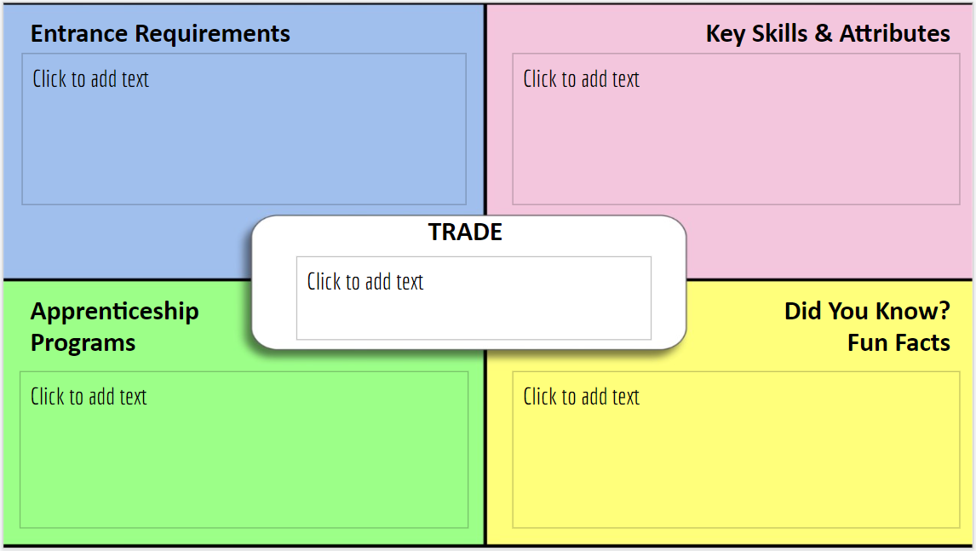  As an extension to this activity, the teacher could connect to a regional training coordinator or secondary school within the same school board/school district, as well as a local college that offers apprenticeships training and local trade unions. Making this connection is a great way to co-teach, develop activities, plan field trips, invite a guest speaker physically or virtually into the classroom to further discuss.  In regards to the CTAO website, teachers can set up an account and then use this with their students.  ------------------------------------------------------------------------------------------------------  The next section of this resource is an exploration where students will design and build a planter that can hold a small plant or seeds. Students will explore several Construction Skilled Trade options using the Construction Training and Apprenticeship Ontario resources, pick a trade available and choose a planter design that they feel best aligns with the trade they have selected. They will be provided with some possible design specifications that they can pull from. Students should be encouraged to work in pairs or small groups (teacher prerogative on groupings). The overall idea is that these designs will be mass, frame, or shell (or possible combinations of) structures (definitions below). Students will be required to provide a reflection as to the efficiency of their planter and decisions as to their design of choice and reflect on some of the reasons they have selected a specific trade within the Construction Training and Apprenticeship Ontario website. If possible, have some small plants/seeds available that students can use as they design and build. It is encouraged that students will add the small plants/seeds to their planters, fill with soil and water to fully observe its functionality.  It is recommended that the teacher does not provide the definitions to mass, frame, and shell until after the exploration is completed.  Mass - Formed by piling up of materials (layers); usually heavier; solid on the inside. (Examples bowling ball, brick, rock, sandcastle)  Frame - Visible skeleton structure or inside “frame” that supports the weight of the other parts; inside is mostly empty space; air can pass through. (Examples include human skeleton, table, ladder, scaffolding, as well direct students to the CTAO website where they can make direct connections to trades).  Shell - Usually hollow on the inside; to cover and protect the materials inside; sometimes a thin outer layer. (Examples egg, balloon, basketball, box)  Please use the worksheets associated with this exploration for possible planter designs. The teacher can provide these to the students so that they have a starting point. Students are also encouraged to research some on their own. Students should inform their teacher of their design prior to building it.  Please follow established safety procedures as per your school/school district and the information below from OCTE.  Planter Examples & Instructions  Cement Balloon Planters  Concrete Bowls  Funny Faces Painted Plants Jars  Lego Planters  Macramé Planters  Milk Carton Planters  Newspaper Planter  Starter Raised Bed  Resource:  Check out these websites for a way of using two ingredients to make molds, which could be applied to all of the examples above.  How To Cast Anything With This Two Ingredient Mold https://acraftymix.com/blog/two-ingredient-mold/  https://martha.net/2018/05/how-to-make-better-100-silicone-caulk-molds/  Worksheets:  Types of Structures  Types of Structures Classify
Apprenticeship & Skilled Trades | For additional information and resources about the Construction trades available to explore on Construction Training and Apprenticeship Ontario website, please visit the Ontario Council for Technology Education apprenticeship information website to prepare for and explore apprenticeship. As well, please check out Ontario Ministry of Education Prepare For Apprenticeship for further information.

Cement Balloon Planters
https://artsyprettyplants.com/cement-balloon-planter/
(Photos with permission from artsyprettyplants.com)

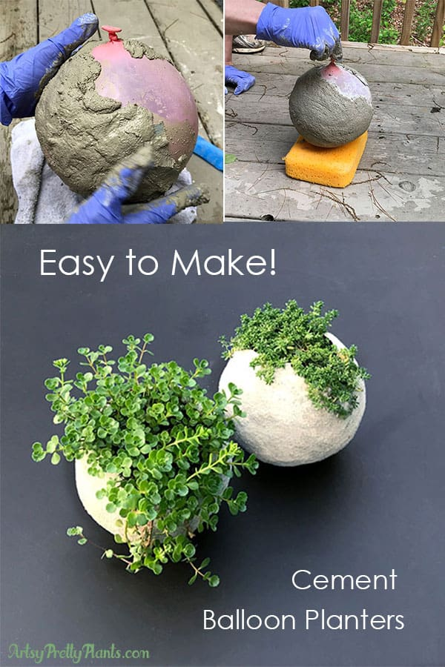

Materials:
- 7″ round balloons
- Cement All, Rapid Set
- * If you are in Australia, use this mortar mix. Check out Brenda’s comment at the bottom of the post (in the comments section), she used this mix and it turned out great. You should also check out her photos of the planters- amazing!
- Durable nitrile gloves
- Old wire mesh strainer with hooks
- Disposable plastic mixing bowl
- Plastic grocery bag
- Disposable measuring cup
- 3 Q-Tips
- Large sponge
- Succulent soil
- Succulent plants

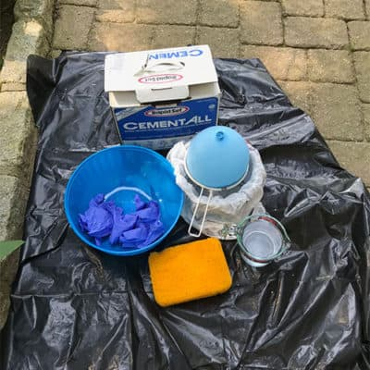

Step 1. Inflate The Balloon
Inflate your balloon but keep in mind, the finished piece will end up being larger than the balloon because of the thickness of the cement.
So make the balloon smaller than what you want your finished planter to be.
The round planter size I wanted was about 6″ and I have one of those 5″ round globe light bulb covers, the common ones you see at every big box store for probably 9 bucks.
So I used that for reference and blew the balloon up to be the same size as the globe. The finished planter ended up being the perfect size.

Step 2. Set Up The Balloon
(See pic in Step 4 for how this looks) If you are using a mesh strainer, then take a mixing bowl and cover it in a plastic grocery bag to protect it.
Otherwise, use your weighed down container. Have the cup of water next to you, along with a rag for cleaning up.

Step 3. Mix The Cement
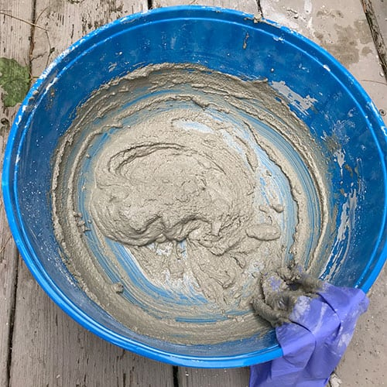
Read the instructions for mixing cement and the Safety Data Sheet for any safety concerns and lessons on safety precautions. Put on your PPE. In a well ventilated area, pour in about 1/2 a cup of water into the big disposable plastic bowl. Slowly add a little bit of cement, making sure to minimize the amount of dust and mix with your hands. Make sure you wear gloves!
Mix the cement slowly, adding more cement as you go. You will do this a few times until the cement is the consistency of cake frosting.

This doesn’t have to be an exact science, just play with it.
If it feels too thick when applying it to the balloon, take the cement off, put it back in the bowl and add a tiny bit of water. If it’s too thin, add cement.

Step 4. Mold The Balloon With Cement
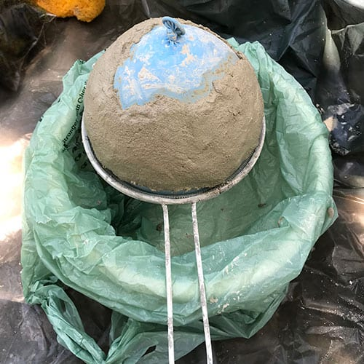
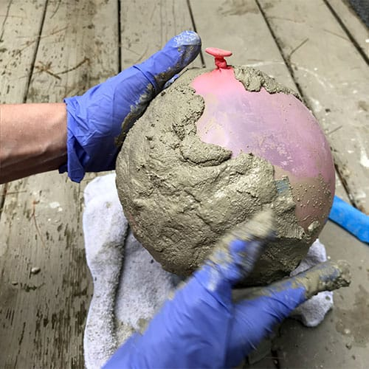
Start with the tied end of the balloon facing upward. Scoop the cement onto the top balloon, but leave the tied area free of cement, this is where you will leave the opening for the plant.

Leave it large enough to get your hand inside for ease of planting. If you get it too close together just push it apart.
Start molding it and work your way around, shaping and smoothing as you go.
You can keep wetting the cement or your hands as you are sculpting, and also add cement to any areas that may need to be built up.
Be careful not to let the cement touch the edge of the container or strainer.
Doing so will cause a bump and even more importantly, if the cement pushes against the strainer, it can cause it to crack.
So keep the cement free and clear of everything except the balloon.
The second side will be easier, so don’t worry about trying to get the first side fully covered, a third will be good.
The cement will cure within an hour or two. Be sure to keep this out of the sun while it’s curing because the balloon may expand and pop.
Keep it somewhere where the temperature won’t vary widely over this hour or two period.

Step 5. Mold The Other Balloon End And Create Drainage Holes
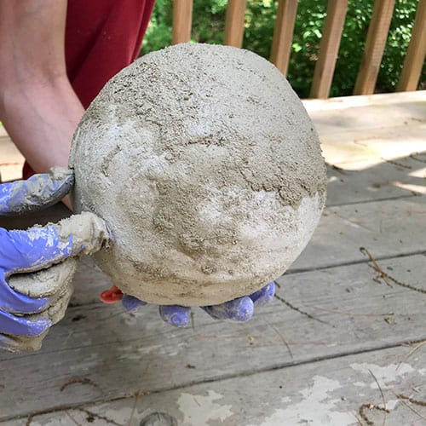
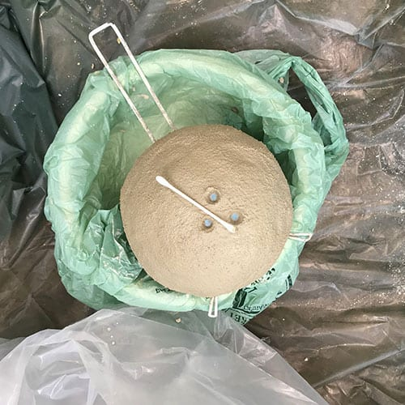
Once the first side has cured, you can flip it over and rest it on the sponge to work on the other side. The sponge will alleviate pressure while you are working on it.
Continue adding cement around the 2nd half of the balloon. Pay special care to the edges where the two ends meet in the middle and smooth as best you can to give it continuity.
After you are done, carefully use a Q-tip to press a few small holes for drainage, just sort of spin the tip to create the space. You may need to wet the Q-tip to get the holes free of cement.

Step 6. Pop The Balloon
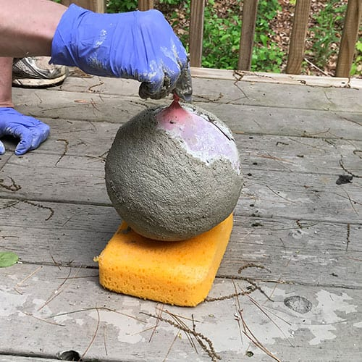
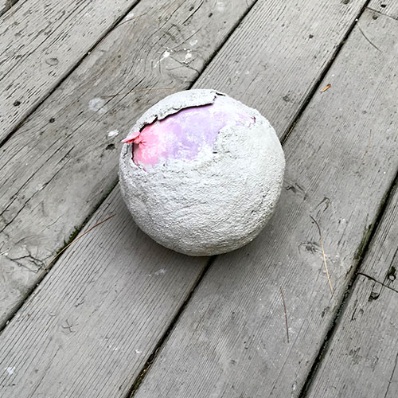
Let the cement dry, you can just let it rest on the sponge, or in the strainer.
It should take about 1-2 hours depending on climate conditions, then you can pop your balloon.
If you wait too long to pop it, the balloon may be more difficult to pull out and could stick to the cement.
To pop it, just use scissors and snip the spot where it’s tied, then pull the balloon out of the cement planter.

Step 7. Reinforce The DIY Cement Planter
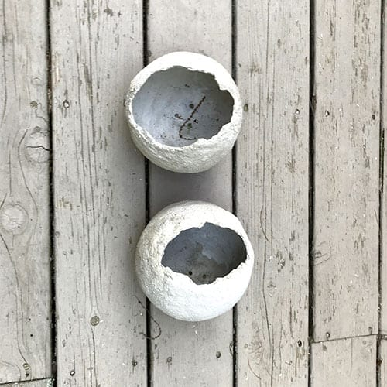
You should reinforce the balloon by adding more cement inside.
Mix up some more cement and pour it into the sphere, make sure to keep your drainage holes clear, use the Q-tips again if you need to.
I made mine about 1/4-1/2″ thick on the bottom, then built up the sides just a bit.
Your planter may be durable enough without this step, but better safe than sorry.

Step 8. Plant Your New Cement Balloon Planter
Add soil and then your plants! What types of plants will you use? Succulents?
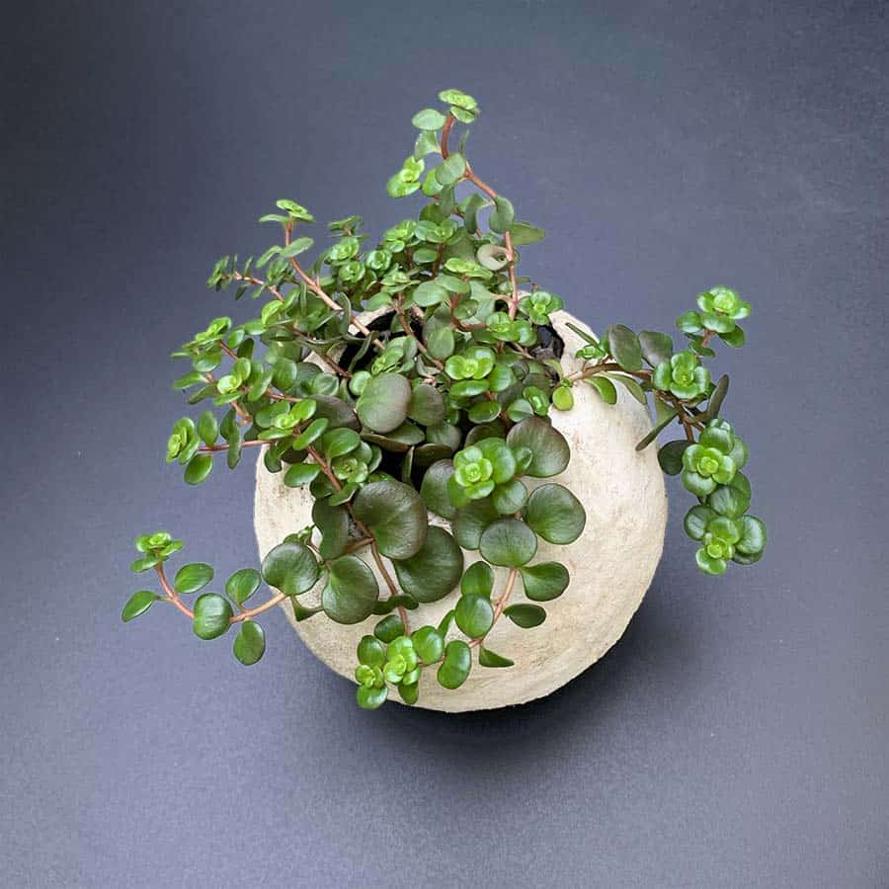

Concrete Bowls
https://www.madebybarb.com/2016/06/26/easy-poured-concrete-bowls/
(Photos with permission from madebybarb.com)

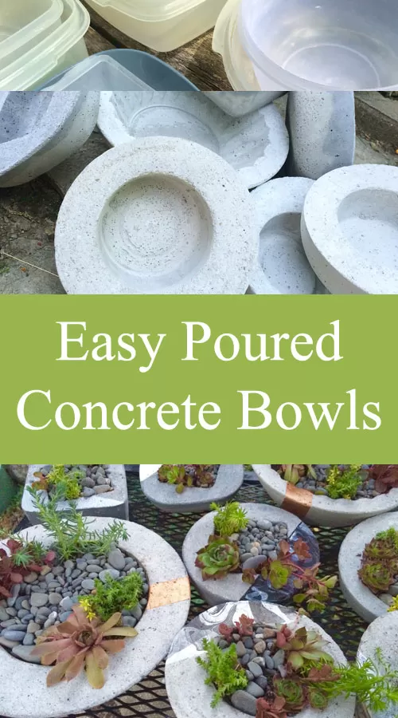

Materials:
- Quikrete Sand Topping Mix Concrete
- OPTIONAL Polypropylene Concrete Fibers
- Water
- Mixing Container & Utensil (shovel, spoon etc.)
- Rubber gloves and Dust mask
- Variety of containers that fit inside each other comfortably.
- Some stones or like for weight
- Some release agent like ‘Pam’ cooking spray or other grease.

Step 1:
Get set up so you have everything handy. Read the instructions for mixing cement and the Safety Data Sheet for any safety concerns and lessons on safety precautions. Put on your PPE. In a well-ventilated area, mix up your concrete by first slowly adding the ‘Quikrete’ to the bucket. Add water very slowly and mix. Stir to the bottom and corners. I like to do smaller batches, as I find them easier to mix. I tend to keep the mix at a somewhat drier mix. It should just hold in clumps, not run like pudding. I then add a small amount of the fibers (optional) and mix again. The fibers are meant to reinforce the structure of the concrete since there is no metal etc. inside the concrete. I would suggest larger bowls need more reinforcement. Mine were on the smaller side so they could have done without the fibers.
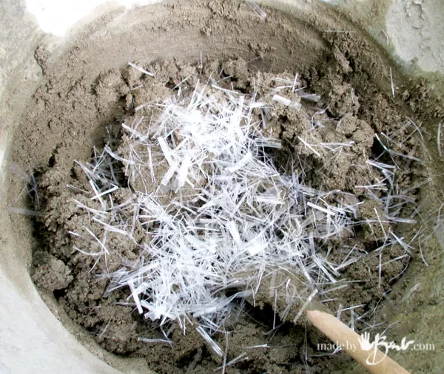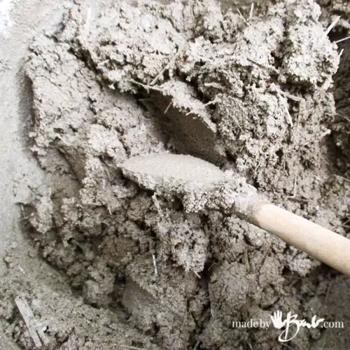
Mix again, to distribute the fibers evenly. The mix should not be leaching water.
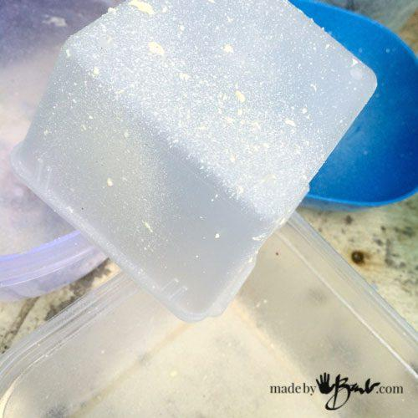

Step 2:
Readying the containers. Make sure that the bowls and shapes are going to allow you to pull out the bowl. That means that the bowl needs to be wider at top than bottom and have nothing that obstructs it. Straight vertical edges do work but take more effort to pull out. It is also very advisable to have something that can flex a bit, but not too soft or it will bow out with the weight of the concrete. Dollar stores have a great variety as well. Spray the inside of the larger containers and the outside of the smaller ones. You don’t need much.
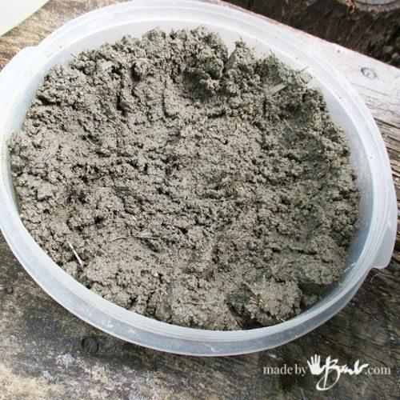

Step #3:
Plop some mix into the bigger of the containers and spread it around. You can use a gloved hand and push it against the walls. The trick to having concrete without bubbles is vibration. I have observed many ‘concrete guys’ working on driveways etc. There is a large vibrating stick that they use to get bubbles out. I just use my hand and slap the heck out the mix, and also slap (like trying to extremely burp a baby) the container. You can tap it on the ground as well. All these are doing the same thing, making air rise to the surface.
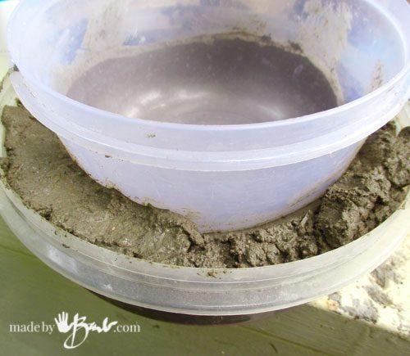

Step 4:
Push the smaller vessel into the middle of the larger one. I sometimes like to add a bit of design by turning it askew, or even sloped. Let your imagination go wild. Again, I wriggle it to get any trapped air out and fill the voids with mix. The more you wriggle, the concrete levels itself. I used to try a wetter mix, but then too much water rose to the surface, which is what concrete does, so I started working a bit drier.
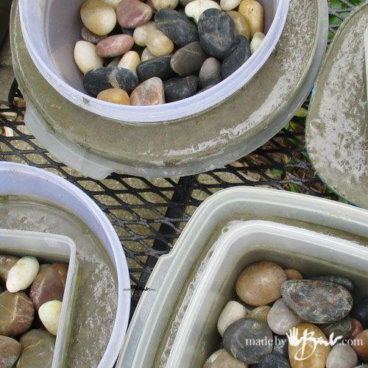
See here, they are all nestled, and I have added the rocks to weigh down the centers.
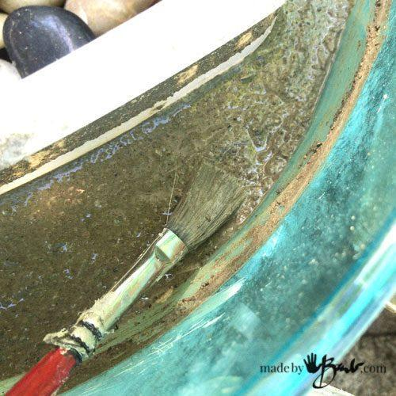

‘Concrete finishers work the surface after it has set for a bit. They trowel and brush it to work out the water and disperse it. I used a small brush to do the same.
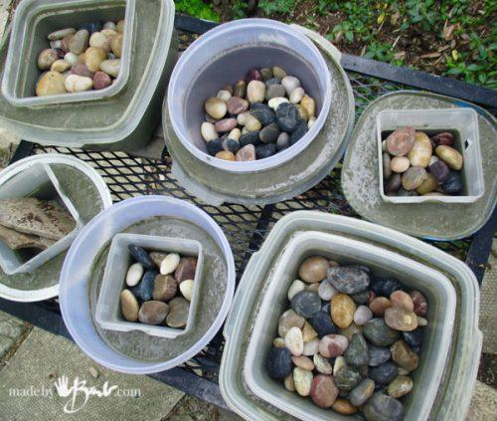

Step 5:
Leave it somewhere out of the direct sun if possible. Now wait… It takes some time to set properly, about 24 hours.

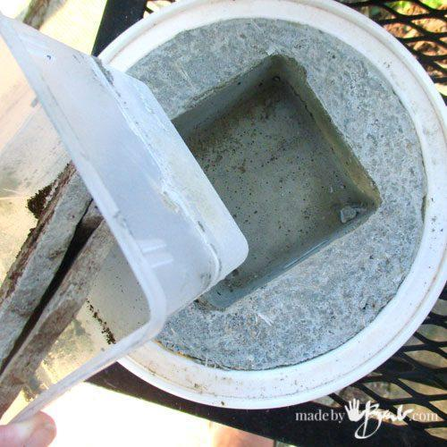

Step 6:
Once it’s set and no longer wet on the surface, gently pull out the centers. Then invert over your hand and let the bowls fall into your hand. If stubborn, slightly flex the form.

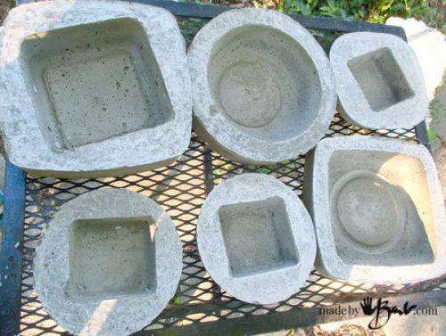

Step 7:
Optional. You may be happy and leave them this way, or further perfect them. These showed uneven surface colour since I had not discovered the brushing technique at that point.

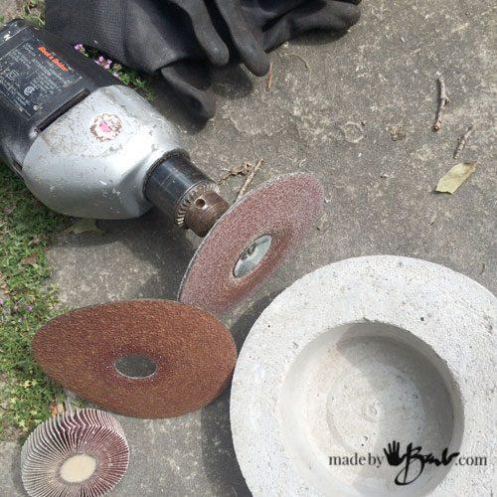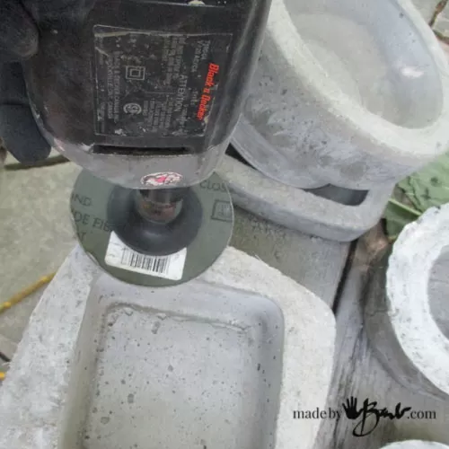

Step 8:
Being a gal with her own power tools, I save my elbow grease and use power. Caution though! Wear your PPE - safety glasses, N95 mask, and shop coat. Use a good mask or even a respirator, as concrete dust is nasty, nasty stuff! It is a good idea to do any sanding in a well-ventilated area. I use aluminum oxide discs on a drill sanding rig. I’m not over obsessed with the sanding, just evening out the surface colour.
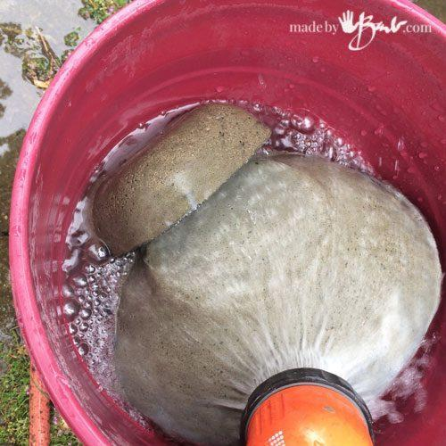

Step 9:
Concrete leaches out chemicals that are not that friendly with plants. Also concrete loves to cure slowly and be wet to gain strength. I pile the bowls in a big bucket for a few days and change the water daily. The first day, the water is quite ‘soapy’. Once drained and dry, they will be a nice light gray colour.

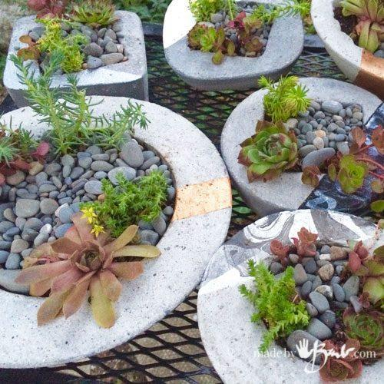

Funny Faces Painted Plant Jars
https://www.hellowonderful.co/post/kid-made-funny-faces-painted-plant-jars/

Materials:
- White spray paint or regular white paint.
- Glass jars
- Paint markers
- Soil
- Small plants (succulents are used here)

- In a well-ventilated area, spray paint your jars white. This may take a couple of coats to get them white.

- Sketch out funny faces on a notepad/scrap paper/recycled paper before deciding on a few designs.

- Use paint markers to draw on the funny faces, allow to dry completely.

- Once the jars are dried, the planting can begin. It helps to add soil to a bowl and use a scoop/spoon to add the soil into the jars.

- Once the plants are potted, add some fresh water and enjoy the funny face pots.

LEGO Planters
https://www.hellowonderful.co/post/mini-diy-lego-planters-fun-planting-project-for-kids/

Materials:
- LEGO blocks
- Soil
- Mini succulents or cactus plants (these are the ones used here)

- Decide what size you need for your planters depending on the size of your plants. It helped us to place the plant on top of our blocks as we were building them.

- Once you’ve figured out your planter shapes, remove the plants from their plastic pots and add them inside your LEGO planters. Add soil if necessary to pack in the empty spaces.
- You can also try to build with LEGO bases which are more rectangular in size. It is like putting a puzzle together and a great exercise in building and engineering.

Macramé Planters
https://www.hellowonderful.co/post/make-easy-kid-friendly-macrame-planters/

Materials:
- Yarn
- Ceramic bowls (these photos are based on 4 inches in diameter ones)
- Small succulents (or other types of plants)
- Soil
- White hooks (these use 3M ones for hanging)

- Gather your materials. You’ll want to transfer the succulents to your containers and add additional soil if needed.
- For each planter, cut eight strips of yarn around 4 feet long each. Gather them up at the top and tie a knot.
- Separate the 8 strands into 4 sections and tie a knot about an inch from the top knot.
- You’ll now have 4 knots. Then repeat this step by taking the left strand from one knot and tying a new knot with the right strand.
After this step we stopped because we felt the knots were strong enough to hold our bowl, but you can continue on to do this one more time depending on how large your planter is.
- Place your bowl with succulent in the center (the knot you made gathering the 8 strands in step 2 is now on the bottom of the planter).
Gather the strands and tie them all into one knot to hold in place. Now you can hang them up on a hook and you’re done!

Milk Carton Planters
https://pysselbolaget.se/2014/02/11/krukor-av-mjolkkartong-milk-carton-planters/
(Photos with permission from pysselbolaget.se)
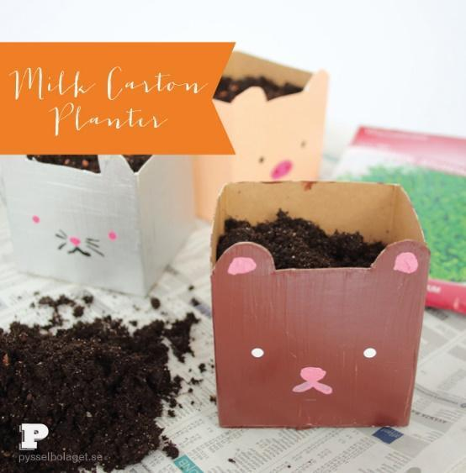
Materials:
- Empty and cleaned milk or juice containers/cartons (of different sizes)
- Soil
- Scissors
- Paint/hobby paint
- Paint brush(es)
- Small plants (succulents are used here)

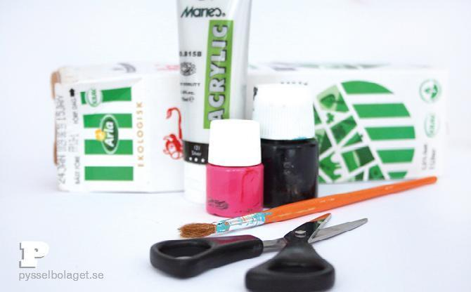

- Start by cutting the box to the desired size. Our pot is 7 cm high and has ‘ears’. Then paint the outside with hobby paint.

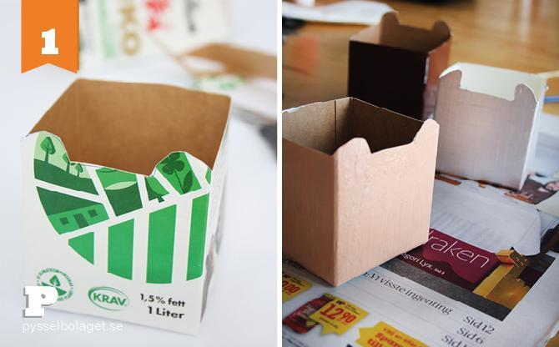

- When the paint has dried, the pots also get eyes and a snout.

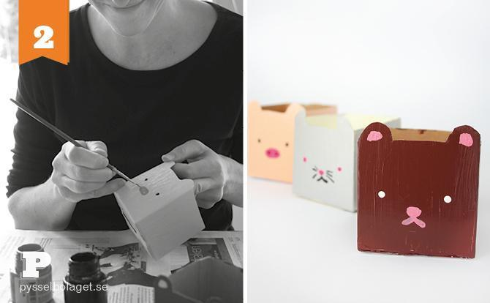

- Since they previously contained liquid, they are also tight for planting and we can enjoy sheer green shoots already now.

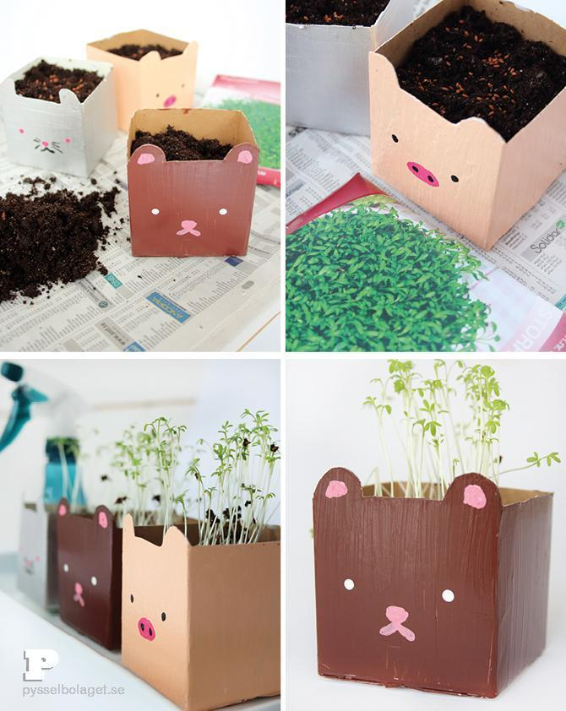

Newspaper Planter
https://carrotsareorange.com/newspaper-planter/

Materials:
- Newspaper
- 12-ounce water bottle
- Tape
- Soil and a small container to put the soil
- Small shovel
- Seeds

Newspaper Planter Approach:
- Lay the newspaper down on the ground or table
- Fold & wrap it around about 2/3 of the bottle
- Tape & slide the bottle out
- Fill the newspaper pot with soil
- Make a small hole with the tip of your finger & plant a seed in the pot
- Find a nice sunny spot in your yard with your child
- Dig a little hole with hands or a small shovel
- Poke a hole or two in or remove the bottom of the pot
- Place the Newspaper Pot in the hole and cover with soil
- Wait for your seeds to sprout

Starter Raised Bed
https://www.finegardening.com/article/diy-starter-raised-bed-for-kids
(Photos with permission from www.finegardening.com)

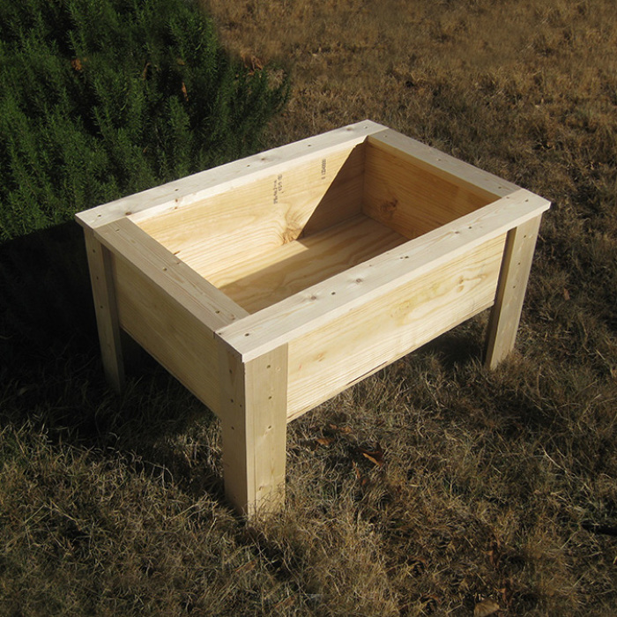

Materials:
- One 10-foot 2×10 board
- 2. One 8-foot 1×3 board
- 3. Four 8-foot 1×4 boards
- 4. One 24×36 piece of 1-inch plywood
- 5. 1½-inch wood deck screws (you’ll need at least 40 to 50; buying them by the box is cheaper)
- 6. 3-inch wood deck screws (you’ll need at least 15 to 20)
- 7. Drill-driver and drill bits (bit size to match screws)
- 8. Saw (circular saw recommended)
- 9. Tape measure
- 10. Square
- 11. Pencil or permanent marker
- 12. Sandpaper and/or sanding block
- 13. Paint or stain (optional)

This project will give them a 2-foot by 3-foot raised bed that’s just the right height for them to work easily and efficiently. While it’s not a large bed by adult standards, it’s large (and deep) enough to plant a sampling of most veggies. Plus, it’s movable.
The things you’ll need
1.Skill level
Easy to intermediate, depending on your woodworking/carpentry skills.
Construction
1. For this project I wanted to go with a bed that was approximately 2 feet by 3 feet. That way I could use a standard-size piece of plywood for the base, or floor, of the bed. I ended up cutting the board’s length to 32 inches.
2. With the base width and length determined, I then cut the 2×10 into two 32-inch side pieces (length) and two side pieces (width) that were about 22½ inches.
3. Drill pilot holes and then start the 3-inch screws on each end of the two length pieces (photo A). Screw the four sides together to form the outside frame (photo B).
4. Attach the frame to the plywood base using the 1½-inch screws (photo C).
5. From the 1x4s, cut eight equal pieces. (Your child’s height will determine how tall the raised bed should be. I went with a height of 20 inches.) These are the legs.
6. Using the 1½-inch screws, attach the leg pieces to the bed frame, aligning the top edge of the leg pieces with the top edge of the frame (photos D and E). The two pieces at each corner meet to form a stable raised bed frame (photo F).
7. Using the 1×3, cut two length side pieces, and two width side pieces. They will be about 32 inches and 22½ inches, respectively, but measure the exact length and width of the bed to confirm.
8. Screw these pieces to the top edge of the frame (Photo G).
9. Using the 1×4, cut two length side pieces and two width side pieces. Here’s the tricky part: Center the 4-inch-wide boards over the 3-inch-wide boards (photo H). This creates a “ledge” around the bed that overlaps the inside sides of the frame.
10. You’re basically done at this point (photo I) but sand any edges and rough areas of the wood with your sandpaper or sanding block.
Note: I did not drill any holes in the bottom board to allow for drainage, pipes, etc. This would need to be done prior to putting in the soil or growing medium. Another option would be to attach a pipe to collect the excess water and direct it away from your deck, patio, etc.
If you desire, you can apply a stain or paint finish of your choice, or simply leave it as is.
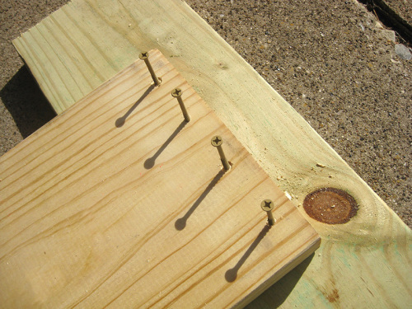

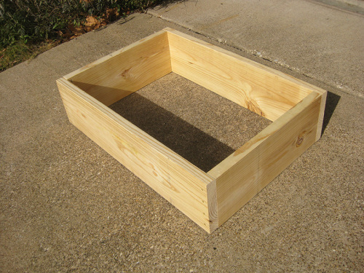

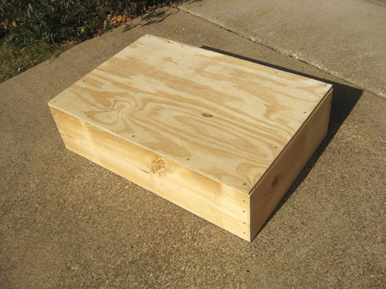

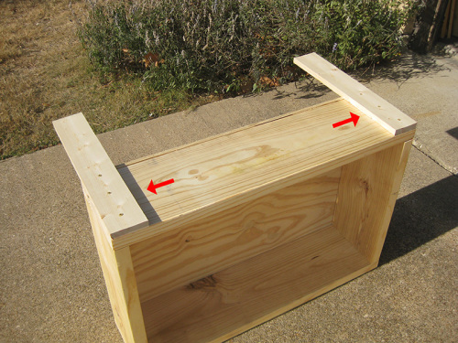

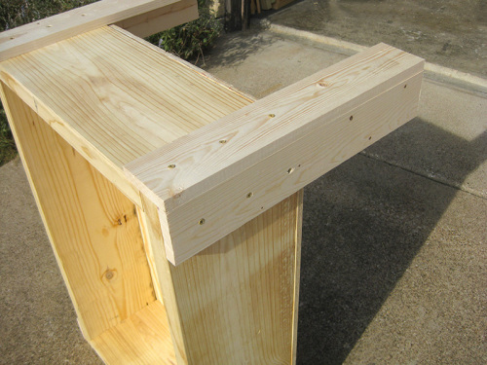

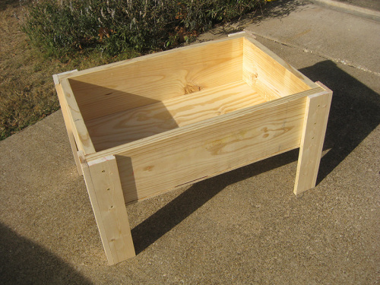

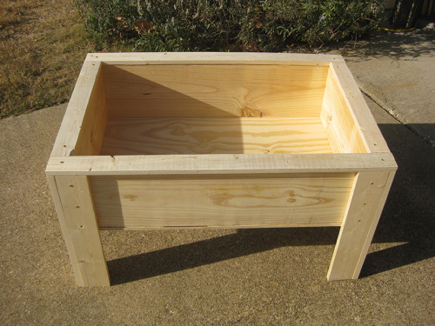

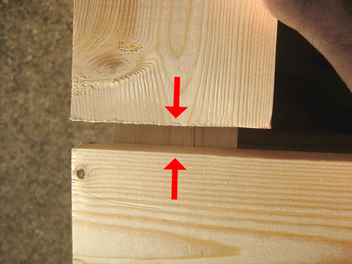

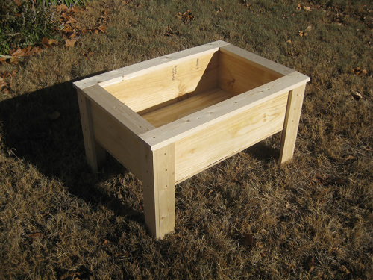

Appendix B – Types of Structures

TYPES OF STRUCTURES

TYPE OF STRUCTURE | DEFINITION | ADVANTAGES | DISADVANTAGES | EXAMPLES
Mass

Frame

Shell

Classify each of the following as MASS, FRAME or SHELL structures:
Beach Ball
Chair
Brick
Egg
Eiffel Tower
Skelton
CN Tower
Table
Bowling Ball
Submarine
Goal Posts
Rogers Centre (formerly known as the SkyDome)
Cucumber
Bridge
Wooden Board
Scaffolding
Cereal Box
Pencil Case
Shelves
Balloon
Paper Weight
Leaning Tower of Pisa
Car
Television

TYPES OF STRUCTURES – SAMPLE ANSWER SHEET

TYPE OF STRUCTURE | DEFINITION | ADVANTAGES | DISADVANTAGES | EXAMPLES
Mass | - Formed by the piling up of materials (layers)  - Usually heavier  - Solid on the inside | - Held in place by its own weight  - Resistant to weathering (not usually affected by outside forces such as wind, rain, snow, etc.) | - A strong force may cause it collapse  - Too much pressure under the structure may cause uneven ground (the structure may fall over)  - Too thin may fall over  - If not anchored down, may fall over | Bowling Ball  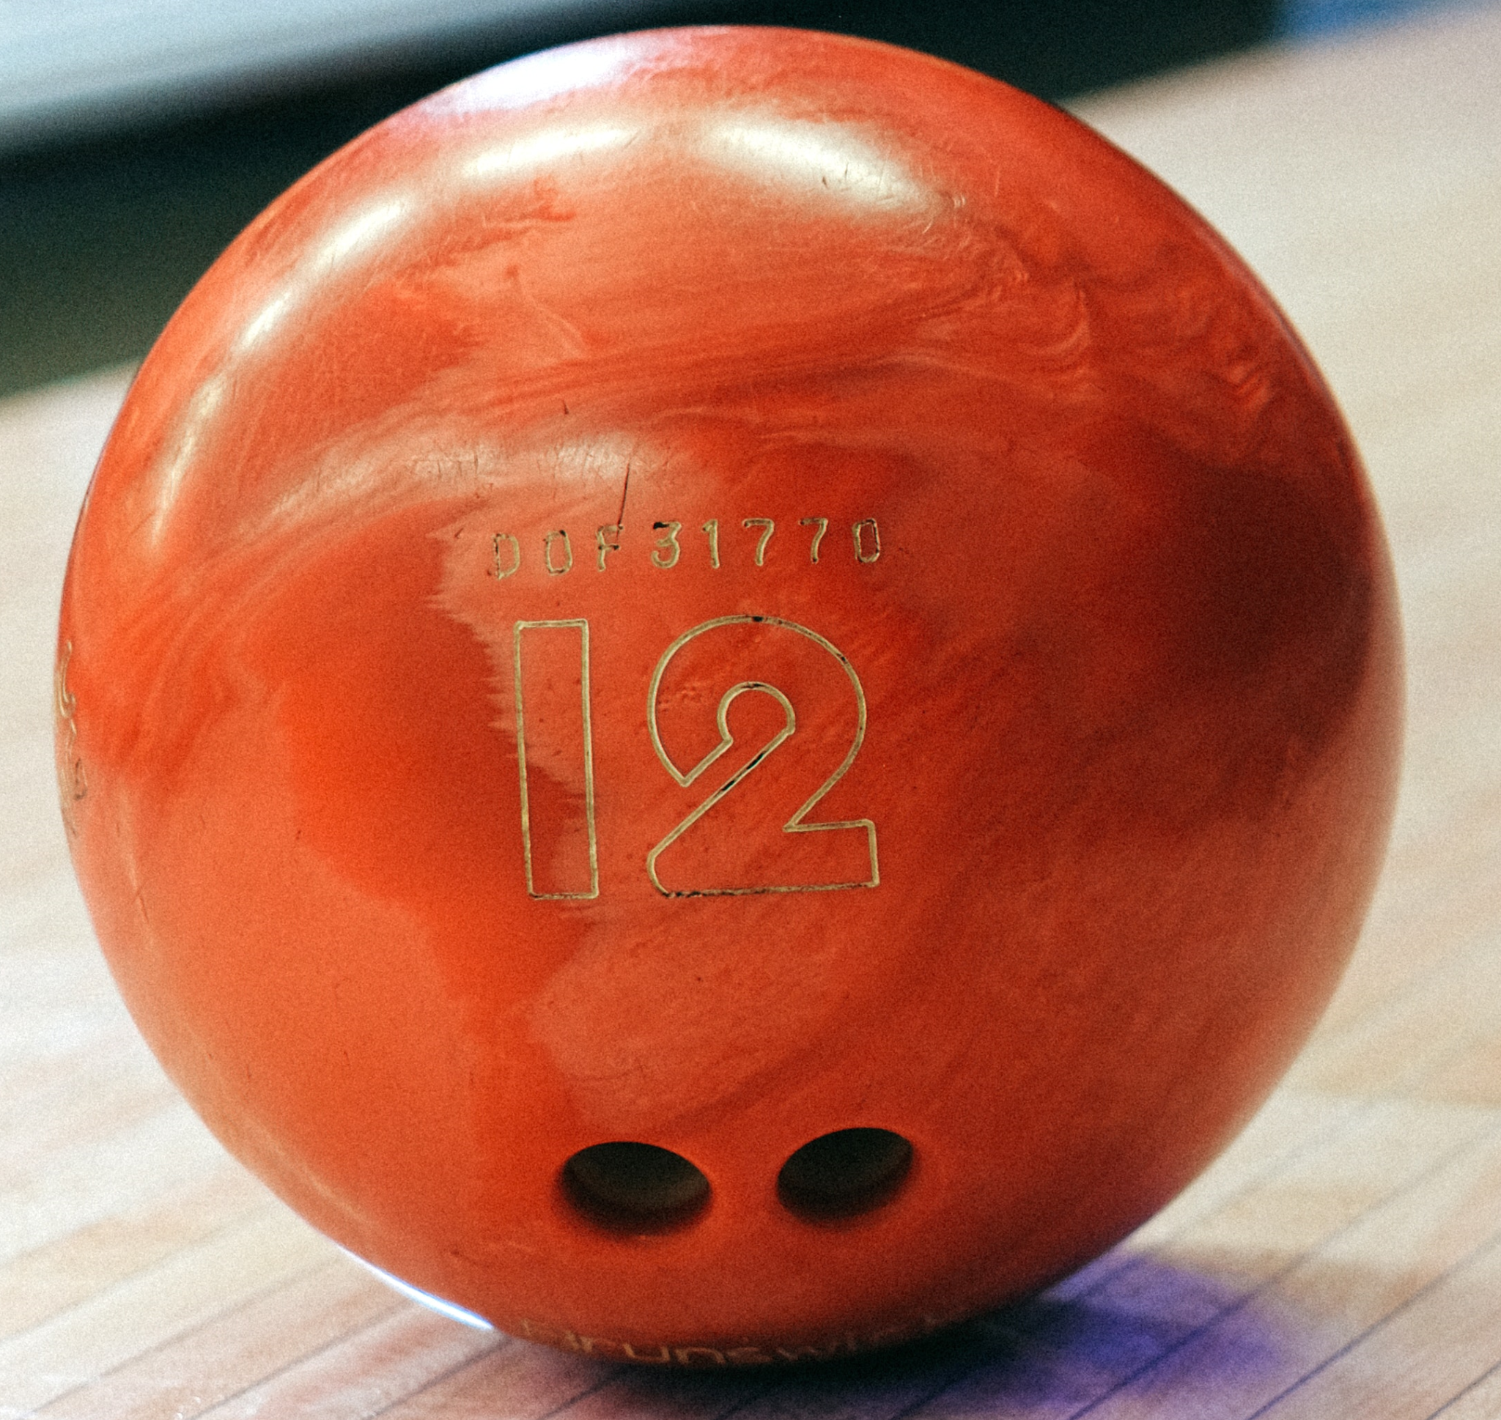  Brick Wall    Rock  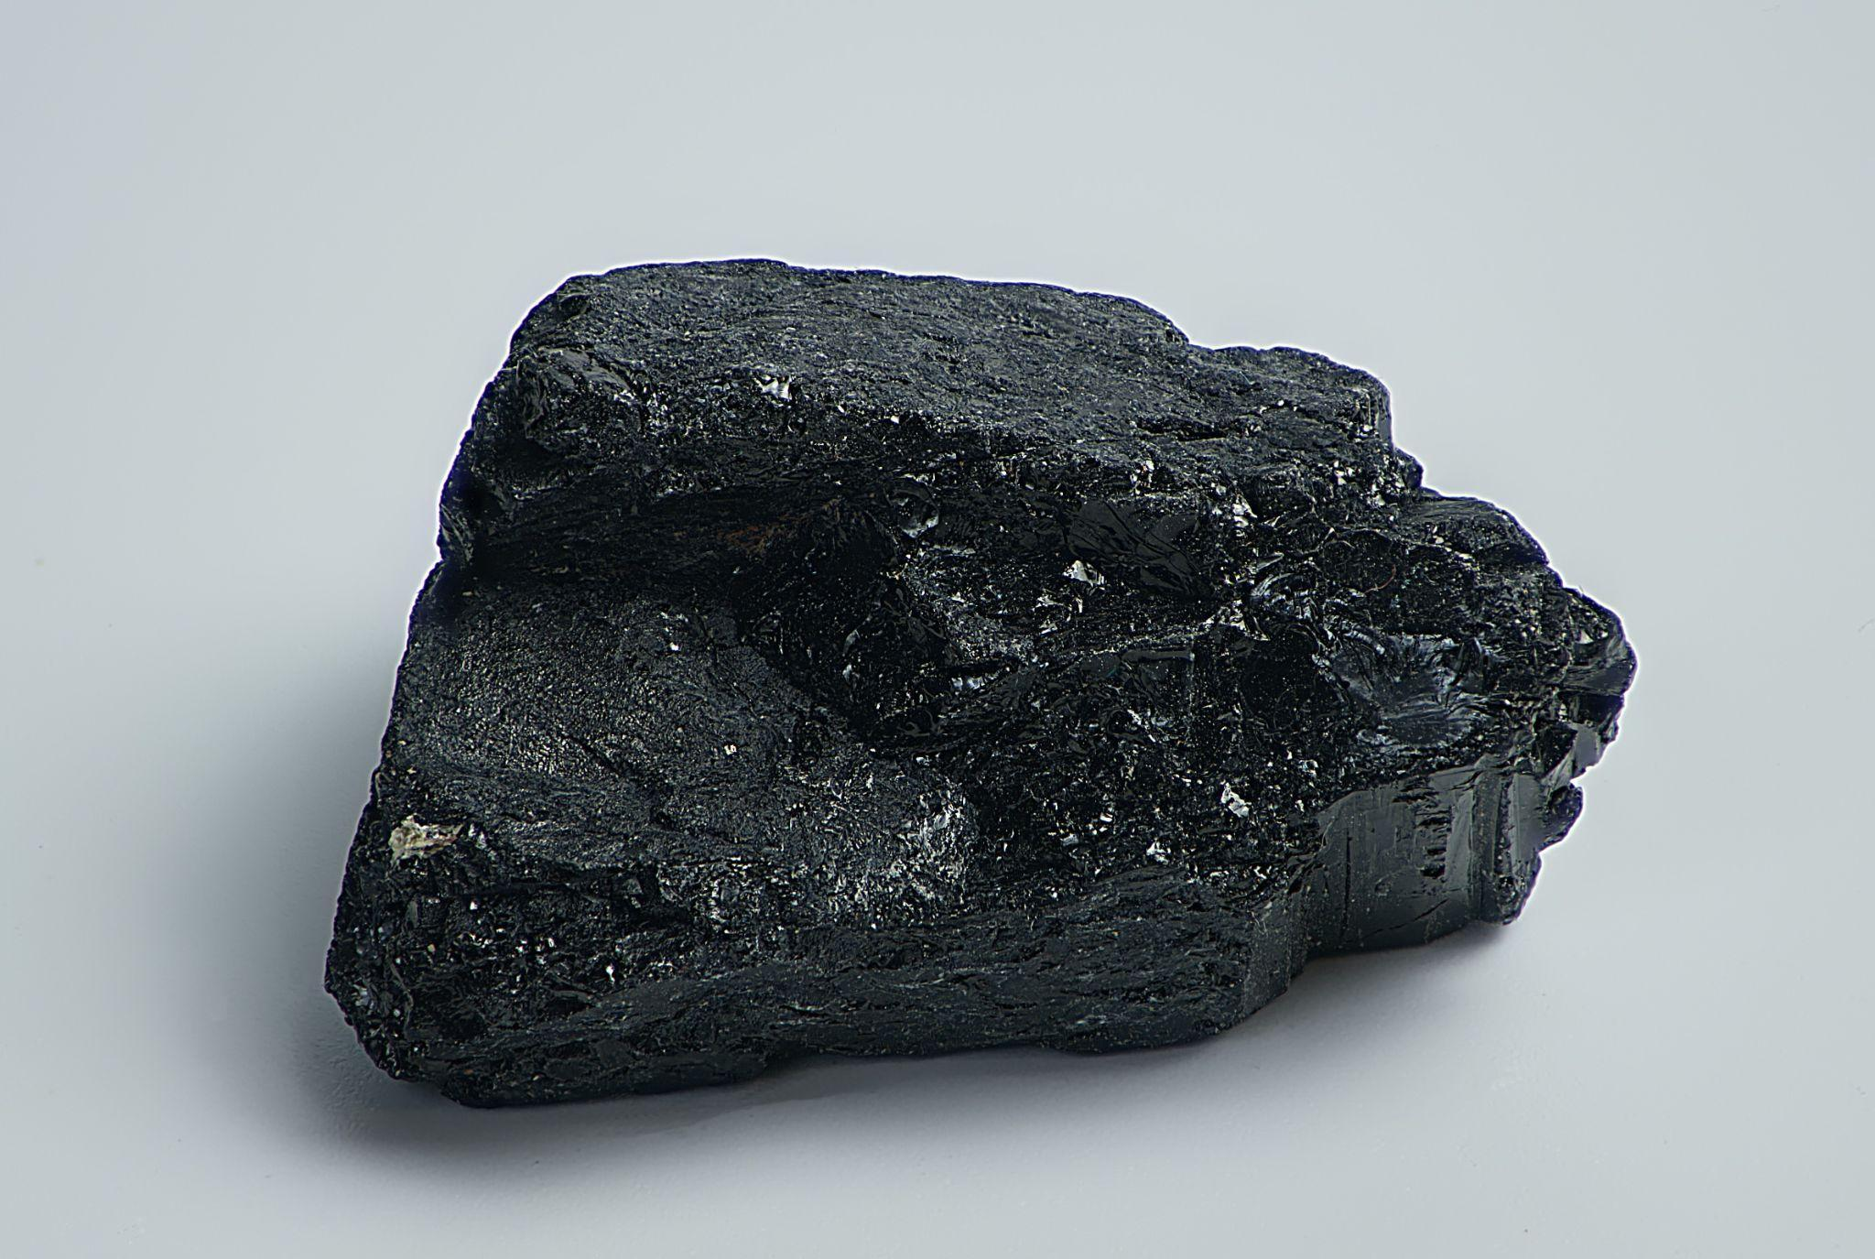  Hockey Puck    Mountain   Sand Castle  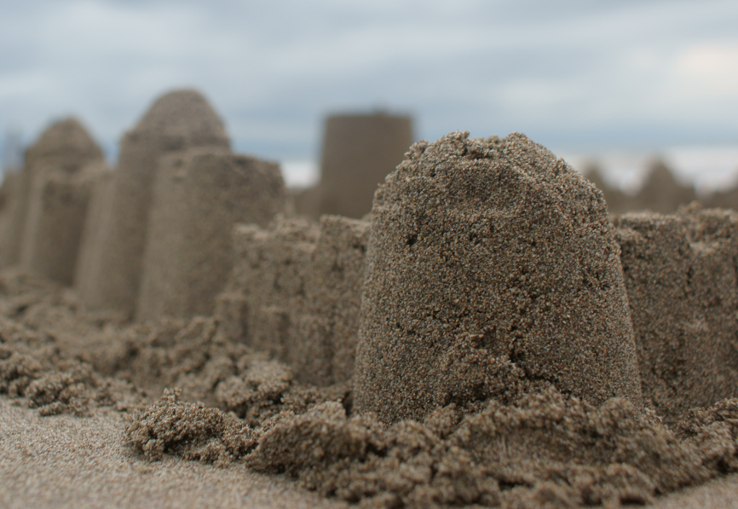
Frame | - A visible skeleton structure or inside “frame” that supports the weight of the other parts  - Inside is mostly empty space  - Air can pass through | - Less material than mass structures  - Lighter | - Difficult to build, potential for more supports required | Human Skeleton  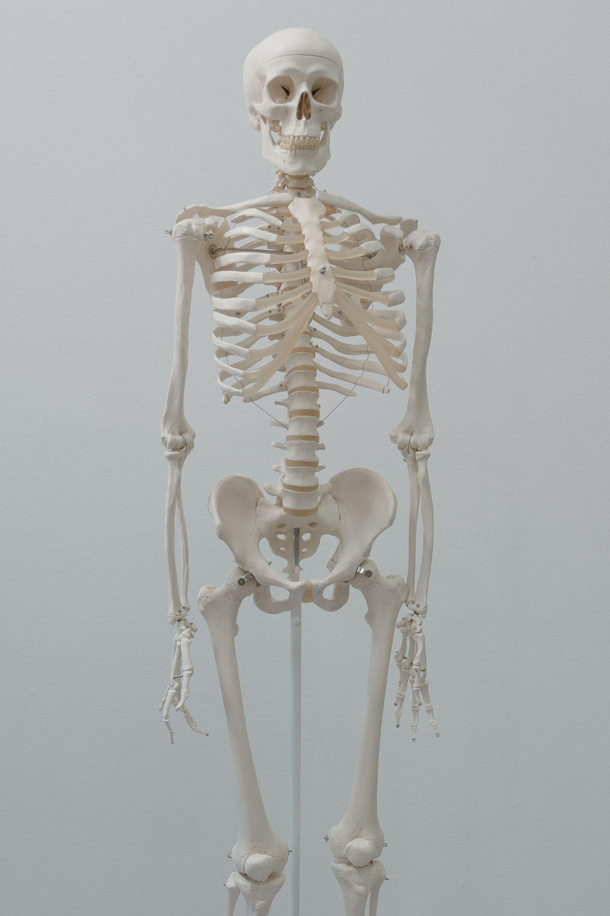  Table  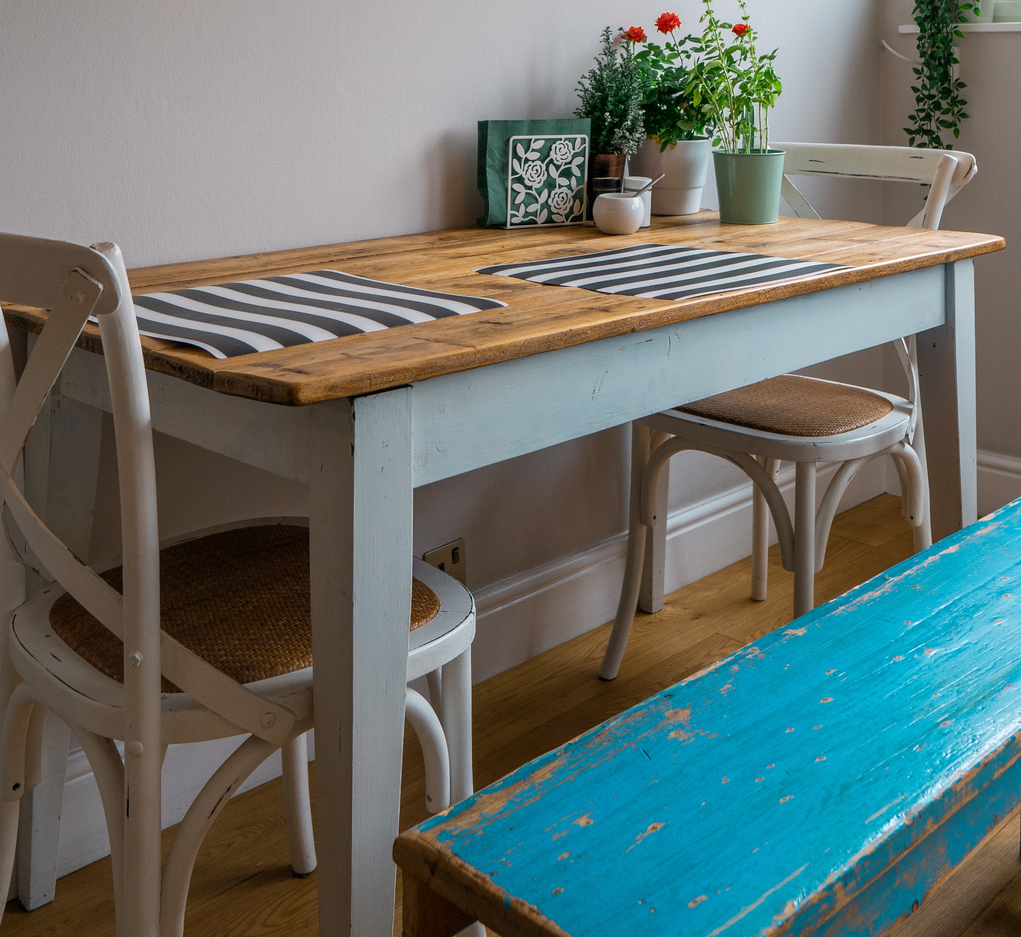  Bicycle  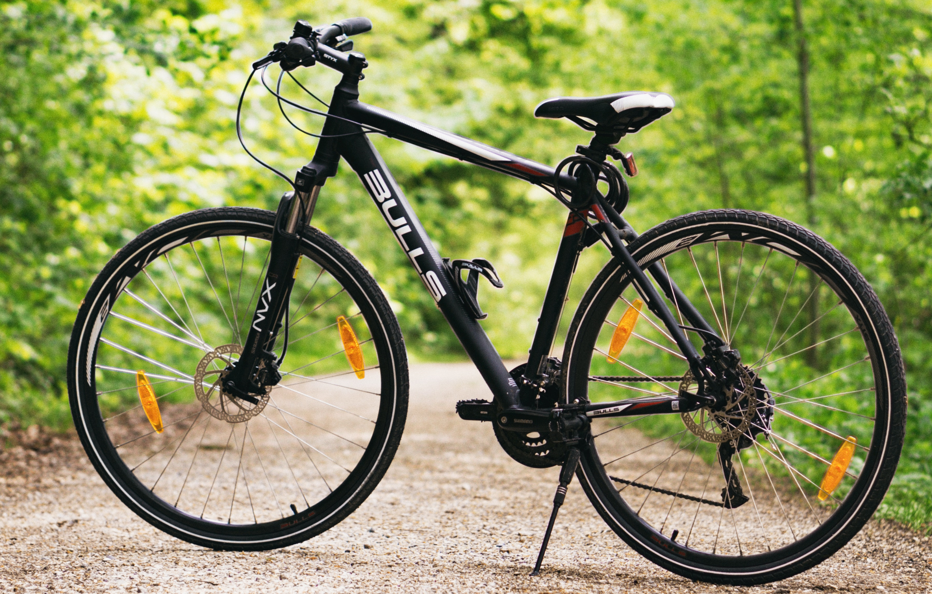  Eiffel Tower    Chair  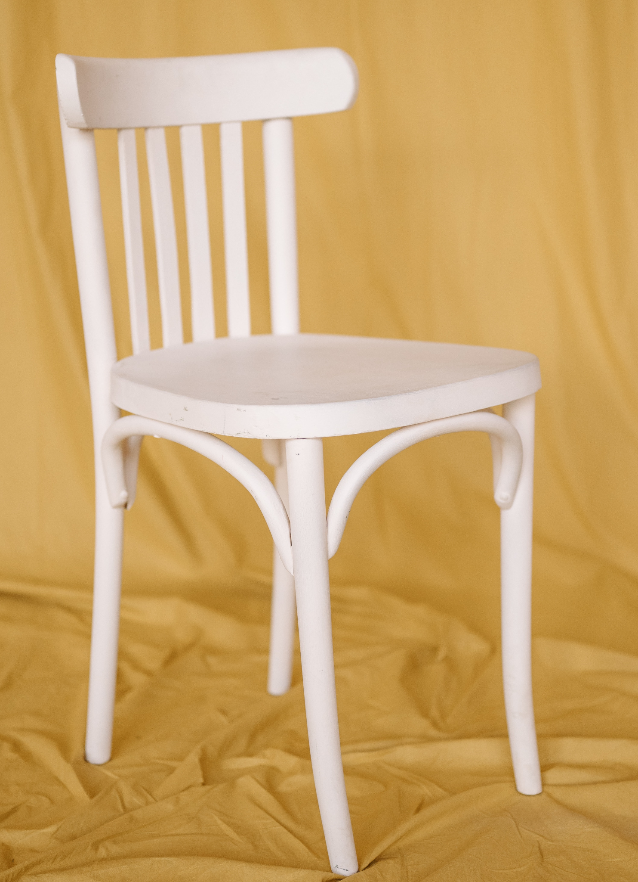  Ladder  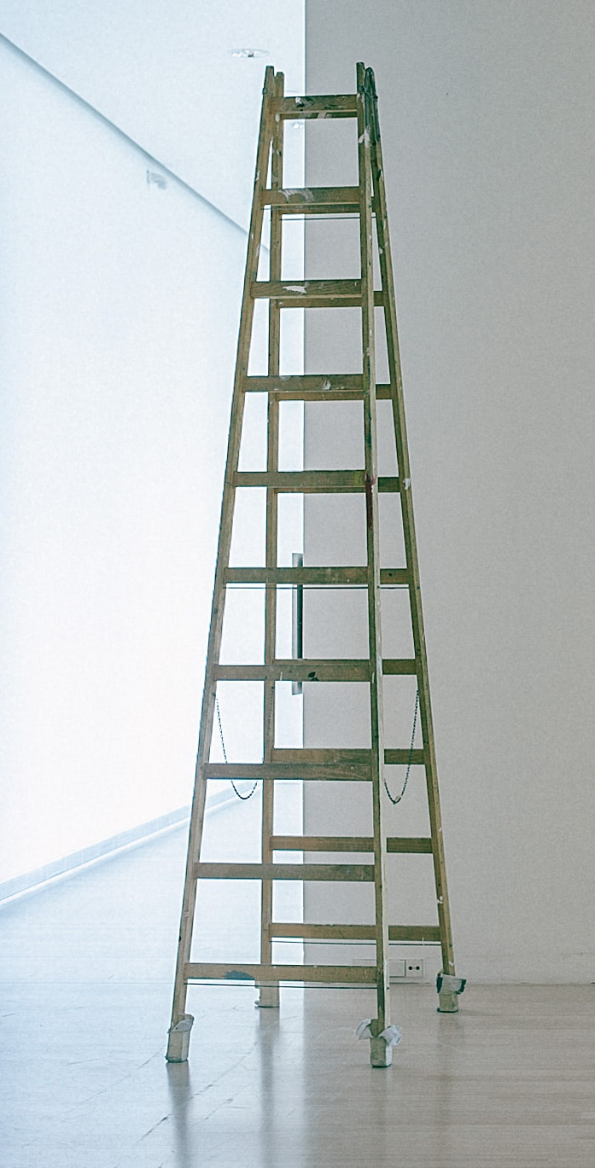
Shell | - Usually hollow on the inside  - Cover and protect the materials inside them  - Sometimes a thin outer layer | - Empty on the inside, so they make for good containers  - Material doesn’t have to be very strong because forces acting on it are spread out | - Any flaws may cause it to fail  - Cooling or drying of the material can cause failure  - Flat materials (e.g. wood) are difficult to make round  - Assembly is difficult and often time consuming | Egg    Beach Ball    Balloon    Box    Basketball  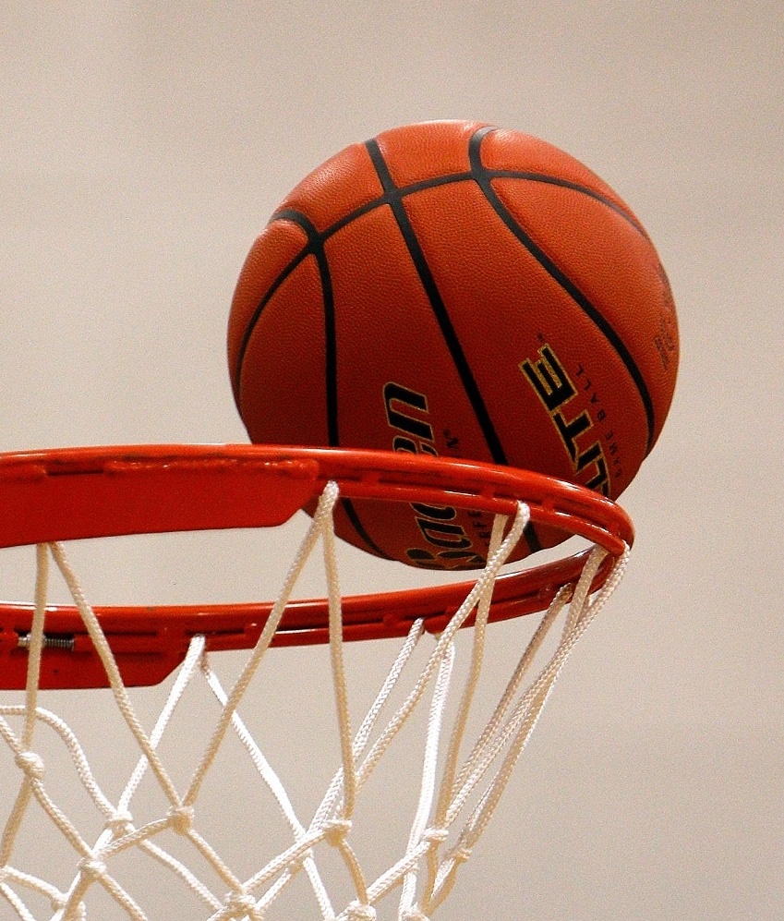  Cup  

ALL IMAGES https://www.pexels.com/

Appendix C – Building Something From The Inside Out Rubric
Categories | Level 1 | Level 2 | Level 3 | Level 4
Knowledge and Understanding
Knowledge of content  Student demonstrates an understanding of interactions between and among biotic and abiotic components in the environment. | demonstrates limited knowledge of content | demonstrate some knowledge of content | demonstrates knowledge of content | demonstrates thorough knowledge of content
Understanding of content relating Science and Technology to our changing World  Student understands the relationship between structural forms and the forces acting on them. | demonstrates limited understanding of content | demonstrates some understanding of content | demonstrates considerable understanding of content | demonstrates thorough understanding of content
Thinking
Assess the impact of human activities and technologies on the environment, and analyse ways to mitigate negative impacts and contribute to environmental sustainability | Assesses the impact with limited effectiveness | Assesses the impact with some effectiveness | Assesses the impact with considerable effectiveness | Assesses the impact with a high degree of effectiveness
Use of planning skills  Student follows a logical order of events to complete assignment | uses planning skills with limited effectiveness | uses planning skills with some effectiveness | uses planning skills with considerable effectiveness | uses planning skills with a high degree of effectiveness
Use of critical/creative thinking processes  Student is able to self-evaluate his/her product, reflect on the process and suggest positive changes. | uses critical/ creative thinking processes with limited effectiveness | uses critical/ creative thinking processes with some effectiveness | uses critical/ creative thinking processes with considerable effectiveness | uses critical/ creative thinking processes with a high degree of effectiveness

Communication
Expression and organization of ideas and information  personal, social, economic, and environmental factors that should be considered when designing and building structures. | expresses and organizes ideas and information with limited effectiveness | expresses and organizes ideas and information with some effectiveness | expresses and organizes ideas and information with considerable effectiveness | expresses and organizes ideas and information with considerable effectiveness
Communication for different audiences in oral, visual, and written forms  Student communicated effectively with teacher | communicates for different audiences and purposes with limited effectiveness | communicates for different audiences and purposes with some effectiveness | communicates for different audiences and purposes with considerable effectiveness | communicates for different audiences and purposes with a high degree of effectiveness
Use of conventions vocabulary, and terminology of the discipline in oral, visual, and written forms  Student produced well drawn and clear sketches. Dimensions in slide show have correct designations. | uses conventions, vocabulary, and terminology of the discipline with limited effectiveness uses | uses conventions, vocabulary, and terminology of the discipline with some effectiveness | uses conventions, vocabulary, and terminology of the discipline with considerable effectiveness | uses conventions, vocabulary, and terminology of the discipline with a high degree of effectiveness

Application

Application of knowledge and skills in familiar contexts  Student was able to take previously learned math concepts and use them to solve a practical problem. | applies knowledge and skills in familiar contexts with limited effectiveness | applies knowledge and skills in familiar contexts with some effectiveness | applies knowledge and skills in familiar contexts with considerable effectiveness | applies knowledge and skills in familiar contexts with a high degree of effectiveness
Transfer of knowledge and skills to new contexts  Student was able to take Evaluate the impact of the ergonomic design of various tools, objects, and work spaces on a user’s health, safety, and ability to work efficiently. | transfers knowledge and skills to new contexts with limited effectiveness | transfers knowledge and skills to new contexts with some effectiveness | transfers knowledge and skills to new contexts with considerable effectiveness | transfers knowledge and skills to new contexts with a high degree of effectiveness

References
21st Century Competencies: Foundation Document for Discussion. Phase 1: Towards Defining 21st Century Competencies for Ontario, Winter 2016 Edition, 2016 http://www.edugains.ca/resources21CL/About21stCentury/21CL_21stCenturyCompetencies.pdf
Basketball on Hoop, Pixabay (picture) 2017 https://www.pexels.com/photo/ball-on-hoop-358042/
Beach Ball, Rodion Kutsaiev (picture), 2021 https://www.pexels.com/photo/white-yellow-and-blue-ball-8566875/
Black and white hardtail bike on brown road between trees, Philipp M (picture), 2016 https://www.pexels.com/photo/black-and-white-hardtail-bike-on-brown-road-between-trees-100582/
Bowling Ball, Anna Schvets (picture), 2020 https://www.pexels.com/photo/close-up-shot-of-a-brown-bowling-ball-on-the-bowling-alley-5952951/
Carton Box, Karolina Grabowska (picture) 2020, https://www.pexels.com/photo/carton-box-and-tape-with-scissors-on-shabby-table-4498135/
Cement Balloon Planter, Artsy Pretty Plants, 2022 https://artsyprettyplants.com/cement-balloon-planter/
College of Trades Training Standards https://www.collegeoftrades.ca/training-standards
Construction Training and Apprenticeship Ontario, CTAO (website), 2022 https://www.ctaontario.com/
Creating a STEAM Classroom, STAO, https://stao.ca/creating-a-steam-classroom-stao-connex/
Easy Poured Concrete Bowls, Made by Barb, 2022 https://www.madebybarb.com/2016/06/26/easy-poured-concrete-bowls/
Egg on a red background, Anna Schvets (picture), 2020 https://www.pexels.com/photo/egg-on-a-red-background-4045697/
Eiffel Tower, Pixabay (picture), 2017 https://www.pexels.com/photo/architecture-blue-sky-city-cityscape-532826/
Empty Corridor with Ladder and Lamps on Ceiling, Maria Orlova (picture), 2020 https://www.pexels.com/photo/empty-corridor-with-ladder-and-lamps-on-ceiling-4947007/
Growing Success: Assessment, Evaluation, and Reporting in Ontario Schools, First Edition, Covering Grades 1 to 12, 2010 www.edu.gov.on.ca/eng/policyfunding/growSuccess.pdf
Hockey Puck, cottonbro (picture), 2021 https://www.pexels.com/photo/cold-snow-man-people-6557325/
How To Cast Anything With This Two Ingredient Mold, A Crafty Mix, 2022 https://acraftymix.com/blog/two-ingredient-mold/
How to Survive a Natural Disaster, STAO Connex, https://connex.stao.ca/classroom-catalyst/how-to-survive-a-natural-disaster-grade-7
Human Skeleton, Tima Miroshnichenko (picture), 2020 https://www.pexels.com/photo/human-skeleton-model-5428147/
Learning for All – A Guide to Effective Assessment and Instruction for All Students, Kindergarten to Grade 12, 2013 http://www.edu.gov.on.ca/eng/general/elemsec/speced/LearningforAll2013.pdf
Making Better 100% Silicone Caulk Molds, Martha.net (article), 2018 https://martha.net/2018/05/how-to-make-better-100-silicone-caulk-molds/
Mini DIY Lego Planters: Fun Planting Project For Kids, Agnes, 2018 https://www.hellowonderful.co/post/mini-diy-lego-planters-fun-planting-project-for-kids/
Mountain, Eberhard Grossgasteiger (photo), 2018 https://www.pexels.com/photo/mountain-range-under-beige-sky-1670187/
Pinterest Wood Shelf site https://pin.it/1cHD4U2
Purple Balloon Against Yellow Background, Deeana Arts (picture), 2013 https://www.pexels.com/photo/purple-balloon-against-yellow-background-2534579/
Red Brick Wall, Pixabay (picture), 2017 https://www.pexels.com/photo/red-brick-wall-51119/
Resources, Ontario College of Trades, 2020 https://www.collegeoftrades.ca/resources
Rock, Peter Dopper (picture), 2019 https://www.pexels.com/photo/black-stone-2363901/
Sand Castle, Gerardo Ramones (picture), 2018 https://www.pexels.com/photo/person-standing-near-sand-castle-1427764/
Skilled Trades Identified in Ontario https://www.collegeoftrades.ca/wp-content/uploads/Sector_Brochure_One_Pager_web.pdf
Skilled Trades Ontario https://www.ontario.ca/page/skilled-trades
Slidesmania – Foldermania (Resource), 2022 https://docs.google.com/presentation/d/1UE-adTH5bBB2xCv1GWRG81mw1ycbGukiyOS_ppWZbc8/edit#slide=id.p1
Slidesmania – Graphic Organizers, 2022 https://docs.google.com/presentation/d/1t7WfrBzj9d21CIUhinXYFdywPwcMoTgAjjjUnPcAMi4/edit#slide=id.p1
Table, Mitchell Henderson (picture), 2019 https://www.pexels.com/photo/flower-vase-on-table-2098913/
The Differentiated Instruction Scrapbook http://www.edugains.ca/resourcesDI/EducatorsPackages/DIEducatorsPackage2010/2010DIScrapbook.pdf
The Ontario Curriculum, Grades 9 and 10: Technological Education, 2009 (revised) http://www.edu.gov.on.ca/eng/curriculum/secondary/teched910curr09.pdf
Types of Structures (worksheet), 2022 https://docs.google.com/document/d/156Hqvsu5-7Jz4vK8hriQpEMjpN5DcTyteC3_yxcjYOc/edit?usp=sharing
Types of Structures Classify (worksheet), 2022 https://docs.google.com/document/d/1XJnLTusDCAuymXobuYYk11yacXy_hAKovo2EmJg-aLI/edit
White Chair on Mustard Cloth, Pavel Danilyuk (picture) 2021 https://www.pexels.com/photo/photo-of-a-white-chair-on-a-mustard-cloth-7881483/
White disposable cups with kraft paper hanging on wall, Angela Roma (picture), 2021 https://www.pexels.com/photo/white-disposable-cups-with-kraft-paper-hanging-on-wall-7319101/

